JAVA NOTES
- The history of Java is very interesting. Java was originally designed for interactive television, but it was too advanced technology for the digital cable television industry at the time. The history of Java starts with the Green Team. Java team members (also known as Green Team), initiated this project to develop a language for digital devices such as set-top boxes, televisions, etc. However, it was best suited for internet programming. Later, Java technology was incorporated by Netscape.
- The principles for creating Java programming were "Simple, Robust, Portable, Platform-independent, Secured, High Performance, Multithreaded, Architecture Neutral, Object-Oriented, Interpreted, and Dynamic". Java was developed by James Gosling, who is known as the father of Java, in 1995. James Gosling and his team members started the project in the early '90s.

- According to Sun, 3 billion devices run Java. There are many devices where Java is currently used. Some of them are as follows:
- Desktop Applications such as acrobat reader, media player, antivirus, etc.
- Web Applications such as irctc.co.in, javatpoint.com, etc.
- Enterprise Applications such as banking applications.
- Mobile
- Embedded System
- Smart Card
- Robotics
- Games, etc.
- Standalone Application
Standalone applications are also known as desktop applications or window-based applications. These are traditional software that we need to install on every machine.
Web Application
An application that runs on the server side and creates a dynamic page is called a web application. Currently, Servlet, JSP, Struts, Spring, Hibernate, JSF, etc. technologies are used for creating web applications in Java.
Enterprise Application
An application that is distributed in nature, such as banking applications, etc. is called an enterprise application. It has advantages like high-level security, load balancing, and clustering. In Java, EJB is used for creating enterprise applications.
Mobile Application
An application which is created for mobile devices is called a mobile application. Currently, Android and Java ME are used for creating mobile applications.

Object and Classes

- An object in Java is the physical as well as a logical entity, whereas, a class in Java is a logical entity only.
- An entity that has state and behavior is known as an object e.g., chair, bike, marker, pen, table, car, etc. It can be physical or logical (tangible and intangible). The example of an intangible object is the banking system.

- State: represents the data (value) of an object.
- Behavior: represents the behavior (functionality) of an object such as deposit, withdraw, etc.
- Identity: An object identity is typically implemented via a unique ID. The value of the ID is not visible to the external user. However, it is used internally by the JVM to identify each object uniquely.

Class in Java

- A class is a group of objects which have common properties. It is a template or blueprint from which objects are created. It is a logical entity. It can't be physical.
- A class in Java can contain:
- Fields
- Methods
- Constructors
- Blocks
- Nested class and interface

Discussion on Public Static Void Main

- 1. Public
- It is an Access modifier, which specifies from where and who can access the method. Making the main() method public makes it globally available. It is made public so that JVM can invoke it from outside the class as it is not present in the current class.
- 2. Static
- It is a keyword that is when associated with a method, making it a class-related method. The main() method is static so that JVM can invoke it without instantiating the class. This also saves the unnecessary wastage of memory which would have been used by the object declared only for calling the main() method by the JVM.
- 3. Void
- It is a keyword and is used to specify that a method doesn’t return anything. As the main() method doesn’t return anything, its return type is void. As soon as the main() method terminates, the java program terminates too. Hence, it doesn’t make any sense to return from the main() method as JVM can’t do anything with the return value of it.
- 4. main
- It is the name of the Java main method. It is the identifier that the JVM looks for as the starting point of the java program. It’s not a keyword.

Can we execute a java program without main method?

- Yes, we can execute a java program without a main method by using a static block.
- A static block in Java is a group of statements that gets executed only once when the class is loaded into the memory by ClassLoader, It is also known as a static initialization block, and it goes into the stack memory.
JVM

- Java program runs as a ‘main thread’ in JVM. The Java program is not even a process of Operating System directly. There is no direct interaction between the Java program and Operating System. There is no direct allocation of resources to the Java program directly, or the Java program does not occupy any place in the process table. Whom should it return an exit status to, then? This is why the main method of Java is designed not to return an int or exit status.
- But JVM is a process of an operating system, and JVM can be terminated with a certain exit status. With help of java.lang.Runtime.exit(int status) or System.exit(int status).
Why Java is Platform Independent
- Whenever, a program is written in JAVA, the javac compiles it.
The result of the JAVA compiler is the .class file or the bytecode and not the machine native code (unlike C compiler).
The bytecode generated is a non-executable code and needs an interpreter to execute on a machine. This interpreter is the JVM and thus the Bytecode is executed by the JVM.
And finally program runs to give the desired output.

Data Types in JAVA
There are 8 types of primitive data types:
- boolean data type
- byte data type
- char data type
- short data type
- int data type
- long data type
- float data type
- double data type
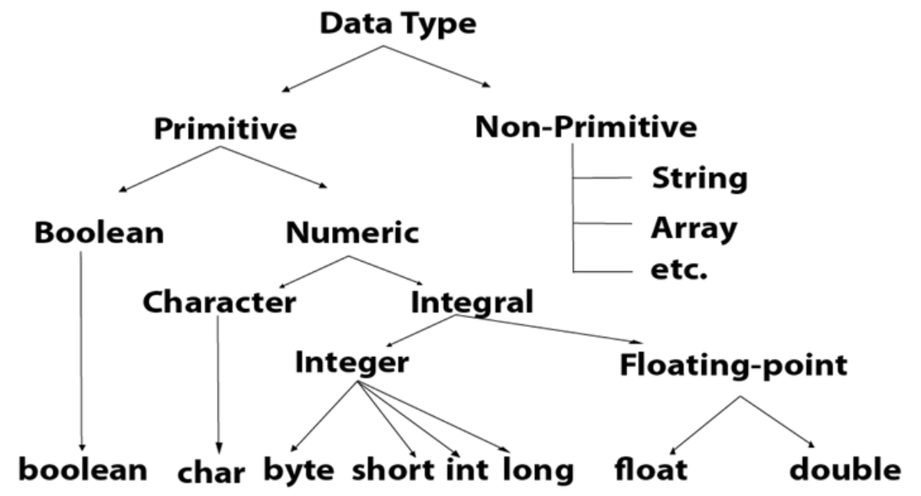

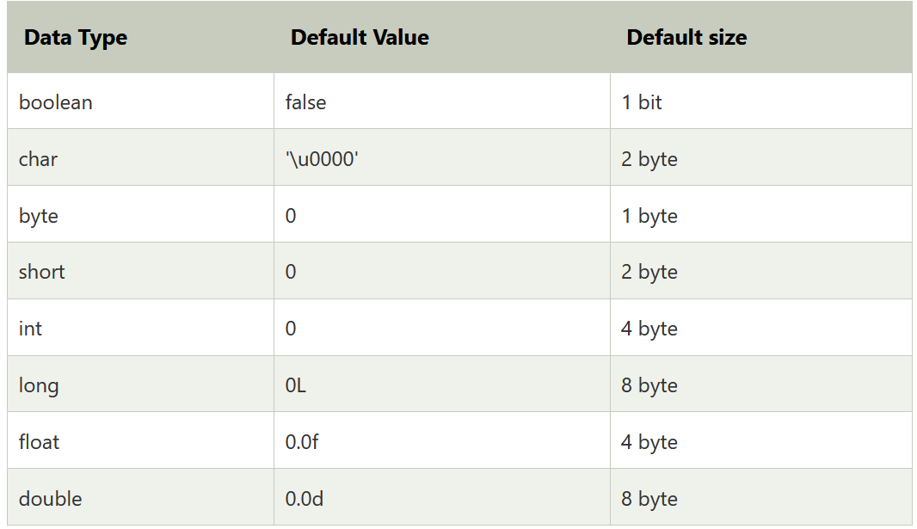

Operators in Java

Operator in Java is a symbol that is used to perform operations. For example: +, -, *, / etc.
There are many types of operators in Java which are given below:
- Unary Operator,
- Arithmetic Operator,
- Shift Operator,
- Relational Operator,
- Bitwise Operator,
- Logical Operator,
- Ternary Operator and
- Assignment Operator.

Java Operator Precedence
Operator Type | Category | Precedence
Unary | postfix | expr++ expr--
 | prefix | ++expr --expr +expr -expr ~ !
Arithmetic | multiplicative | * / %
 | additive | + -
Shift | shift | << >> >>>
Relational | comparison | < > <= >= instanceof
 | equality | == !=
Bitwise | bitwise AND | &
 | bitwise exclusive OR | ^
 | bitwise inclusive OR | |
Logical | logical AND | &&
 | logical OR | ||
Ternary | ternary | ? :
Assignment | assignment | = += -= *= /= %= &= ^= |= <<= >>= >>>=

Java Unary Operator
The Java unary operators require only one operand. Unary operators are used to perform various operations i.e.:
- incrementing/decrementing a value by one
- negating an expression
- inverting the value of a boolean

Java Unary Operator Example: ++ and --
- public class OperatorExample{
- public static void main(String args[]){
- int x=10;
- System.out.println(x++);//10 (11)
- System.out.println(++x);//12
- System.out.println(x--);//12 (11)
- System.out.println(--x);//10
- }}
Output:
10
12
12
10

Java Unary Operator Example 2: ++ and --
- public class OperatorExample{
- public static void main(String args[]){
- int a=10;
- int b=10;
- System.out.println(a++ + ++a);//10+12=22
- System.out.println(b++ + b++);//10+11=21

- }}
Output:
22
21

Java Unary Operator Example: ~ and !
- public class OperatorExample{
- public static void main(String args[]){
- int a=10;
- int b=-10;
- boolean c=true;
- boolean d=false;
- System.out.println(~a);//-11 (minus of total positive value which starts from 0)
- System.out.println(~b);//9 (positive of total minus, positive starts from 0)
- System.out.println(!c);//false (opposite of boolean value)
- System.out.println(!d);//true
- }}
Output:
-11
9
false
true

Java Arithmetic Operators
Java arithmetic operators are used to perform addition, subtraction, multiplication, and division. They act as basic mathematical operations.

Java Arithmetic Operator Example
- public class OperatorExample{
- public static void main(String args[]){
- int a=10;
- int b=5;
- System.out.println(a+b);//15
- System.out.println(a-b);//5
- System.out.println(a*b);//50
- System.out.println(a/b);//2
- System.out.println(a%b);//0
- }}
Output:
15
5
50
2
0

Java Arithmetic Operator Example: Expression
- public class OperatorExample{
- public static void main(String args[]){
- System.out.println(10*10/5+3-1*4/2);
- }}
Output:
21

Java Left Shift Operator
The Java left shift operator << is used to shift all of the bits in a value to the left side of a specified number of times.

Java Left Shift Operator Example
- public class OperatorExample{
- public static void main(String args[]){
- System.out.println(10<<2);//10*2^2=10*4=40
- System.out.println(10<<3);//10*2^3=10*8=80
- System.out.println(20<<2);//20*2^2=20*4=80
- System.out.println(15<<4);//15*2^4=15*16=240
- }}
Output:
40
80
80
240

Java Right Shift Operator
The Java right shift operator >> is used to move the value of the left operand to right by the number of bits specified by the right operand.

Java Right Shift Operator Example
- public OperatorExample{
- public static void main(String args[]){
- System.out.println(10>>2);//10/2^2=10/4=2
- System.out.println(20>>2);//20/2^2=20/4=5
- System.out.println(20>>3);//20/2^3=20/8=2
- }}
Output:
2
5
2

Java Shift Operator Example: >> vs >>>
- public class OperatorExample{
- public static void main(String args[]){
- //For positive number, >> and >>> works same
- System.out.println(20>>2);
- System.out.println(20>>>2);
- //For negative number, >>> changes parity bit (MSB) to 0
- System.out.println(-20>>2);
- System.out.println(-20>>>2);
- }}
Output:
5
5
-5
1073741819

Java AND Operator Example: Logical && and Bitwise &
The logical && operator doesn't check the second condition if the first condition is false. It checks the second condition only if the first one is true.
The bitwise & operator always checks both conditions whether first condition is true or false.
- public class OperatorExample{
- public static void main(String args[]){
- int a=10;
- int b=5;
- int c=20;
- System.out.println(a<b&&a<c);//false && true = false
- System.out.println(a<b&a<c);//false & true = false
- }}
Output:
false
false

Java AND Operator Example: Logical && vs Bitwise &
- public class OperatorExample{
- public static void main(String args[]){
- int a=10;
- int b=5;
- int c=20;
- System.out.println(a<b&&a++<c);//false && true = false
- System.out.println(a);//10 because second condition is not checked
- System.out.println(a<b&a++<c);//false && true = false
- System.out.println(a);//11 because second condition is checked
- }}
Output:
false
10
false
11

Java OR Operator Example: Logical || and Bitwise |
The logical || operator doesn't check the second condition if the first condition is true. It checks the second condition only if the first one is false.
The bitwise | operator always checks both conditions whether first condition is true or false.
- public class OperatorExample{
- public static void main(String args[]){
- int a=10;
- int b=5;
- int c=20;
- System.out.println(a>b||a<c);//true || true = true
- System.out.println(a>b|a<c);//true | true = true
- //|| vs |
- System.out.println(a>b||a++<c);//true || true = true
- System.out.println(a);//10 because second condition is not checked
- System.out.println(a>b|a++<c);//true | true = true
- System.out.println(a);//11 because second condition is checked
- }}
Output:
true
true
true
10
true
11

Java Ternary Operator
Java Ternary operator is used as one line replacement for if-then-else statement and used a lot in Java programming. It is the only conditional operator which takes three operands.

Java Ternary Operator Example
- public class OperatorExample{
- public static void main(String args[]){
- int a=2;
- int b=5;
- int min=(a<b)?a:b;
- System.out.println(min);
- }}
Output:
2
Another Example:
- public class OperatorExample{
- public static void main(String args[]){
- int a=10;
- int b=5;
- int min=(a<b)?a:b;
- System.out.println(min);
- }}
Output:
5

Java Assignment Operator
Java assignment operator is one of the most common operators. It is used to assign the value on its right to the operand on its left.

Java Assignment Operator Example
- public class OperatorExample{
- public static void main(String args[]){
- int a=10;
- int b=20;
- a+=4;//a=a+4 (a=10+4)
- b-=4;//b=b-4 (b=20-4)
- System.out.println(a);
- System.out.println(b);
- }}
Output:
14
16

Java Assignment Operator Example
- public class OperatorExample{
- public static void main(String[] args){
- int a=10;
- a+=3;//10+3
- System.out.println(a);
- a-=4;//13-4
- System.out.println(a);
- a*=2;//9*2
- System.out.println(a);
- a/=2;//18/2
- System.out.println(a);
- }}
Output:
13
9
18
9

Java Assignment Operator Example: Adding short
- public class OperatorExample{
- public static void main(String args[]){
- short a=10;
- short b=10;
- //a+=b;//a=a+b internally so fine
- a=a+b;//Compile time error because 10+10=20 now int
- System.out.println(a);
- }}
Output:
Compile time error
After type cast:
- public class OperatorExample{
- public static void main(String args[]){
- short a=10;
- short b=10;
- a=(short)(a+b);//20 which is int now converted to short
- System.out.println(a);
- }}
Output:
20

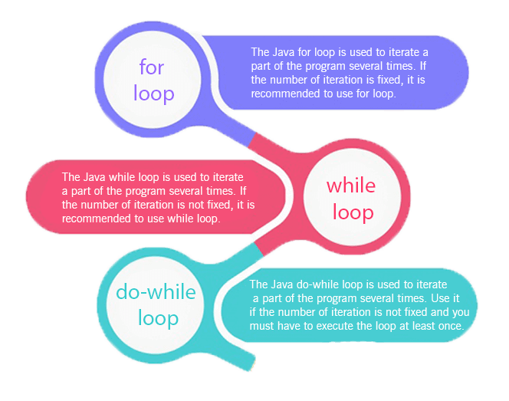
- Simple for Loop
- For-each or Enhanced for Loop
- Labeled for Loop

Java Simple for Loop
A simple for loop is the same as C/C++. We can initialize the variable, check condition and increment/decrement value. It consists of four parts:
- Initialization: It is the initial condition which is executed once when the loop starts. Here, we can initialize the variable, or we can use an already initialized variable. It is an optional condition.
- Condition: It is the second condition which is executed each time to test the condition of the loop. It continues execution until the condition is false. It must return boolean value either true or false. It is an optional condition.
- Increment/Decrement: It increments or decrements the variable value. It is an optional condition.
- Statement: The statement of the loop is executed each time until the second condition is false.
Syntax:
- for(initialization; condition; increment/decrement){
- //statement or code to be executed
- }
Flowchart:
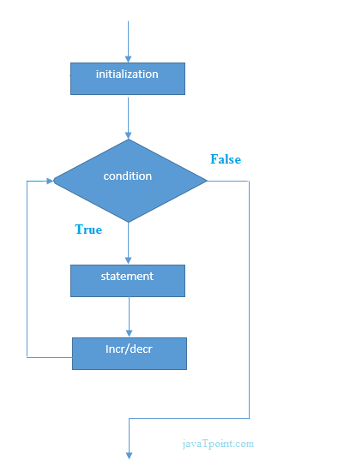
Example:
ForExample.java
- //Java Program to demonstrate the example of for loop
- //which prints table of 1
- public class ForExample {
- public static void main(String[] args) {
- //Code of Java for loop
- for(int i=1;i<=10;i++){
- System.out.println(i);
- }
- }
- }
Test it Now
Output:
1
2
3
4
5
6
7
8
9
10

Java Nested for Loop
If we have a for loop inside the another loop, it is known as nested for loop. The inner loop executes completely whenever outer loop executes.
Example:
NestedForExample.java
- public class NestedForExample {
- public static void main(String[] args) {
- //loop of i
- for(int i=1;i<=3;i++){
- //loop of j
- for(int j=1;j<=3;j++){
- System.out.println(i+" "+j);
- }//end of i
- }//end of j
- }
- }
Output:
1 1
1 2
1 3
2 1
2 2
2 3
3 1
3 2
3 3
Pyramid Example 1:
PyramidExample.java
- public class PyramidExample {
- public static void main(String[] args) {
- for(int i=1;i<=5;i++){
- for(int j=1;j<=i;j++){
- System.out.print("* ");
- }
- System.out.println();//new line
- }
- }
- }
Output:
*
* *
* * *
* * * *
* * * * *
Pyramid Example 2:
PyramidExample2.java
- public class PyramidExample2 {
- public static void main(String[] args) {
- int term=6;
- for(int i=1;i<=term;i++){
- for(int j=term;j>=i;j--){
- System.out.print("* ");
- }
- System.out.println();//new line
- }
- }
- }
Output:
* * * * * *
* * * * *
* * * *
* * *
* *
*

Java for-each Loop
The for-each loop is used to traverse array or collection in Java. It is easier to use than simple for loop because we don't need to increment value and use subscript notation.
It works on the basis of elements and not the index. It returns element one by one in the defined variable.
Syntax:
- for(data_type variable : array_name){
- //code to be executed
- }
Example:
ForEachExample.java
- //Java For-each loop example which prints the
- //elements of the array
- public class ForEachExample {
- public static void main(String[] args) {
- //Declaring an array
- int arr[]={12,23,44,56,78};
- //Printing array using for-each loop
- for(int i:arr){
- System.out.println(i);
- }
- }
- }
Test it Now
Output:
12
23
44
56
78

Java Labeled For Loop
We can have a name of each Java for loop. To do so, we use label before the for loop. It is useful while using the nested for loop as we can break/continue specific for loop.

Note: The break and continue keywords breaks or continues the innermost for loop respectively.
Syntax:
- labelname:
- for(initialization; condition; increment/decrement){
- //code to be executed
- }
Example:
LabeledForExample.java
- //A Java program to demonstrate the use of labeled for loop
- public class LabeledForExample {
- public static void main(String[] args) {
- //Using Label for outer and for loop
- aa:
- for(int i=1;i<=3;i++){
- bb:
- for(int j=1;j<=3;j++){
- if(i==2&&j==2){
- break aa;
- }
- System.out.println(i+" "+j);
- }
- }
- }
- }
Output:
1 1
1 2
1 3
2 1
If you use break bb;, it will break inner loop only which is the default behaviour of any loop.
LabeledForExample2.java
- public class LabeledForExample2 {
- public static void main(String[] args) {
- aa:
- for(int i=1;i<=3;i++){
- bb:
- for(int j=1;j<=3;j++){
- if(i==2&&j==2){
- break bb;
- }
- System.out.println(i+" "+j);
- }
- }
- }
- }

Java While Loop

The Java while loop is used to iterate a part of the program repeatedly until the specified Boolean condition is true. As soon as the Boolean condition becomes false, the loop automatically stops.
The while loop is considered as a repeating if statement. If the number of iteration is not fixed, it is recommended to use the while loop.
Syntax:
- while (condition){
- //code to be executed
- I ncrement / decrement statement
- }
The different parts of do-while loop:
1. Condition: It is an expression which is tested. If the condition is true, the loop body is executed and control goes to update expression. When the condition becomes false, we exit the while loop.
Example:
i <=100
2. Update expression: Every time the loop body is executed, this expression increments or decrements loop variable.
Example:
i++;
Flowchart of Java While Loop
Here, the important thing about while loop is that, sometimes it may not even execute. If the condition to be tested results into false, the loop body is skipped and first statement after the while loop will be executed.
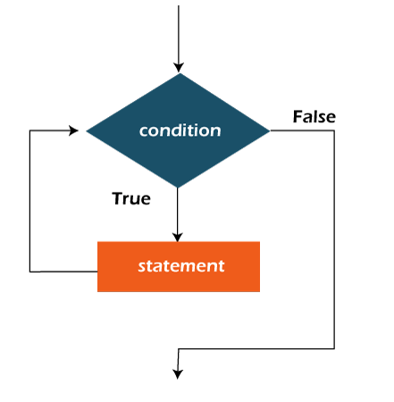
Example:
In the below example, we print integer values from 1 to 10. Unlike the for loop, we separately need to initialize and increment the variable used in the condition (here, i). Otherwise, the loop will execute infinitely.
WhileExample.java
- public class WhileExample {
- public static void main(String[] args) {
- int i=1;
- while(i<=10){
- System.out.println(i);
- i++;
- }
- }
- }
Test it Now
Output:
1
2
3
4
5
6
7
8
9
10

Java Infinitive While Loop
If you pass true in the while loop, it will be infinitive while loop.
Syntax:
- while(true){
- //code to be executed
- }
Example:
WhileExample2.java
- public class WhileExample2 {
- public static void main(String[] args) {
- // setting the infinite while loop by passing true to the condition
- while(true){
- System.out.println("infinitive while loop");
- }
- }
- }
Output:
infinitive while loop
infinitive while loop
infinitive while loop
infinitive while loop
infinitive while loop
ctrl+c

DO WHILE LOOP
The Java do-while loop is used to iterate a part of the program repeatedly, until the specified condition is true. If the number of iteration is not fixed and you must have to execute the loop at least once, it is recommended to use a do-while loop.
Java do-while loop is called an exit control loop. Therefore, unlike while loop and for loop, the do-while check the condition at the end of loop body. The Java do-while loop is executed at least once because condition is checked after loop body.
Syntax:
- do{
- //code to be executed / loop body
- //update statement
- }while (condition);
The different parts of do-while loop:
1. Condition: It is an expression which is tested. If the condition is true, the loop body is executed and control goes to update expression. As soon as the condition becomes false, loop breaks automatically.
Example:
i <=100
2. Update expression: Every time the loop body is executed, the this expression increments or decrements loop variable.
Example:
i++;

Note: The do block is executed at least once, even if the condition is false.
Flowchart of do-while loop:
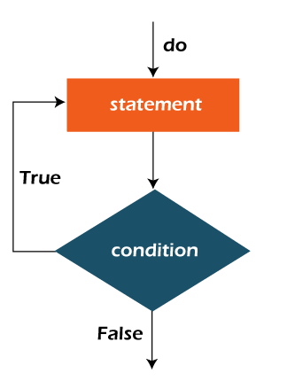
Example:
In the below example, we print integer values from 1 to 10. Unlike the for loop, we separately need to initialize and increment the variable used in the condition (here, i). Otherwise, the loop will execute infinitely.
DoWhileExample.java
- public class DoWhileExample {
- public static void main(String[] args) {
- int i=1;
- do{
- System.out.println(i);
- i++;
- }while(i<=10);
- }
- }
Test it Now
Output:
1
2
3
4
5
6
7
8
9
10

Java Infinitive do-while Loop
If you pass true in the do-while loop, it will be infinitive do-while loop.
Syntax:
- do{
- //code to be executed
- }while(true);
Example:
DoWhileExample2.java
- public class DoWhileExample2 {
- public static void main(String[] args) {
- do{
- System.out.println("infinitive do while loop");
- }while(true);
- }
- }

Constructors in Java

In Java, a constructor is a block of codes similar to the method. It is called when an instance of the class is created. At the time of calling constructor, memory for the object is allocated in the memory.
It is a special type of method which is used to initialize the object.
Every time an object is created using the new() keyword, at least one constructor is called.
It calls a default constructor if there is no constructor available in the class. In such case, Java compiler provides a default constructor by default.
There are two types of constructors in Java: no-arg constructor, and parameterized constructor.
Note: It is called constructor because it constructs the values at the time of object creation. It is not necessary to write a constructor for a class. It is because java compiler creates a default constructor if your class doesn't have any.

Rules for creating Java constructor
There are two rules defined for the constructor.
- Constructor name must be the same as its class name
- A Constructor must have no explicit return type
- A Java constructor cannot be abstract, static, final, and synchronized

Note: We can use access modifiers while declaring a constructor. It controls the object creation. In other words, we can have private, protected, public or default constructor in Java.

Types of Java constructors
There are two types of constructors in Java:
- Default constructor (no-arg constructor)
- Parameterized constructor
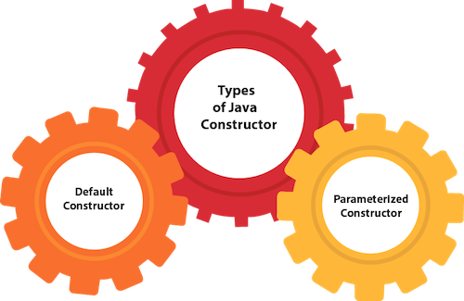

Java Default Constructor
A constructor is called "Default Constructor" when it doesn't have any parameter.

Syntax of default constructor:
- <class_name>(){}

Example of default constructor
In this example, we are creating the no-arg constructor in the Bike class. It will be invoked at the time of object creation.
- //Java Program to create and call a default constructor
- class Bike1{
- //creating a default constructor
- Bike1(){System.out.println("Bike is created");}
- //main method
- public static void main(String args[]){
- //calling a default constructor
- Bike1 b=new Bike1();
- }
- }
Test it Now
Output:
Bike is created

Rule: If there is no constructor in a class, compiler automatically creates a default constructor.
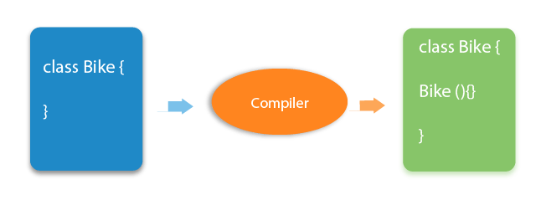

Q) What is the purpose of a default constructor?
The default constructor is used to provide the default values to the object like 0, null, etc., depending on the type.

Example of default constructor that displays the default values
- //Let us see another example of default constructor
- //which displays the default values
- class Student3{
- int id;
- String name;
- //method to display the value of id and name
- void display(){System.out.println(id+" "+name);}

- public static void main(String args[]){
- //creating objects
- Student3 s1=new Student3();
- Student3 s2=new Student3();
- //displaying values of the object
- s1.display();
- s2.display();
- }
- }
Test it Now
Output:
0 null
0 null
Explanation:In the above class,you are not creating any constructor so compiler provides you a default constructor. Here 0 and null values are provided by default constructor.

Java Parameterized Constructor
A constructor which has a specific number of parameters is called a parameterized constructor.

Why use the parameterized constructor?
The parameterized constructor is used to provide different values to distinct objects. However, you can provide the same values also.

Example of parameterized constructor
In this example, we have created the constructor of Student class that have two parameters. We can have any number of parameters in the constructor.
- //Java Program to demonstrate the use of the parameterized constructor.
- class Student4{
- int id;
- String name;
- //creating a parameterized constructor
- Student4(int i,String n){
- id = i;
- name = n;
- }
- //method to display the values
- void display(){System.out.println(id+" "+name);}

- public static void main(String args[]){
- //creating objects and passing values
- Student4 s1 = new Student4(111,"Karan");
- Student4 s2 = new Student4(222,"Aryan");
- //calling method to display the values of object
- s1.display();
- s2.display();
- }
- }
Test it Now
Output:
111 Karan
222 Aryan

Constructor Overloading in Java
In Java, a constructor is just like a method but without return type. It can also be overloaded like Java methods.
Constructor overloading in Java is a technique of having more than one constructor with different parameter lists. They are arranged in a way that each constructor performs a different task. They are differentiated by the compiler by the number of parameters in the list and their types.

Example of Constructor Overloading
- //Java program to overload constructors
- class Student5{
- int id;
- String name;
- int age;
- //creating two arg constructor
- Student5(int i,String n){
- id = i;
- name = n;
- }
- //creating three arg constructor
- Student5(int i,String n,int a){
- id = i;
- name = n;
- age=a;
- }
- void display(){System.out.println(id+" "+name+" "+age);}

- public static void main(String args[]){
- Student5 s1 = new Student5(111,"Karan");
- Student5 s2 = new Student5(222,"Aryan",25);
- s1.display();
- s2.display();
- }
- }
Test it Now
Output:
111 Karan 0
222 Aryan 25

Difference between constructor and method in Java
There are many differences between constructors and methods. They are given below.
Java Constructor | Java Method
A constructor is used to initialize the state of an object. | A method is used to expose the behavior of an object.
A constructor must not have a return type. | A method must have a return type.
The constructor is invoked implicitly. | The method is invoked explicitly.
The Java compiler provides a default constructor if you don't have any constructor in a class. | The method is not provided by the compiler in any case.
The constructor name must be same as the class name. | The method name may or may not be same as the class name.
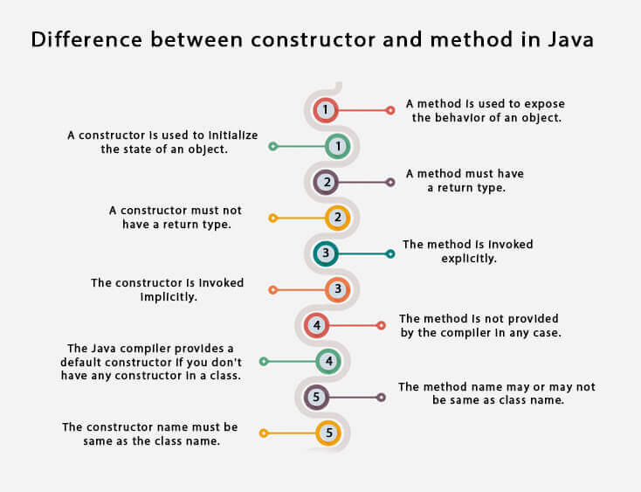

Static keyword in Java

The static keyword in Java is used for memory management mainly. We can apply static keyword with variables, methods, blocks and nested classes. The static keyword belongs to the class than an instance of the class.

The static can be:
- Variable (also known as a class variable)
- Method (also known as a class method)
- Block
- Nested class
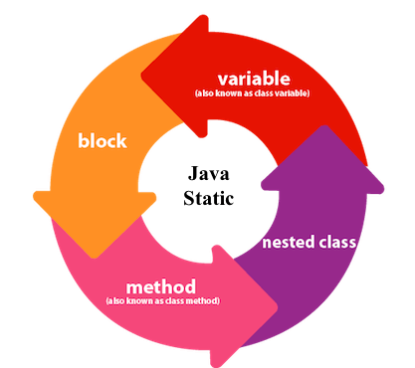

1) Java static variable
If you declare any variable as static, it is known as a static variable.
- The static variable can be used to refer to the common property of all objects (which is not unique for each object), for example, the company name of employees, college name of students, etc.
- The static variable gets memory only once in the class area at the time of class loading.

Advantages of static variable
It makes your program memory efficient (i.e., it saves memory).

Understanding the problem without static variable
- class Student{
- int rollno;
- String name;
- String college="ITS";
- }
Suppose there are 500 students in my college, now all instance data members will get memory each time when the object is created. All students have its unique rollno and name, so instance data member is good in such case. Here, "college" refers to the common property of all objects. If we make it static, this field will get the memory only once.

Java static property is shared to all objects.

Example of static variable
- //Java Program to demonstrate the use of static variable
- class Student{
- int rollno;//instance variable
- String name;
- static String college ="ITS";//static variable
- //constructor
- Student(int r, String n){
- rollno = r;
- name = n;
- }
- //method to display the values
- void display (){System.out.println(rollno+" "+name+" "+college);}
- }
- //Test class to show the values of objects
- public class TestStaticVariable1{
- public static void main(String args[]){
- Student s1 = new Student(111,"Karan");
- Student s2 = new Student(222,"Aryan");
- //we can change the college of all objects by the single line of code
- //Student.college="BBDIT";
- s1.display();
- s2.display();
- }
- }
Test it Now
Output:
111 Karan ITS
222 Aryan ITS
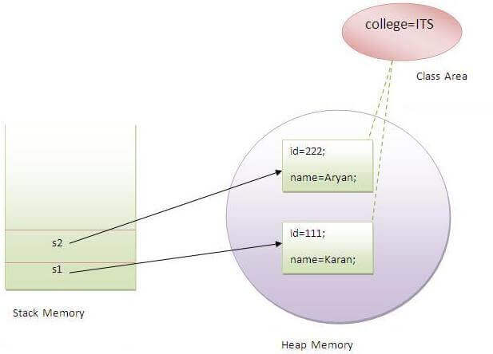

Program of the counter without static variable
In this example, we have created an instance variable named count which is incremented in the constructor. Since instance variable gets the memory at the time of object creation, each object will have the copy of the instance variable. If it is incremented, it won't reflect other objects. So each object will have the value 1 in the count variable.
- //Java Program to demonstrate the use of an instance variable
- //which get memory each time when we create an object of the class.
- class Counter{
- int count=0;//will get memory each time when the instance is created

- Counter(){
- count++;//incrementing value
- System.out.println(count);
- }

- public static void main(String args[]){
- //Creating objects
- Counter c1=new Counter();
- Counter c2=new Counter();
- Counter c3=new Counter();
- }
- }
Test it Now
Output:
1
1
1

Program of counter by static variable
As we have mentioned above, static variable will get the memory only once, if any object changes the value of the static variable, it will retain its value.
- //Java Program to illustrate the use of static variable which
- //is shared with all objects.
- class Counter2{
- static int count=0;//will get memory only once and retain its value

- Counter2(){
- count++;//incrementing the value of static variable
- System.out.println(count);
- }

- public static void main(String args[]){
- //creating objects
- Counter2 c1=new Counter2();
- Counter2 c2=new Counter2();
- Counter2 c3=new Counter2();
- }
- }
Test it Now
Output:
1
2
3

2) Java static method
If you apply static keyword with any method, it is known as static method.
- A static method belongs to the class rather than the object of a class.
- A static method can be invoked without the need for creating an instance of a class.
- A static method can access static data member and can change the value of it.

Example of static method
- //Java Program to demonstrate the use of a static method.
- class Student{
- int rollno;
- String name;
- static String college = "ITS";
- //static method to change the value of static variable
- static void change(){
- college = "BBDIT";
- }
- //constructor to initialize the variable
- Student(int r, String n){
- rollno = r;
- name = n;
- }
- //method to display values
- void display(){System.out.println(rollno+" "+name+" "+college);}
- }
- //Test class to create and display the values of object
- public class TestStaticMethod{
- public static void main(String args[]){
- Student.change();//calling change method
- //creating objects
- Student s1 = new Student(111,"Karan");
- Student s2 = new Student(222,"Aryan");
- Student s3 = new Student(333,"Sonoo");
- //calling display method
- s1.display();
- s2.display();
- s3.display();
- }
- }
Test it Now
Output:111 Karan BBDIT
222 Aryan BBDIT
333 Sonoo BBDIT

Another example of a static method that performs a normal calculation
- //Java Program to get the cube of a given number using the static method

- class Calculate{
- static int cube(int x){
- return x*x*x;
- }

- public static void main(String args[]){
- int result=Calculate.cube(5);
- System.out.println(result);
- }
- }
Test it Now
Output:125

Restrictions for the static method
There are two main restrictions for the static method. They are:
- The static method can not use non static data member or call non-static method directly.
- this and super cannot be used in static context.
- class A{
- int a=40;//non static

- public static void main(String args[]){
- System.out.println(a);
- }
- }
Test it Now
Output:Compile Time Error

Q) Why is the Java main method static?
Ans) It is because the object is not required to call a static method. If it were a non-static method, JVM creates an object first then call main() method that will lead the problem of extra memory allocation.

3) Java static block
- Is used to initialize the static data member.
- It is executed before the main method at the time of classloading.

Example of static block
- class A2{
- static{System.out.println("static block is invoked");}
- public static void main(String args[]){
- System.out.println("Hello main");
- }
- }
Test it Now
Output:static block is invoked
Hello main

Q) Can we execute a program without main() method?
Ans) No, one of the ways was the static block, but it was possible till JDK 1.6. Since JDK 1.7, it is not possible to execute a Java class without the main method.
- class A3{
- static{
- System.out.println("static block is invoked");
- System.exit(0);
- }
- }
Test it Now
Output:
static block is invoked
Since JDK 1.7 and above, output would be:
Error: Main method not found in class A3, please define the main method as:
public static void main(String[] args)
or a JavaFX application class must extend javafx.application.Application

Inheritance in Java
Inheritance in Java is a mechanism in which one object acquires all the properties and behaviors of a parent object. It is an important part of OOPs (Object Oriented programming system).

The idea behind inheritance in Java is that you can create new classes that are built upon existing classes. When you inherit from an existing class, you can reuse methods and fields of the parent class. Moreover, you can add new methods and fields in your current class also.
Inheritance represents the IS-A relationship which is also known as a parent-child relationship.

Why use inheritance in java
- For Method Overriding (so runtime polymorphism can be achieved).
- For Code Reusability.

Terms used in Inheritance
- Class: A class is a group of objects which have common properties. It is a template or blueprint from which objects are created.
- Sub Class/Child Class: Subclass is a class which inherits the other class. It is also called a derived class, extended class, or child class.
- Super Class/Parent Class: Superclass is the class from where a subclass inherits the features. It is also called a base class or a parent class.
- Reusability: As the name specifies, reusability is a mechanism which facilitates you to reuse the fields and methods of the existing class when you create a new class. You can use the same fields and methods already defined in the previous class.

The syntax of Java Inheritance
- class Subclass-name extends Superclass-name
- {
- //methods and fields
- }
The extends keyword indicates that you are making a new class that derives from an existing class. The meaning of "extends" is to increase the functionality.
In the terminology of Java, a class which is inherited is called a parent or superclass, and the new class is called child or subclass.

Java Inheritance Example
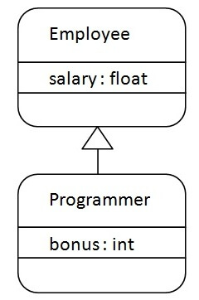
As displayed in the above figure, Programmer is the subclass and Employee is the superclass. The relationship between the two classes is Programmer IS-A Employee. It means that Programmer is a type of Employee.
- class Employee{
- float salary=40000;
- }
- class Programmer extends Employee{
- int bonus=10000;
- public static void main(String args[]){
- Programmer p=new Programmer();
- System.out.println("Programmer salary is:"+p.salary);
- System.out.println("Bonus of Programmer is:"+p.bonus);
- }
- }
Test it Now
Programmer salary is:40000.0
Bonus of programmer is:10000
In the above example, Programmer object can access the field of own class as well as of Employee class i.e. code reusability.

Types of inheritance in java
On the basis of class, there can be three types of inheritance in java: single, multilevel and hierarchical.
In java programming, multiple and hybrid inheritance is supported through interface only. We will learn about interfaces later.
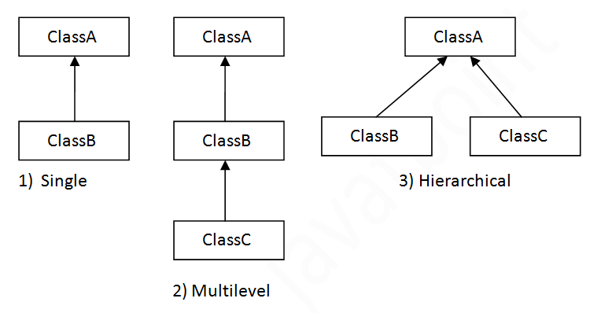

Note: Multiple inheritance is not supported in Java through class.
When one class inherits multiple classes, it is known as multiple inheritance. For Example:
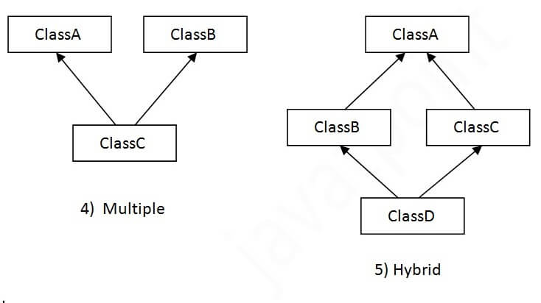

Single Inheritance Example
When a class inherits another class, it is known as a single inheritance. In the example given below, Dog class inherits the Animal class, so there is the single inheritance.
File: TestInheritance.java
- class Animal{
- void eat(){System.out.println("eating...");}
- }
- class Dog extends Animal{
- void bark(){System.out.println("barking...");}
- }
- class TestInheritance{
- public static void main(String args[]){
- Dog d=new Dog();
- d.bark();
- d.eat();
- }}
Output:
barking...
eating...

Multilevel Inheritance Example
When there is a chain of inheritance, it is known as multilevel inheritance. As you can see in the example given below, BabyDog class inherits the Dog class which again inherits the Animal class, so there is a multilevel inheritance.
File: TestInheritance2.java
- class Animal{
- void eat(){System.out.println("eating...");}
- }
- class Dog extends Animal{
- void bark(){System.out.println("barking...");}
- }
- class BabyDog extends Dog{
- void weep(){System.out.println("weeping...");}
- }
- class TestInheritance2{
- public static void main(String args[]){
- BabyDog d=new BabyDog();
- d.weep();
- d.bark();
- d.eat();
- }}
Output:
weeping...
barking...
eating...

Hierarchical Inheritance Example
When two or more classes inherits a single class, it is known as hierarchical inheritance. In the example given below, Dog and Cat classes inherits the Animal class, so there is hierarchical inheritance.
File: TestInheritance3.java
- class Animal{
- void eat(){System.out.println("eating...");}
- }
- class Dog extends Animal{
- void bark(){System.out.println("barking...");}
- }
- class Cat extends Animal{
- void meow(){System.out.println("meowing...");}
- }
- class TestInheritance3{
- public static void main(String args[]){
- Cat c=new Cat();
- c.meow();
- c.eat();
- //c.bark();//C.T.Error
- }}
Output:
meowing...
eating...

Q) Why multiple inheritance is not supported in java?
To reduce the complexity and simplify the language, multiple inheritance is not supported in java.
Consider a scenario where A, B, and C are three classes. The C class inherits A and B classes. If A and B classes have the same method and you call it from child class object, there will be ambiguity to call the method of A or B class.
Since compile-time errors are better than runtime errors, Java renders compile-time error if you inherit 2 classes. So whether you have same method or different, there will be compile time error.
- class A{
- void msg(){System.out.println("Hello");}
- }
- class B{
- void msg(){System.out.println("Welcome");}
- }
- class C extends A,B{//suppose if it were

- public static void main(String args[]){
- C obj=new C();
- obj.msg();//Now which msg() method would be invoked?
- }
- }
Test it Now
Compile Time Error

Polymorphism

If one task is performed in different ways, it is known as polymorphism. For example: to convince the customer differently, to draw something, for example, shape, triangle, rectangle, etc.
In Java, we use method overloading and method overriding to achieve polymorphism.
Another example can be to speak something; for example, a cat speaks meow, dog barks woof, etc.

Method Overloading in Java
If a class has multiple methods having same name but different in parameters, it is known as Method Overloading.
If we have to perform only one operation, having same name of the methods increases the readability of the program.
Suppose you have to perform addition of the given numbers but there can be any number of arguments, if you write the method such as a(int,int) for two parameters, and b(int,int,int) for three parameters then it may be difficult for you as well as other programmers to understand the behavior of the method because its name differs.
So, we perform method overloading to figure out the program quickly.

Advantage of method overloading
Method overloading increases the readability of the program.

Different ways to overload the method
There are two ways to overload the method in java
- By changing number of arguments
- By changing the data type

In Java, Method Overloading is not possible by changing the return type of the method only.

1) Method Overloading: changing no. of arguments
In this example, we have created two methods, first add() method performs addition of two numbers and second add method performs addition of three numbers.
In this example, we are creating static methods so that we don't need to create instance for calling methods.
- class Adder{
- static int add(int a,int b){return a+b;}
- static int add(int a,int b,int c){return a+b+c;}
- }
- class TestOverloading1{
- public static void main(String[] args){
- System.out.println(Adder.add(11,11));
- System.out.println(Adder.add(11,11,11));
- }}
Test it Now
Output:
22
33

2) Method Overloading: changing data type of arguments
In this example, we have created two methods that differs in data type. The first add method receives two integer arguments and second add method receives two double arguments.
- class Adder{
- static int add(int a, int b){return a+b;}
- static double add(double a, double b){return a+b;}
- }
- class TestOverloading2{
- public static void main(String[] args){
- System.out.println(Adder.add(11,11));
- System.out.println(Adder.add(12.3,12.6));
- }}
Test it Now
Output:
22
24.9

Q) Why Method Overloading is not possible by changing the return type of method only?
In java, method overloading is not possible by changing the return type of the method only because of ambiguity. Let's see how ambiguity may occur:
- class Adder{
- static int add(int a,int b){return a+b;}
- static double add(int a,int b){return a+b;}
- }
- class TestOverloading3{
- public static void main(String[] args){
- System.out.println(Adder.add(11,11));//ambiguity
- }}
Test it Now
Output:
Compile Time Error: method add(int,int) is already defined in class Adder
System.out.println(Adder.add(11,11)); //Here, how can java determine which sum() method should be called?

Note: Compile Time Error is better than Run Time Error. So, java compiler renders compiler time error if you declare the same method having same parameters.

Can we overload java main() method?
Yes, by method overloading. You can have any number of main methods in a class by method overloading. But JVM calls main() method which receives string array as arguments only. Let's see the simple example:
- class TestOverloading4{
- public static void main(String[] args){System.out.println("main with String[]");}
- public static void main(String args){System.out.println("main with String");}
- public static void main(){System.out.println("main without args");}
- }
Test it Now
Output:
main with String[]

Example of Method Overloading with TypePromotion
- class OverloadingCalculation1{
- void sum(int a,long b){System.out.println(a+b);}
- void sum(int a,int b,int c){System.out.println(a+b+c);}

- public static void main(String args[]){
- OverloadingCalculation1 obj=new OverloadingCalculation1();
- obj.sum(20,20);//now second int literal will be promoted to long
- obj.sum(20,20,20);

- }
- }
Test it Now
Output:40
60

Example of Method Overloading with Type Promotion if matching found
If there are matching type arguments in the method, type promotion is not performed.
- class OverloadingCalculation2{
- void sum(int a,int b){System.out.println("int arg method invoked");}
- void sum(long a,long b){System.out.println("long arg method invoked");}

- public static void main(String args[]){
- OverloadingCalculation2 obj=new OverloadingCalculation2();
- obj.sum(20,20);//now int arg sum() method gets invoked
- }
- }
Test it Now
Output:int arg method invoked

Example of Method Overloading with Type Promotion in case of ambiguity
If there are no matching type arguments in the method, and each method promotes similar number of arguments, there will be ambiguity.
- class OverloadingCalculation3{
- void sum(int a,long b){System.out.println("a method invoked");}
- void sum(long a,int b){System.out.println("b method invoked");}

- public static void main(String args[]){
- OverloadingCalculation3 obj=new OverloadingCalculation3();
- obj.sum(20,20);//now ambiguity
- }
- }
Test it Now
Output:Compile Time Error

Method Overriding in Java

If subclass (child class) has the same method as declared in the parent class, it is known as method overriding in Java.

n other words, If a subclass provides the specific implementation of the method that has been declared by one of its parent class, it is known as method overriding.

Usage of Java Method Overriding
- Method overriding is used to provide the specific implementation of a method which is already provided by its superclass.
- Method overriding is used for runtime polymorphism

Rules for Java Method Overriding
- The method must have the same name as in the parent class
- The method must have the same parameter as in the parent class.
- There must be an IS-A relationship (inheritance).
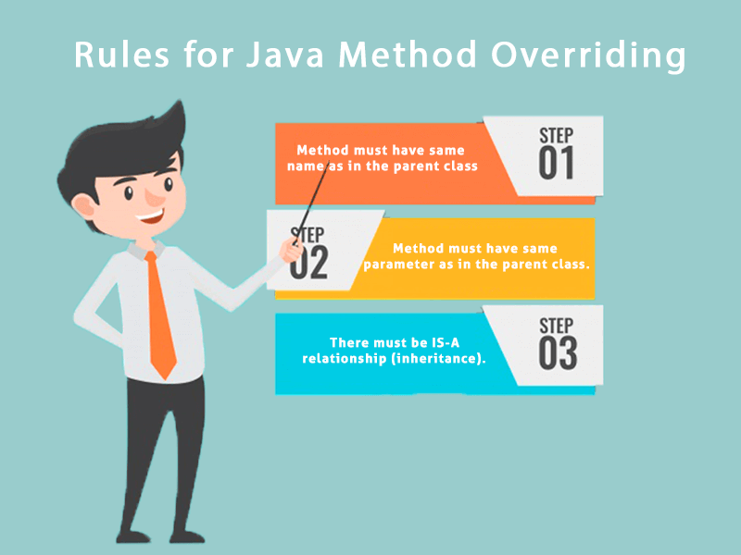

Understanding the problem without method overriding
Let's understand the problem that we may face in the program if we don't use method overriding.
- //Java Program to demonstrate why we need method overriding
- //Here, we are calling the method of parent class with child
- //class object.
- //Creating a parent class
- class Vehicle{
- void run(){System.out.println("Vehicle is running");}
- }
- //Creating a child class
- class Bike extends Vehicle{
- public static void main(String args[]){
- //creating an instance of child class
- Bike obj = new Bike();
- //calling the method with child class instance
- obj.run();
- }
- }
Test it Now
Output:
Vehicle is running
Problem is that I have to provide a specific implementation of run() method in subclass that is why we use method overriding.

Example of method overriding
In this example, we have defined the run method in the subclass as defined in the parent class but it has some specific implementation. The name and parameter of the method are the same, and there is IS-A relationship between the classes, so there is method overriding.
- //Java Program to illustrate the use of Java Method Overriding
- //Creating a parent class.
- class Vehicle{
- //defining a method
- void run(){System.out.println("Vehicle is running");}
- }
- //Creating a child class
- class Bike2 extends Vehicle{
- //defining the same method as in the parent class
- void run(){System.out.println("Bike is running safely");}

- public static void main(String args[]){
- Bike2 obj = new Bike2();//creating object
- obj.run();//calling method
- }
- }
Test it Now
Output:
Bike is running safely

A real example of Java Method Overriding
Consider a scenario where Bank is a class that provides functionality to get the rate of interest. However, the rate of interest varies according to banks. For example, SBI, ICICI and AXIS banks could provide 8%, 7%, and 9% rate of interest.
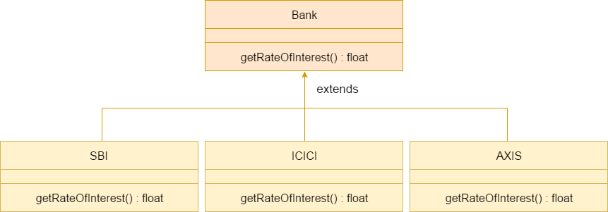

Java method overriding is mostly used in Runtime Polymorphism which we will learn in next pages.
- //Java Program to demonstrate the real scenario of Java Method Overriding
- //where three classes are overriding the method of a parent class.
- //Creating a parent class.
- class Bank{
- int getRateOfInterest(){return 0;}
- }
- //Creating child classes.
- class SBI extends Bank{
- int getRateOfInterest(){return 8;}
- }

- class ICICI extends Bank{
- int getRateOfInterest(){return 7;}
- }
- class AXIS extends Bank{
- int getRateOfInterest(){return 9;}
- }
- //Test class to create objects and call the methods
- class Test2{
- public static void main(String args[]){
- SBI s=new SBI();
- ICICI i=new ICICI();
- AXIS a=new AXIS();
- System.out.println("SBI Rate of Interest: "+s.getRateOfInterest());
- System.out.println("ICICI Rate of Interest: "+i.getRateOfInterest());
- System.out.println("AXIS Rate of Interest: "+a.getRateOfInterest());
- }
- }
Test it Now
Output:
SBI Rate of Interest: 8
ICICI Rate of Interest: 7
AXIS Rate of Interest: 9

Can we override static method?
No, a static method cannot be overridden. It can be proved by runtime polymorphism, so we will learn it later.

Why can we not override static method?
It is because the static method is bound with class whereas instance method is bound with an object. Static belongs to the class area, and an instance belongs to the heap area.

Can we override java main method?
No, because the main is a static method.

Super Keyword in Java
The super keyword in Java is a reference variable which is used to refer immediate parent class object.

Whenever you create the instance of subclass, an instance of parent class is created implicitly which is referred by super reference variable.

Usage of Java super Keyword
- super can be used to refer immediate parent class instance variable.
- super can be used to invoke immediate parent class method.
- super() can be used to invoke immediate parent class constructor.
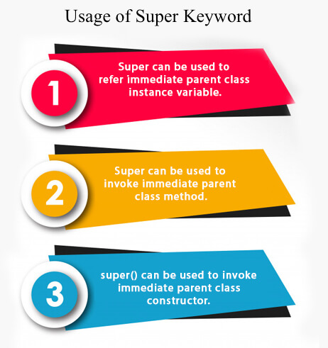

1) super is used to refer immediate parent class instance variable.
We can use super keyword to access the data member or field of parent class. It is used if parent class and child class have same fields.
- class Animal{
- String color="white";
- }
- class Dog extends Animal{
- String color="black";
- void printColor(){
- System.out.println(color);//prints color of Dog class
- System.out.println(super.color);//prints color of Animal class
- }
- }
- class TestSuper1{
- public static void main(String args[]){
- Dog d=new Dog();
- d.printColor();
- }}
Test it Now
Output:
black
white
In the above example, Animal and Dog both classes have a common property color. If we print color property, it will print the color of current class by default. To access the parent property, we need to use super keyword.

2) super can be used to invoke parent class method
The super keyword can also be used to invoke parent class method. It should be used if subclass contains the same method as parent class. In other words, it is used if method is overridden.
- class Animal{
- void eat(){System.out.println("eating...");}
- }
- class Dog extends Animal{
- void eat(){System.out.println("eating bread...");}
- void bark(){System.out.println("barking...");}
- void work(){
- super.eat();
- bark();
- }
- }
- class TestSuper2{
- public static void main(String args[]){
- Dog d=new Dog();
- d.work();
- }}
Test it Now
Output:
eating...
barking...
In the above example Animal and Dog both classes have eat() method if we call eat() method from Dog class, it will call the eat() method of Dog class by default because priority is given to local.
To call the parent class method, we need to use super keyword.

3) super is used to invoke parent class constructor.
The super keyword can also be used to invoke the parent class constructor. Let's see a simple example:
- class Animal{
- Animal(){System.out.println("animal is created");}
- }
- class Dog extends Animal{
- Dog(){
- super();
- System.out.println("dog is created");
- }
- }
- class TestSuper3{
- public static void main(String args[]){
- Dog d=new Dog();
- }}
Test it Now
Output:
animal is created
dog is created

Note: super() is added in each class constructor automatically by compiler if there is no super() or this().
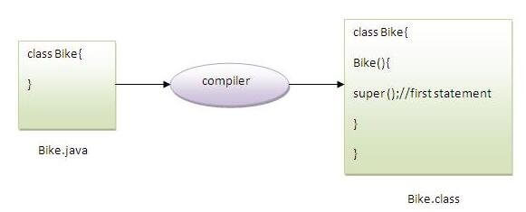
As we know well that default constructor is provided by compiler automatically if there is no constructor. But, it also adds super() as the first statement.
Another example of super keyword where super() is provided by the compiler implicitly.
- class Animal{
- Animal(){System.out.println("animal is created");}
- }
- class Dog extends Animal{
- Dog(){
- System.out.println("dog is created");
- }
- }
- class TestSuper4{
- public static void main(String args[]){
- Dog d=new Dog();
- }}
Test it Now
Output:
animal is created
dog is created

super example: real use
Let's see the real use of super keyword. Here, Emp class inherits Person class so all the properties of Person will be inherited to Emp by default. To initialize all the property, we are using parent class constructor from child class. In such way, we are reusing the parent class constructor.
- class Person{
- int id;
- String name;
- Person(int id,String name){
- this.id=id;
- this.name=name;
- }
- }
- class Emp extends Person{
- float salary;
- Emp(int id,String name,float salary){
- super(id,name);//reusing parent constructor
- this.salary=salary;
- }
- void display(){System.out.println(id+" "+name+" "+salary);}
- }
- class TestSuper5{
- public static void main(String[] args){
- Emp e1=new Emp(1,"ankit",45000f);
- e1.display();
- }}
Test it Now
Output:
1 ankit 45000

This Keyword in Java
There can be a lot of usage of Java this keyword. In Java, this is a reference variable that refers to the current object.
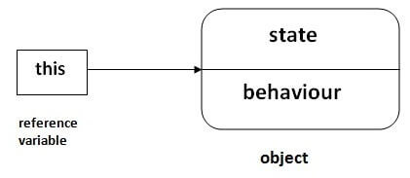

Here is given the 3 usage of java this keyword.
- this can be used to refer current class instance variable.
- this can be used to invoke current class method (implicitly)
- this() can be used to invoke current class constructor.

1) this: to refer current class instance variable
The this keyword can be used to refer current class instance variable. If there is ambiguity between the instance variables and parameters, this keyword resolves the problem of ambiguity.

Understanding the problem without this keyword
Let's understand the problem if we don't use this keyword by the example given below:
- class Student{
- int rollno;
- String name;
- float fee;
- Student(int rollno,String name,float fee){
- rollno=rollno;
- name=name;
- fee=fee;
- }
- void display(){System.out.println(rollno+" "+name+" "+fee);}
- }
- class TestThis1{
- public static void main(String args[]){
- Student s1=new Student(111,"ankit",5000f);
- Student s2=new Student(112,"sumit",6000f);
- s1.display();
- s2.display();
- }}
Test it Now
Output:
0 null 0.0
0 null 0.0
In the above example, parameters (formal arguments) and instance variables are same. So, we are using this keyword to distinguish local variable and instance variable.

Solution of the above problem by this keyword
- class Student{
- int rollno;
- String name;
- float fee;
- Student(int rollno,String name,float fee){
- this.rollno=rollno;
- this.name=name;
- this.fee=fee;
- }
- void display(){System.out.println(rollno+" "+name+" "+fee);}
- }

- class TestThis2{
- public static void main(String args[]){
- Student s1=new Student(111,"ankit",5000f);
- Student s2=new Student(112,"sumit",6000f);
- s1.display();
- s2.display();
- }}
Test it Now
Output:
111 ankit 5000.0
112 sumit 6000.0
If local variables(formal arguments) and instance variables are different, there is no need to use this keyword like in the following program:

Program where this keyword is not required
- class Student{
- int rollno;
- String name;
- float fee;
- Student(int r,String n,float f){
- rollno=r;
- name=n;
- fee=f;
- }
- void display(){System.out.println(rollno+" "+name+" "+fee);}
- }

- class TestThis3{
- public static void main(String args[]){
- Student s1=new Student(111,"ankit",5000f);
- Student s2=new Student(112,"sumit",6000f);
- s1.display();
- s2.display();
- }}
Test it Now
Output:
111 ankit 5000.0
112 sumit 6000.0

It is better approach to use meaningful names for variables. So we use same name for instance variables and parameters in real time, and always use this keyword.

2) this: to invoke current class method
You may invoke the method of the current class by using the this keyword. If you don't use the this keyword, compiler automatically adds this keyword while invoking the method. Let's see the example
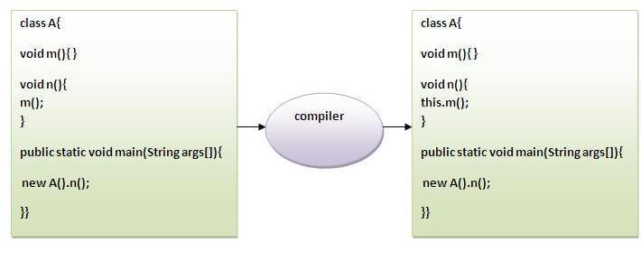
- class A{
- void m(){System.out.println("hello m");}
- void n(){
- System.out.println("hello n");
- //m();//same as this.m()
- this.m();
- }
- }
- class TestThis4{
- public static void main(String args[]){
- A a=new A();
- a.n();
- }}
Test it Now
Output:
hello n
hello m

3) this() : to invoke current class constructor
The this() constructor call can be used to invoke the current class constructor. It is used to reuse the constructor. In other words, it is used for constructor chaining.
Calling default constructor from parameterized constructor:
- class A{
- A(){System.out.println("hello a");}
- A(int x){
- this();
- System.out.println(x);
- }
- }
- class TestThis5{
- public static void main(String args[]){
- A a=new A(10);
- }}
Test it Now
Output:
hello a
10

Final Keyword in Java
The final keyword in java is used to restrict the user. The java final keyword can be used in many context. Final can be:
- variable
- method
- class
The final keyword can be applied with the variables, a final variable that have no value it is called blank final variable or uninitialized final variable. It can be initialized in the constructor only. The blank final variable can be static also which will be initialized in the static block only. We will have detailed learning of these. Let's first learn the basics of final keyword.

1) Java final variable
If you make any variable as final, you cannot change the value of final variable(It will be constant).

Example of final variable
There is a final variable speedlimit, we are going to change the value of this variable, but It can't be changed because final variable once assigned a value can never be changed.
- class Bike9{
- final int speedlimit=90;//final variable
- void run(){
- speedlimit=400;
- }
- public static void main(String args[]){
- Bike9 obj=new Bike9();
- obj.run();
- }
- }//end of class
Test it Now
Output:Compile Time Error

2) Java final method
If you make any method as final, you cannot override it.

Example of final method
- class Bike{
- final void run(){System.out.println("running");}
- }

- class Honda extends Bike{
- void run(){System.out.println("running safely with 100kmph");}

- public static void main(String args[]){
- Honda honda= new Honda();
- honda.run();
- }
- }
Test it Now
Output:Compile Time Error

3) Java final class
If you make any class as final, you cannot extend it.

Example of final class
- final class Bike{}

- class Honda1 extends Bike{
- void run(){System.out.println("running safely with 100kmph");}

- public static void main(String args[]){
- Honda1 honda= new Honda1();
- honda.run();
- }
- }
Test it Now
Output:Compile Time Error

Q) Is final method inherited?
Ans) Yes, final method is inherited but you cannot override it. For Example:
- class Bike{
- final void run(){System.out.println("running...");}
- }
- class Honda2 extends Bike{
- public static void main(String args[]){
- new Honda2().run();
- }
- }
Test it Now
Output:running...

Abstract Class in Java
A class which is declared with the abstract keyword is known as an abstract class in Java. It can have abstract and non-abstract methods (method with the body)

Abstraction in Java
Abstraction is a process of hiding the implementation details and showing only functionality to the user.
Another way, it shows only essential things to the user and hides the internal details, for example, sending SMS where you type the text and send the message. You don't know the internal processing about the message delivery.
Abstraction lets you focus on what the object does instead of how it does it.

Ways to achieve Abstraction
There are two ways to achieve abstraction in java
- Abstract class (0 to 100%)
- Interface (100%)

Points to Remember
- An abstract class must be declared with an abstract keyword.
- It can have abstract and non-abstract methods.
- It cannot be instantiated.
- It can have constructors and static methods also.
- It can have final methods which will force the subclass not to change the body of the method.
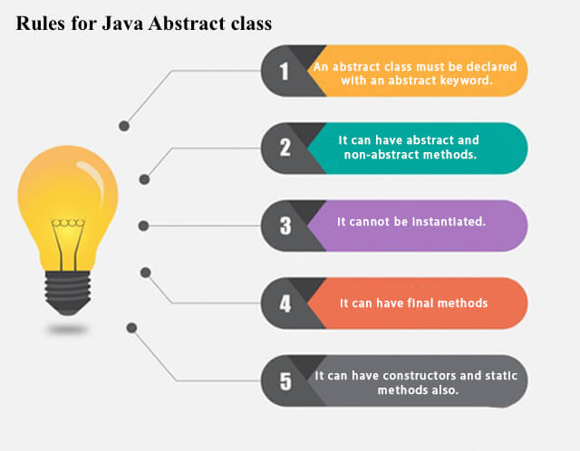
Example of abstract class
- abstract class A{}

Abstract Method in Java
A method which is declared as abstract and does not have implementation is known as an abstract method.
Example of abstract method
- abstract void printStatus();//no method body and abstract

Example of Abstract class that has an abstract method
In this example, Bike is an abstract class that contains only one abstract method run. Its implementation is provided by the Honda class.
- abstract class Bike{
- abstract void run();
- }
- class Honda4 extends Bike{
- void run(){System.out.println("running safely");}
- public static void main(String args[]){
- Bike obj = new Honda4();
- obj.run();
- }
- }
Test it Now
running safely

Understanding the real scenario of Abstract class
In this example, Shape is the abstract class, and its implementation is provided by the Rectangle and Circle classes.
Mostly, we don't know about the implementation class (which is hidden to the end user), and an object of the implementation class is provided by the factory method.
A factory method is a method that returns the instance of the class. We will learn about the factory method later.
In this example, if you create the instance of Rectangle class, draw() method of Rectangle class will be invoked.
File: TestAbstraction1.java
- abstract class Shape{
- abstract void draw();
- }
- //In real scenario, implementation is provided by others i.e. unknown by end user
- class Rectangle extends Shape{
- void draw(){System.out.println("drawing rectangle");}
- }
- class Circle1 extends Shape{
- void draw(){System.out.println("drawing circle");}
- }
- //In real scenario, method is called by programmer or user
- class TestAbstraction1{
- public static void main(String args[]){
- Shape s=new Circle1();//In a real scenario, object is provided through method, e.g., getShape() method
- s.draw();
- }
- }
Test it Now
drawing circle

Another example of Abstract class in java
File: TestBank.java
- abstract class Bank{
- abstract int getRateOfInterest();
- }
- class SBI extends Bank{
- int getRateOfInterest(){return 7;}
- }
- class PNB extends Bank{
- int getRateOfInterest(){return 8;}
- }

- class TestBank{
- public static void main(String args[]){
- Bank b;
- b=new SBI();
- System.out.println("Rate of Interest is: "+b.getRateOfInterest()+" %");
- b=new PNB();
- System.out.println("Rate of Interest is: "+b.getRateOfInterest()+" %");
- }}
Test it Now
Rate of Interest is: 7 %
Rate of Interest is: 8 %

Abstract class having constructor, data member and methods
An abstract class can have a data member, abstract method, method body (non-abstract method), constructor, and even main() method.
File: TestAbstraction2.java
- //Example of an abstract class that has abstract and non-abstract methods
- abstract class Bike{
- Bike(){System.out.println("bike is created");}
- abstract void run();
- void changeGear(){System.out.println("gear changed");}
- }
- //Creating a Child class which inherits Abstract class
- class Honda extends Bike{
- void run(){System.out.println("running safely..");}
- }
- //Creating a Test class which calls abstract and non-abstract methods
- class TestAbstraction2{
- public static void main(String args[]){
- Bike obj = new Honda();
- obj.run();
- obj.changeGear();
- }
- }
Test it Now
bike is created
running safely..
gear changed

Rule: If there is an abstract method in a class, that class must be abstract.
- class Bike12{
- abstract void run();
- }
Test it Now
compile time error

Rule: If you are extending an abstract class that has an abstract method, you must either provide the implementation of the method or make this class abstract.

Another real scenario of abstract class
The abstract class can also be used to provide some implementation of the interface. In such case, the end user may not be forced to override all the methods of the interface.

Note: If you are beginner to java, learn interface first and skip this example.
- interface A{
- void a();
- void b();
- void c();
- void d();
- }

- abstract class B implements A{
- public void c(){System.out.println("I am c");}
- }

- class M extends B{
- public void a(){System.out.println("I am a");}
- public void b(){System.out.println("I am b");}
- public void d(){System.out.println("I am d");}
- }

- class Test5{
- public static void main(String args[]){
- A a=new M();
- a.a();
- a.b();
- a.c();
- a.d();
- }}

Interface in Java

An interface in Java is a blueprint of a class. It has static constants and abstract methods.
The interface in Java is a mechanism to achieve abstraction. There can be only abstract methods in the Java interface, not method body. It is used to achieve abstraction and multiple inheritance in Java.
In other words, you can say that interfaces can have abstract methods and variables. It cannot have a method body.
Java Interface also represents the IS-A relationship.
It cannot be instantiated just like the abstract class.
Since Java 8, we can have default and static methods in an interface.
Since Java 9, we can have private methods in an interface.

Why use Java interface?
There are mainly three reasons to use interface. They are given below.
- It is used to achieve abstraction.
- By interface, we can support the functionality of multiple inheritance.
- It can be used to achieve loose coupling.
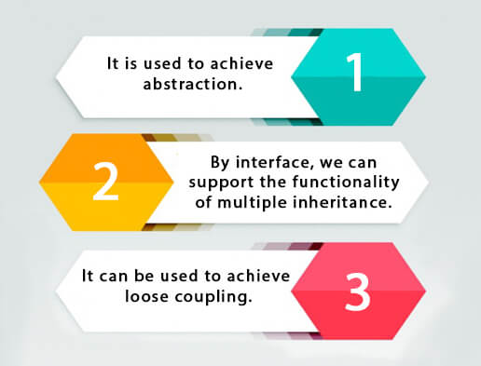

How to declare an interface?
An interface is declared by using the interface keyword. It provides total abstraction; means all the methods in an interface are declared with the empty body, and all the fields are public, static and final by default. A class that implements an interface must implement all the methods declared in the interface.

Syntax:
- interface <interface_name>{

- // declare constant fields
- // declare methods that abstract
- // by default.
- }

Java 8 Interface Improvement
Since Java 8, interface can have default and static methods which is discussed later.

Internal addition by the compiler

The Java compiler adds public and abstract keywords before the interface method. Moreover, it adds public, static and final keywords before data members.
In other words, Interface fields are public, static and final by default, and the methods are public and abstract.
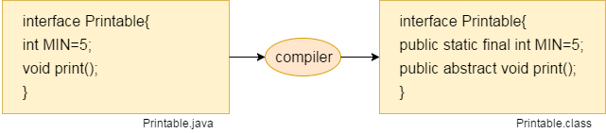

The relationship between classes and interfaces
As shown in the figure given below, a class extends another class, an interface extends another interface, but a class implements an interface.
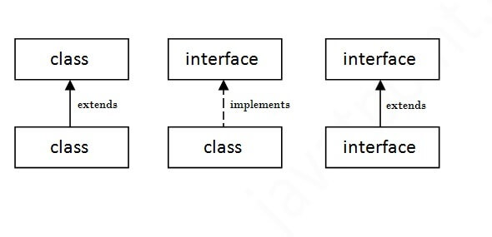

Java Interface Example
In this example, the Printable interface has only one method, and its implementation is provided in the A6 class.
- interface printable{
- void print();
- }
- class A6 implements printable{
- public void print(){System.out.println("Hello");}

- public static void main(String args[]){
- A6 obj = new A6();
- obj.print();
- }
- }
Test it Now
Output:
Hello

Java Interface Example: Drawable
In this example, the Drawable interface has only one method. Its implementation is provided by Rectangle and Circle classes. In a real scenario, an interface is defined by someone else, but its implementation is provided by different implementation providers. Moreover, it is used by someone else. The implementation part is hidden by the user who uses the interface.
File: TestInterface1.java
- //Interface declaration: by first user
- interface Drawable{
- void draw();
- }
- //Implementation: by second user
- class Rectangle implements Drawable{
- public void draw(){System.out.println("drawing rectangle");}
- }
- class Circle implements Drawable{
- public void draw(){System.out.println("drawing circle");}
- }
- //Using interface: by third user
- class TestInterface1{
- public static void main(String args[]){
- Drawable d=new Circle();//In real scenario, object is provided by method e.g. getDrawable()
- d.draw();
- }}
Test it Now
Output:
drawing circle

Java Interface Example: Bank
Let's see another example of java interface which provides the implementation of Bank interface.
File: TestInterface2.java
- interface Bank{
- float rateOfInterest();
- }
- class SBI implements Bank{
- public float rateOfInterest(){return 9.15f;}
- }
- class PNB implements Bank{
- public float rateOfInterest(){return 9.7f;}
- }
- class TestInterface2{
- public static void main(String[] args){
- Bank b=new SBI();
- System.out.println("ROI: "+b.rateOfInterest());
- }}
Test it Now
Output:
ROI: 9.15

Multiple inheritance in Java by interface
If a class implements multiple interfaces, or an interface extends multiple interfaces, it is known as multiple inheritance.
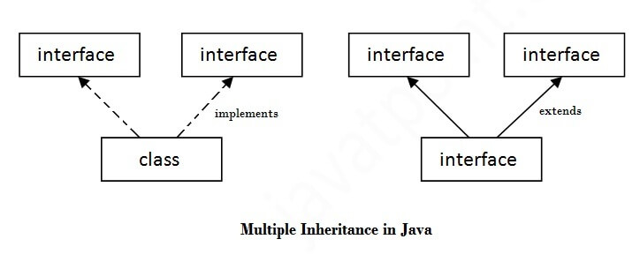
- interface Printable{
- void print();
- }
- interface Showable{
- void show();
- }
- class A7 implements Printable,Showable{
- public void print(){System.out.println("Hello");}
- public void show(){System.out.println("Welcome");}

- public static void main(String args[]){
- A7 obj = new A7();
- obj.print();
- obj.show();
- }
- }
Test it Now
Output:Hello
Welcome

Q) Multiple inheritance is not supported through class in java, but it is possible by an interface, why?
As we have explained in the inheritance chapter, multiple inheritance is not supported in the case of class because of ambiguity. However, it is supported in case of an interface because there is no ambiguity. It is because its implementation is provided by the implementation class. For example:
- interface Printable{
- void print();
- }
- interface Showable{
- void print();
- }

- class TestInterface3 implements Printable, Showable{
- public void print(){System.out.println("Hello");}
- public static void main(String args[]){
- TestInterface3 obj = new TestInterface3();
- obj.print();
- }
- }
Test it Now
Output:
Hello
As you can see in the above example, Printable and Showable interface have same methods but its implementation is provided by class TestTnterface1, so there is no ambiguity.

Interface inheritance
A class implements an interface, but one interface extends another interface.
- interface Printable{
- void print();
- }
- interface Showable extends Printable{
- void show();
- }
- class TestInterface4 implements Showable{
- public void print(){System.out.println("Hello");}
- public void show(){System.out.println("Welcome");}

- public static void main(String args[]){
- TestInterface4 obj = new TestInterface4();
- obj.print();
- obj.show();
- }
- }
Test it Now
Output:
Hello
Welcome

Java 8 Default Method in Interface
Since Java 8, we can have method body in interface. But we need to make it default method. Let's see an example:
File: TestInterfaceDefault.java
- interface Drawable{
- void draw();
- default void msg(){System.out.println("default method");}
- }
- class Rectangle implements Drawable{
- public void draw(){System.out.println("drawing rectangle");}
- }
- class TestInterfaceDefault{
- public static void main(String args[]){
- Drawable d=new Rectangle();
- d.draw();
- d.msg();
- }}
Test it Now
Output:
drawing rectangle
default method

Java 8 Static Method in Interface
Since Java 8, we can have static method in interface. Let's see an example:
File: TestInterfaceStatic.java
- interface Drawable{
- void draw();
- static int cube(int x){return x*x*x;}
- }
- class Rectangle implements Drawable{
- public void draw(){System.out.println("drawing rectangle");}
- }

- class TestInterfaceStatic{
- public static void main(String args[]){
- Drawable d=new Rectangle();
- d.draw();
- System.out.println(Drawable.cube(3));
- }}
Test it Now
Output:
drawing rectangle
27

Q) What is marker or tagged interface?
An interface which has no member is known as a marker or tagged interface, for example, Serializable, Cloneable, Remote, etc. They are used to provide some essential information to the JVM so that JVM may perform some useful operation.
- //How Serializable interface is written?
- public interface Serializable{
- }

Encapsulation in Java
Encapsulation in Java is a process of wrapping code and data together into a single unit, for example, a capsule which is mixed of several medicines.

We can create a fully encapsulated class in Java by making all the data members of the class private. Now we can use setter and getter methods to set and get the data in it.

Advantage of Encapsulation in Java
By providing only a setter or getter method, you can make the class read-only or write-only. In other words, you can skip the getter or setter methods.
It provides you the control over the data. Suppose you want to set the value of id which should be greater than 100 only, you can write the logic inside the setter method. You can write the logic not to store the negative numbers in the setter methods.
It is a way to achieve data hiding in Java because other class will not be able to access the data through the private data members.
The encapsulate class is easy to test. So, it is better for unit testing.
The standard IDE's are providing the facility to generate the getters and setters. So, it is easy and fast to create an encapsulated class in Java.

Simple Example of Encapsulation in Java
Let's see the simple example of encapsulation that has only one field with its setter and getter methods.
File: Student.java
- //A Java class which is a fully encapsulated class.
- //It has a private data member and getter and setter methods.
- public class Student{
- //private data member
- private String name;
- //getter method for name
- public String getName(){
- return name;
- }
- //setter method for name
- public void setName(String name){
- this.name=name
- }
- }

- class Test{
- public static void main(String[] args){
- //creating instance of the encapsulated class
- Student s=new Student();
- //setting value in the name member
- s.setName("vijay");
- //getting value of the name member
- System.out.println(s.getName());
- }
- }

Access Modifiers in Java
There are two types of modifiers in Java: access modifiers and non-access modifiers.

The access modifiers in Java specifies the accessibility or scope of a field, method, constructor, or class. We can change the access level of fields, constructors, methods, and class by applying the access modifier on it.
There are four types of Java access modifiers:
- Private: The access level of a private modifier is only within the class. It cannot be accessed from outside the class.
- Default: The access level of a default modifier is only within the package. It cannot be accessed from outside the package. If you do not specify any access level, it will be the default.
- Protected: The access level of a protected modifier is within the package and outside the package through child class. If you do not make the child class, it cannot be accessed from outside the package.
- Public: The access level of a public modifier is everywhere. It can be accessed from within the class, outside the class, within the package and outside the package.
There are many non-access modifiers, such as static, abstract, synchronized, native, volatile, transient, etc. Here, we are going to learn the access modifiers only.

Understanding Java Access Modifiers
Let's understand the access modifiers in Java by a simple table.
Access Modifier | within class | within package | outside package by subclass only | outside package
Private | Y | N | N | N
Default | Y | Y | N | N
Protected | Y | Y | Y | N
Public | Y | Y | Y | Y

1) Private
The private access modifier is accessible only within the class.
Simple example of private access modifier
In this example, we have created two classes A and Simple. A class contains private data member and private method. We are accessing these private members from outside the class, so there is a compile-time error.
- class A{
- private int data=40;
- private void msg(){System.out.println("Hello java");}
- }

- public class Simple{
- public static void main(String args[]){
- A obj=new A();
- System.out.println(obj.data);//Compile Time Error
- obj.msg();//Compile Time Error
- }
- }

Role of Private Constructor
If you make any class constructor private, you cannot create the instance of that class from outside the class. For example:
- class A{
- private A(){}//private constructor
- void msg(){System.out.println("Hello java");}
- }
- public class Simple{
- public static void main(String args[]){
- A obj=new A();//Compile Time Error
- }
- }

Note: A class cannot be private or protected except nested class.

2) Default
If you don't use any modifier, it is treated as default by default. The default modifier is accessible only within package. It cannot be accessed from outside the package. It provides more accessibility than private. But, it is more restrictive than protected, and public.
Example of default access modifier
In this example, we have created two packages pack and mypack. We are accessing the A class from outside its package, since A class is not public, so it cannot be accessed from outside the package.
- //save by A.java
- package pack;
- class A{
- void msg(){System.out.println("Hello");}
- }
- //save by B.java
- package mypack;
- import pack.*;
- class B{
- public static void main(String args[]){
- A obj = new A();//Compile Time Error
- obj.msg();//Compile Time Error
- }
- }
In the above example, the scope of class A and its method msg() is default so it cannot be accessed from outside the package.

3) Protected
The protected access modifier is accessible within package and outside the package but through inheritance only.
The protected access modifier can be applied on the data member, method and constructor. It can't be applied on the class.
It provides more accessibility than the default modifer.
Example of protected access modifier
In this example, we have created the two packages pack and mypack. The A class of pack package is public, so can be accessed from outside the package. But msg method of this package is declared as protected, so it can be accessed from outside the class only through inheritance.
- //save by A.java
- package pack;
- public class A{
- protected void msg(){System.out.println("Hello");}
- }
- //save by B.java
- package mypack;
- import pack.*;

- class B extends A{
- public static void main(String args[]){
- B obj = new B();
- obj.msg();
- }
- }
Output:Hello

4) Public
The public access modifier is accessible everywhere. It has the widest scope among all other modifiers.
Example of public access modifier
- //save by A.java

- package pack;
- public class A{
- public void msg(){System.out.println("Hello");}
- }
- //save by B.java

- package mypack;
- import pack.*;

- class B{
- public static void main(String args[]){
- A obj = new A();
- obj.msg();
- }
- }
Output:Hello

Arrays in Java
Java array is an object which contains elements of a similar data type. Additionally, The elements of an array are stored in a contiguous memory location. It is a data structure where we store similar elements. We can store only a fixed set of elements in a Java array.
Array in Java is index-based, the first element of the array is stored at the 0th index, 2nd element is stored on 1st index and so on.
Unlike C/C++, we can get the length of the array using the length member. In C/C++, we need to use the sizeof operator.
In Java, array is an object of a dynamically generated class. Java array inherits the Object class, and implements the Serializable as well as Cloneable interfaces. We can store primitive values or objects in an array in Java. Like C/C++, we can also create single dimentional or multidimentional arrays in Java.
Moreover, Java provides the feature of anonymous arrays which is not available in C/C++.
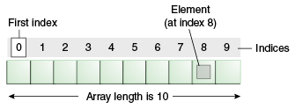

Advantages
- Code Optimization: It makes the code optimized, we can retrieve or sort the data efficiently.
- Random access: We can get any data located at an index position.

Disadvantages
- Size Limit: We can store only the fixed size of elements in the array. It doesn't grow its size at runtime. To solve this problem, collection framework is used in Java which grows automatically.

Types of Array in java
There are two types of array.
- Single Dimensional Array
- Multidimensional Array

Single Dimensional Array in Java
Syntax to Declare an Array in Java
- dataType[] arr; (or)
- dataType []arr; (or)
- dataType arr[];
Instantiation of an Array in Java
- arrayRefVar=new datatype[size];

Example of Java Array
Let's see the simple example of java array, where we are going to declare, instantiate, initialize and traverse an array.
- //Java Program to illustrate how to declare, instantiate, initialize
- //and traverse the Java array.
- class Testarray{
- public static void main(String args[]){
- int a[]=new int[5];//declaration and instantiation
- a[0]=10;//initialization
- a[1]=20;
- a[2]=70;
- a[3]=40;
- a[4]=50;
- //traversing array
- for(int i=0;i<a.length;i++)//length is the property of array
- System.out.println(a[i]);
- }}
Test it Now
Output:
10
20
70
40
50

Declaration, Instantiation and Initialization of Java Array
We can declare, instantiate and initialize the java array together by:
- int a[]={33,3,4,5};//declaration, instantiation and initialization
Let's see the simple example to print this array.
- //Java Program to illustrate the use of declaration, instantiation
- //and initialization of Java array in a single line
- class Testarray1{
- public static void main(String args[]){
- int a[]={33,3,4,5};//declaration, instantiation and initialization
- //printing array
- for(int i=0;i<a.length;i++)//length is the property of array
- System.out.println(a[i]);
- }}
Test it Now
Output:
33
3
4
5

For-each Loop for Java Array
We can also print the Java array using for-each loop. The Java for-each loop prints the array elements one by one. It holds an array element in a variable, then executes the body of the loop.
The syntax of the for-each loop is given below:
- for(data_type variable:array){
- //body of the loop
- }
Let us see the example of print the elements of Java array using the for-each loop.
- //Java Program to print the array elements using for-each loop
- class Testarray1{
- public static void main(String args[]){
- int arr[]={33,3,4,5};
- //printing array using for-each loop
- for(int i:arr)
- System.out.println(i);
- }}
Output:
33
3
4
5

Passing Array to a Method in Java
We can pass the java array to method so that we can reuse the same logic on any array.
Let's see the simple example to get the minimum number of an array using a method.
- //Java Program to demonstrate the way of passing an array
- //to method.
- class Testarray2{
- //creating a method which receives an array as a parameter
- static void min(int arr[]){
- int min=arr[0];
- for(int i=1;i<arr.length;i++)
- if(min>arr[i])
- min=arr[i];

- System.out.println(min);
- }

- public static void main(String args[]){
- int a[]={33,3,4,5};//declaring and initializing an array
- min(a);//passing array to method
- }}
Test it Now
Output:
3

Anonymous Array in Java
Java supports the feature of an anonymous array, so you don't need to declare the array while passing an array to the method.
- //Java Program to demonstrate the way of passing an anonymous array
- //to method.
- public class TestAnonymousArray{
- //creating a method which receives an array as a parameter
- static void printArray(int arr[]){
- for(int i=0;i<arr.length;i++)
- System.out.println(arr[i]);
- }

- public static void main(String args[]){
- printArray(new int[]{10,22,44,66});//passing anonymous array to method
- }}
Test it Now
Output:
10
22
44
66

Returning Array from the Method
We can also return an array from the method in Java.
- //Java Program to return an array from the method
- class TestReturnArray{
- //creating method which returns an array
- static int[] get(){
- return new int[]{10,30,50,90,60};
- }

- public static void main(String args[]){
- //calling method which returns an array
- int arr[]=get();
- //printing the values of an array
- for(int i=0;i<arr.length;i++)
- System.out.println(arr[i]);
- }}
Test it Now
Output:
10
30
50
90
60

ArrayIndexOutOfBoundsException
The Java Virtual Machine (JVM) throws an ArrayIndexOutOfBoundsException if length of the array in negative, equal to the array size or greater than the array size while traversing the array.
- //Java Program to demonstrate the case of
- //ArrayIndexOutOfBoundsException in a Java Array.
- public class TestArrayException{
- public static void main(String args[]){
- int arr[]={50,60,70,80};
- for(int i=0;i<=arr.length;i++){
- System.out.println(arr[i]);
- }
- }}
Test it Now
Output:
Exception in thread "main" java.lang.ArrayIndexOutOfBoundsException: 4
at TestArrayException.main(TestArrayException.java:5)
50
60
70
80

Multidimensional Array in Java
In such case, data is stored in row and column based index (also known as matrix form).
Syntax to Declare Multidimensional Array in Java
- dataType[][] arrayRefVar; (or)
- dataType [][]arrayRefVar; (or)
- dataType arrayRefVar[][]; (or)
- dataType []arrayRefVar[];
Example to instantiate Multidimensional Array in Java
- int[][] arr=new int[3][3];//3 row and 3 column
Example to initialize Multidimensional Array in Java
- arr[0][0]=1;
- arr[0][1]=2;
- arr[0][2]=3;
- arr[1][0]=4;
- arr[1][1]=5;
- arr[1][2]=6;
- arr[2][0]=7;
- arr[2][1]=8;
- arr[2][2]=9;

Example of Multidimensional Java Array
Let's see the simple example to declare, instantiate, initialize and print the 2Dimensional array.
- //Java Program to illustrate the use of multidimensional array
- class Testarray3{
- public static void main(String args[]){
- //declaring and initializing 2D array
- int arr[][]={{1,2,3},{2,4,5},{4,4,5}};
- //printing 2D array
- for(int i=0;i<3;i++){
- for(int j=0;j<3;j++){
- System.out.print(arr[i][j]+" ");
- }
- System.out.println();
- }
- }}
Test it Now
Output:
1 2 3
2 4 5
4 4 5

What is the class name of Java array?
In Java, an array is an object. For array object, a proxy class is created whose name can be obtained by getClass().getName() method on the object.
- //Java Program to get the class name of array in Java
- class Testarray4{
- public static void main(String args[]){
- //declaration and initialization of array
- int arr[]={4,4,5};
- //getting the class name of Java array
- Class c=arr.getClass();
- String name=c.getName();
- //printing the class name of Java array
- System.out.println(name);

- }}
Test it Now
Output:
I

Copying a Java Array
We can copy an array to another by the arraycopy() method of System class.
Syntax of arraycopy method
- public static void arraycopy(
- Object src, int srcPos,Object dest, int destPos, int length
- )

Example of Copying an Array in Java
- //Java Program to copy a source array into a destination array in Java
- class TestArrayCopyDemo {
- public static void main(String[] args) {
- //declaring a source array
- char[] copyFrom = { 'd', 'e', 'c', 'a', 'f', 'f', 'e',
- 'i', 'n', 'a', 't', 'e', 'd' };
- //declaring a destination array
- char[] copyTo = new char[7];
- //copying array using System.arraycopy() method
- System.arraycopy(copyFrom, 2, copyTo, 0, 7);
- //printing the destination array
- System.out.println(String.valueOf(copyTo));
- }
- }
Test it Now
Output:
caffein

Cloning an Array in Java
Since, Java array implements the Cloneable interface, we can create the clone of the Java array. If we create the clone of a single-dimensional array, it creates the deep copy of the Java array. It means, it will copy the actual value. But, if we create the clone of a multidimensional array, it creates the shallow copy of the Java array which means it copies the references.
- //Java Program to clone the array
- class Testarray1{
- public static void main(String args[]){
- int arr[]={33,3,4,5};
- System.out.println("Printing original array:");
- for(int i:arr)
- System.out.println(i);

- System.out.println("Printing clone of the array:");
- int carr[]=arr.clone();
- for(int i:carr)
- System.out.println(i);

- System.out.println("Are both equal?");
- System.out.println(arr==carr);

- }}
Output:
Printing original array:
33
3
4
5
Printing clone of the array:
33
3
4
5
Are both equal?
false

Addition of 2 Matrices in Java
Let's see a simple example that adds two matrices.
- //Java Program to demonstrate the addition of two matrices in Java
- class Testarray5{
- public static void main(String args[]){
- //creating two matrices
- int a[][]={{1,3,4},{3,4,5}};
- int b[][]={{1,3,4},{3,4,5}};

- //creating another matrix to store the sum of two matrices
- int c[][]=new int[2][3];

- //adding and printing addition of 2 matrices
- for(int i=0;i<2;i++){
- for(int j=0;j<3;j++){
- c[i][j]=a[i][j]+b[i][j];
- System.out.print(c[i][j]+" ");
- }
- System.out.println();//new line
- }

- }}
Test it Now
Output:
2 6 8
6 8 10

Multiplication of 2 Matrices in Java
In the case of matrix multiplication, a one-row element of the first matrix is multiplied by all the columns of the second matrix which can be understood by the image given below.
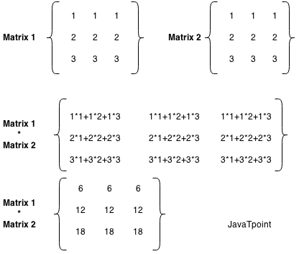
Let's see a simple example to multiply two matrices of 3 rows and 3 columns.
- //Java Program to multiply two matrices
- public class MatrixMultiplicationExample{
- public static void main(String args[]){
- //creating two matrices
- int a[][]={{1,1,1},{2,2,2},{3,3,3}};
- int b[][]={{1,1,1},{2,2,2},{3,3,3}};

- //creating another matrix to store the multiplication of two matrices
- int c[][]=new int[3][3]; //3 rows and 3 columns

- //multiplying and printing multiplication of 2 matrices
- for(int i=0;i<3;i++){
- for(int j=0;j<3;j++){
- c[i][j]=0;
- for(int k=0;k<3;k++)
- {
- c[i][j]+=a[i][k]*b[k][j];
- }//end of k loop
- System.out.print(c[i][j]+" "); //printing matrix element
- }//end of j loop
- System.out.println();//new line
- }
- }}
Test it Now
Output:
6 6 6
12 12 12
18 18 18

String in Java
In Java, string is basically an object that represents sequence of char values. An array of characters works same as Java string. For example:
- char[] ch={'j','a','v','a','t','p','o','i','n','t'};
- String s=new String(ch);
is same as:
- String s="javatpoint";
PlayNext
Unmute
Current TimeÂ 0:00
/
DurationÂ 18:10
Loaded: 0.37%
Â
Fullscreen
Backward Skip 10sPlay VideoForward Skip 10s
Java String class provides a lot of methods to perform operations on strings such as compare(), concat(), equals(), split(), length(), replace(), compareTo(), intern(), substring() etc.
The java.lang.String class implements Serializable, Comparable and CharSequence interfaces.
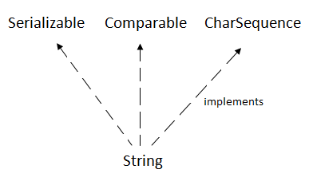

CharSequence Interface
The CharSequence interface is used to represent the sequence of characters. String, StringBuffer and StringBuilder classes implement it. It means, we can create strings in Java by using these three classes.
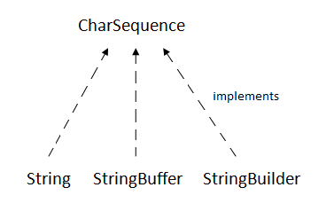
The Java String is immutable which means it cannot be changed. Whenever we change any string, a new instance is created. For mutable strings, you can use StringBuffer and StringBuilder classes.
We will discuss immutable string later. Let's first understand what String in Java is and how to create the String object.

What is String in Java?
Generally, String is a sequence of characters. But in Java, string is an object that represents a sequence of characters. The java.lang.String class is used to create a string object.

How to create a string object?
There are two ways to create String object:
- By string literal
- By new keyword

1) String Literal
Java String literal is created by using double quotes. For Example:
- String s="welcome";
Each time you create a string literal, the JVM checks the "string constant pool" first. If the string already exists in the pool, a reference to the pooled instance is returned. If the string doesn't exist in the pool, a new string instance is created and placed in the pool. For example:
- String s1="Welcome";
- String s2="Welcome";//It doesn't create a new instance
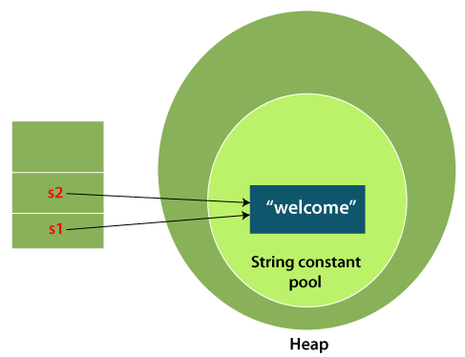
In the above example, only one object will be created. Firstly, JVM will not find any string object with the value "Welcome" in string constant pool that is why it will create a new object. After that it will find the string with the value "Welcome" in the pool, it will not create a new object but will return the reference to the same instance.

Note: String objects are stored in a special memory area known as the "string constant pool".

Why Java uses the concept of String literal?
To make Java more memory efficient (because no new objects are created if it exists already in the string constant pool).

2) By new keyword
- String s=new String("Welcome");//creates two objects and one reference variable
In such case, JVM will create a new string object in normal (non-pool) heap memory, and the literal "Welcome" will be placed in the string constant pool. The variable s will refer to the object in a heap (non-pool).

Java String Example
StringExample.java
- public class StringExample{
- public static void main(String args[]){
- String s1="java";//creating string by Java string literal
- char ch[]={'s','t','r','i','n','g','s'};
- String s2=new String(ch);//converting char array to string
- String s3=new String("example");//creating Java string by new keyword
- System.out.println(s1);
- System.out.println(s2);
- System.out.println(s3);
- }}
Test it Now
Output:
java
strings
example
The above code, converts a char array into a String object. And displays the String objects s1, s2, and s3 on console using println() method.
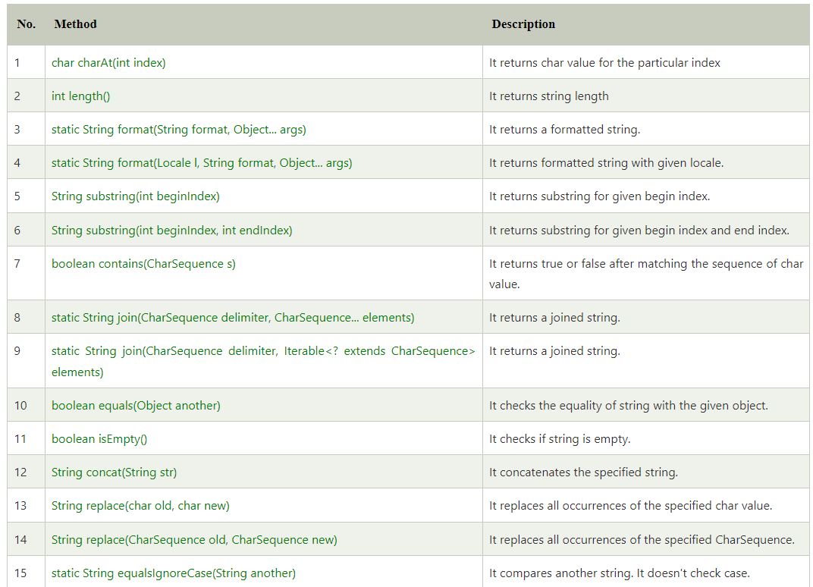

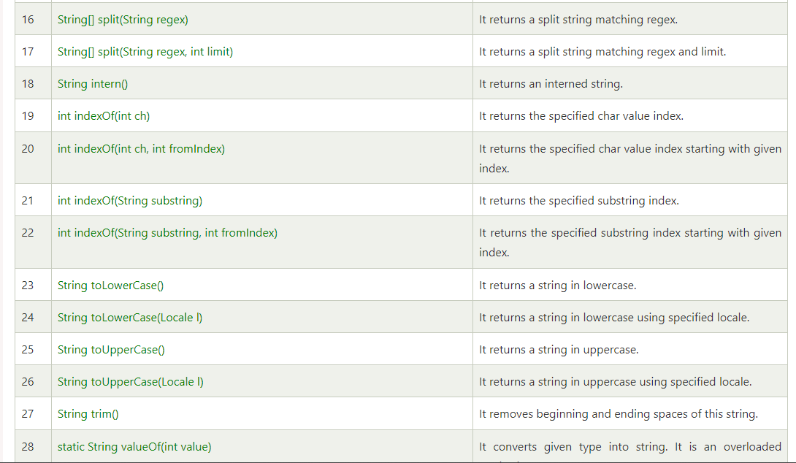

String Buffer
Java StringBuffer class is used to create mutable (modifiable) String objects. The StringBuffer class in Java is the same as String class except it is mutable i.e. it can be changed.

Note: Java StringBuffer class is thread-safe i.e. multiple threads cannot access it simultaneously. So it is safe and will result in an order.

Important Constructors of StringBuffer Class
Constructor | Description
StringBuffer() | It creates an empty String buffer with the initial capacity of  16.
StringBuffer(String str) | It creates a String buffer with the specified string..
StringBuffer(int capacity) | It creates an empty String buffer with the specified  capacity as length.

1) StringBuffer Class append() Method
The append() method concatenates the given argument with this String.
StringBufferExample.java
- class StringBufferExample{
- public static void main(String args[]){
- StringBuffer sb=new StringBuffer("Hello ");
- sb.append("Java");//now original string is changed
- System.out.println(sb);//prints Hello Java
- }
- }
Output:
Hello Java

2) StringBuffer insert() Method
The insert() method inserts the given String with this string at the given position.
StringBufferExample2.java
- class StringBufferExample2{
- public static void main(String args[]){
- StringBuffer sb=new StringBuffer("Hello ");
- sb.insert(1,"Java");//now original string is changed
- System.out.println(sb);//prints HJavaello
- }
- }
Output:
HJavaello

3) StringBuffer replace() Method
The replace() method replaces the given String from the specified beginIndex and endIndex.
StringBufferExample3.java
- class StringBufferExample3{
- public static void main(String args[]){
- StringBuffer sb=new StringBuffer("Hello");
- sb.replace(1,3,"Java");
- System.out.println(sb);//prints HJavalo
- }
- }
Output:
HJavalo

4) StringBuffer delete() Method
The delete() method of the StringBuffer class deletes the String from the specified beginIndex to endIndex.
StringBufferExample4.java
- class StringBufferExample4{
- public static void main(String args[]){
- StringBuffer sb=new StringBuffer("Hello");
- sb.delete(1,3);
- System.out.println(sb);//prints Hlo
- }
- }
Output:
Hlo

5) StringBuffer reverse() Method
The reverse() method of the StringBuilder class reverses the current String.
StringBufferExample5.java
- class StringBufferExample5{
- public static void main(String args[]){
- StringBuffer sb=new StringBuffer("Hello");
- sb.reverse();
- System.out.println(sb);//prints olleH
- }
- }
Output:
olleH

6) StringBuffer capacity() Method
The capacity() method of the StringBuffer class returns the current capacity of the buffer. The default capacity of the buffer is 16. If the number of character increases from its current capacity, it increases the capacity by (oldcapacity*2)+2. For example if your current capacity is 16, it will be (16*2)+2=34.
StringBufferExample6.java
- class StringBufferExample6{
- public static void main(String args[]){
- StringBuffer sb=new StringBuffer();
- System.out.println(sb.capacity());//default 16
- sb.append("Hello");
- System.out.println(sb.capacity());//now 16
- sb.append("java is my favourite language");
- System.out.println(sb.capacity());//now (16*2)+2=34 i.e (oldcapacity*2)+2
- }
- }
Output:
16
16
34

7) StringBuffer ensureCapacity() method
The ensureCapacity() method of the StringBuffer class ensures that the given capacity is the minimum to the current capacity. If it is greater than the current capacity, it increases the capacity by (oldcapacity*2)+2. For example if your current capacity is 16, it will be (16*2)+2=34.
StringBufferExample7.java
- class StringBufferExample7{
- public static void main(String args[]){
- StringBuffer sb=new StringBuffer();
- System.out.println(sb.capacity());//default 16
- sb.append("Hello");
- System.out.println(sb.capacity());//now 16
- sb.append("java is my favourite language");
- System.out.println(sb.capacity());//now (16*2)+2=34 i.e (oldcapacity*2)+2
- sb.ensureCapacity(10);//now no change
- System.out.println(sb.capacity());//now 34
- sb.ensureCapacity(50);//now (34*2)+2
- System.out.println(sb.capacity());//now 70
- }
- }
Output:
16
16
34
34
70

Java StringBuilder class is used to create mutable (modifiable) String. The Java StringBuilder class is same as StringBuffer class except that it is non-synchronized. It is available since JDK 1.5.

Important Constructors of StringBuilder class
Constructor | Description
StringBuilder() | It creates an empty String Builder with the initial capacity of 16.
StringBuilder(String str) | It creates a String Builder with the specified string.
StringBuilder(int length) | It creates an empty String Builder with the specified capacity as length.

Important methods of StringBuilder class

Method | Description
public StringBuilder append(String s) | It is used to append the specified string with this string. The append() method is overloaded like append(char), append(boolean), append(int), append(float), append(double) etc.
public StringBuilder insert(int offset, String s) | It is used to insert the specified string with this string at the specified position. The insert() method is overloaded like insert(int, char), insert(int, boolean), insert(int, int), insert(int, float), insert(int, double) etc.
public StringBuilder replace(int startIndex, int endIndex, String str) | It is used to replace the string from specified startIndex and endIndex.
public StringBuilder delete(int startIndex, int endIndex) | It is used to delete the string from specified startIndex and endIndex.
public StringBuilder reverse() | It is used to reverse the string.
public int capacity() | It is used to return the current capacity.
public void ensureCapacity(int minimumCapacity) | It is used to ensure the capacity at least equal to the given minimum.
public char charAt(int index) | It is used to return the character at the specified position.
public int length() | It is used to return the length of the string i.e. total number of characters.
public String substring(int beginIndex) | It is used to return the substring from the specified beginIndex.
public String substring(int beginIndex, int endIndex) | It is used to return the substring from the specified beginIndex and endIndex.

Java StringBuilder Examples
Let's see the examples of different methods of StringBuilder class.

1) StringBuilder append() method
The StringBuilder append() method concatenates the given argument with this String.
StringBuilderExample.java
- class StringBuilderExample{
- public static void main(String args[]){
- StringBuilder sb=new StringBuilder("Hello ");
- sb.append("Java");//now original string is changed
- System.out.println(sb);//prints Hello Java
- }
- }
Output:
Hello Java

2) StringBuilder insert() method
The StringBuilder insert() method inserts the given string with this string at the given position.
StringBuilderExample2.java
- class StringBuilderExample2{
- public static void main(String args[]){
- StringBuilder sb=new StringBuilder("Hello ");
- sb.insert(1,"Java");//now original string is changed
- System.out.println(sb);//prints HJavaello
- }
- }
Output:
HJavaello

3) StringBuilder replace() method
The StringBuilder replace() method replaces the given string from the specified beginIndex and endIndex.
StringBuilderExample3.java
- class StringBuilderExample3{
- public static void main(String args[]){
- StringBuilder sb=new StringBuilder("Hello");
- sb.replace(1,3,"Java");
- System.out.println(sb);//prints HJavalo
- }
- }
Output:
HJavalo

4) StringBuilder delete() method
The delete() method of StringBuilder class deletes the string from the specified beginIndex to endIndex.
StringBuilderExample4.java
- class StringBuilderExample4{
- public static void main(String args[]){
- StringBuilder sb=new StringBuilder("Hello");
- sb.delete(1,3);
- System.out.println(sb);//prints Hlo
- }
- }
Output:
Hlo

5) StringBuilder reverse() method
The reverse() method of StringBuilder class reverses the current string.
StringBuilderExample5.java
- class StringBuilderExample5{
- public static void main(String args[]){
- StringBuilder sb=new StringBuilder("Hello");
- sb.reverse();
- System.out.println(sb);//prints olleH
- }
- }
Output:
olleH

6) StringBuilder capacity() method
The capacity() method of StringBuilder class returns the current capacity of the Builder. The default capacity of the Builder is 16. If the number of character increases from its current capacity, it increases the capacity by (oldcapacity*2)+2. For example if your current capacity is 16, it will be (16*2)+2=34.
StringBuilderExample6.java
- class StringBuilderExample6{
- public static void main(String args[]){
- StringBuilder sb=new StringBuilder();
- System.out.println(sb.capacity());//default 16
- sb.append("Hello");
- System.out.println(sb.capacity());//now 16
- sb.append("Java is my favourite language");
- System.out.println(sb.capacity());//now (16*2)+2=34 i.e (oldcapacity*2)+2
- }
- }
Output:
16
16
34

7) StringBuilder ensureCapacity() method
The ensureCapacity() method of StringBuilder class ensures that the given capacity is the minimum to the current capacity. If it is greater than the current capacity, it increases the capacity by (oldcapacity*2)+2. For example if your current capacity is 16, it will be (16*2)+2=34.
StringBuilderExample7.java
- class StringBuilderExample7{
- public static void main(String args[]){
- StringBuilder sb=new StringBuilder();
- System.out.println(sb.capacity());//default 16
- sb.append("Hello");
- System.out.println(sb.capacity());//now 16
- sb.append("Java is my favourite language");
- System.out.println(sb.capacity());//now (16*2)+2=34 i.e (oldcapacity*2)+2
- sb.ensureCapacity(10);//now no change
- System.out.println(sb.capacity());//now 34
- sb.ensureCapacity(50);//now (34*2)+2
- System.out.println(sb.capacity());//now 70
- }
- }
Output:
16
16
34
34
70

Exception Handling in Java
The Exception Handling in Java is one of the powerful mechanism to handle the runtime errors so that the normal flow of the application can be maintained.
In this tutorial, we will learn about Java exceptions, it's types, and the difference between checked and unchecked exceptions.

What is Exception in Java?
Dictionary Meaning: Exception is an abnormal condition.
In Java, an exception is an event that disrupts the normal flow of the program. It is an object which is thrown at runtime.

What is Exception Handling?
Exception Handling is a mechanism to handle runtime errors such as ClassNotFoundException, IOException, SQLException, RemoteException, etc.

Advantage of Exception Handling
The core advantage of exception handling is to maintain the normal flow of the application. An exception normally disrupts the normal flow of the application; that is why we need to handle exceptions. Let's consider a scenario:
- statement 1;
- statement 2;
- statement 3;
- statement 4;
- statement 5;//exception occurs
- statement 6;
- statement 7;
- statement 8;
- statement 9;
- statement 10;
Suppose there are 10 statements in a Java program and an exception occurs at statement 5; the rest of the code will not be executed, i.e., statements 6 to 10 will not be executed. However, when we perform exception handling, the rest of the statements will be executed. That is why we use exception handling in Java.

Hierarchy of Java Exception classes
The java.lang.Throwable class is the root class of Java Exception hierarchy inherited by two subclasses: Exception and Error. The hierarchy of Java Exception classes is given below:
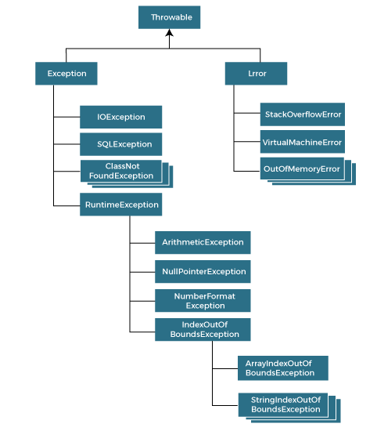

Types of Java Exceptions
There are mainly two types of exceptions: checked and unchecked. An error is considered as the unchecked exception. However, according to Oracle, there are three types of exceptions namely:
- Checked Exception
- Unchecked Exception
- Error
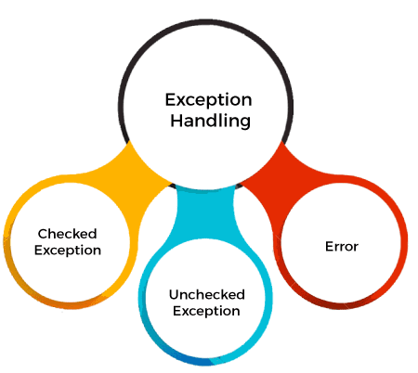

Difference between Checked and Unchecked Exceptions

1) Checked Exception
The classes that directly inherit the Throwable class except RuntimeException and Error are known as checked exceptions. For example, IOException, SQLException, etc. Checked exceptions are checked at compile-time.

2) Unchecked Exception
The classes that inherit the RuntimeException are known as unchecked exceptions. For example, ArithmeticException, NullPointerException, ArrayIndexOutOfBoundsException, etc. Unchecked exceptions are not checked at compile-time, but they are checked at runtime.

3) Error
Error is irrecoverable. Some example of errors are OutOfMemoryError, VirtualMachineError, AssertionError etc.

Java Exception Keywords
Java provides five keywords that are used to handle the exception. The following table describes each.
Keyword | Description
try | The "try" keyword is used to specify a block where we should place an exception code. It means we can't use try block alone. The try block must be followed by either catch or finally.
catch | The "catch" block is used to handle the exception. It must be preceded by try block which means we can't use catch block alone. It can be followed by finally block later.
finally | The "finally" block is used to execute the necessary code of the program. It is executed whether an exception is handled or not.
throw | The "throw" keyword is used to throw an exception.
throws | The "throws" keyword is used to declare exceptions. It specifies that there may occur an exception in the method. It doesn't throw an exception. It is always used with method signature.

Java Exception Handling Example
Let's see an example of Java Exception Handling in which we are using a try-catch statement to handle the exception.
JavaExceptionExample.java
- public class JavaExceptionExample{
- public static void main(String args[]){
- try{
- //code that may raise exception
- int data=100/0;
- }catch(ArithmeticException e){System.out.println(e);}
- //rest code of the program
- System.out.println("rest of the code...");
- }
- }
Test it Now
Output:
Exception in thread main java.lang.ArithmeticException:/ by zero
rest of the code...
In the above example, 100/0 raises an ArithmeticException which is handled by a try-catch block.

Common Scenarios of Java Exceptions
There are given some scenarios where unchecked exceptions may occur. They are as follows:

1) A scenario where ArithmeticException occurs
If we divide any number by zero, there occurs an ArithmeticException.
- int a=50/0;//ArithmeticException

2) A scenario where NullPointerException occurs
If we have a null value in any variable, performing any operation on the variable throws a NullPointerException.
- String s=null;
- System.out.println(s.length());//NullPointerException

3) A scenario where NumberFormatException occurs
If the formatting of any variable or number is mismatched, it may result into NumberFormatException. Suppose we have a string variable that has characters; converting this variable into digit will cause NumberFormatException.
- String s="abc";
- int i=Integer.parseInt(s);//NumberFormatException

4) A scenario where ArrayIndexOutOfBoundsException occurs
When an array exceeds to it's size, the ArrayIndexOutOfBoundsException occurs. there may be other reasons to occur ArrayIndexOutOfBoundsException. Consider the following statements.
- int a[]=new int[5];
- a[10]=50; //ArrayIndexOutOfBoundsException

Java try block
Java try block is used to enclose the code that might throw an exception. It must be used within the method.
If an exception occurs at the particular statement in the try block, the rest of the block code will not execute. So, it is recommended not to keep the code in try block that will not throw an exception.
Java try block must be followed by either catch or finally block.
PlayNext
Unmute
Current TimeÂ 0:00
/
DurationÂ 18:10
Loaded: 0.37%
Â
Fullscreen
Backward Skip 10sPlay VideoForward Skip 10s

Syntax of Java try-catch
- try{
- //code that may throw an exception
- }catch(Exception_class_Name ref){}

Syntax of try-finally block
- try{
- //code that may throw an exception
- }finally{}

Java catch block
Java catch block is used to handle the Exception by declaring the type of exception within the parameter. The declared exception must be the parent class exception ( i.e., Exception) or the generated exception type. However, the good approach is to declare the generated type of exception.
The catch block must be used after the try block only. You can use multiple catch block with a single try block.

Internal Working of Java try-catch block
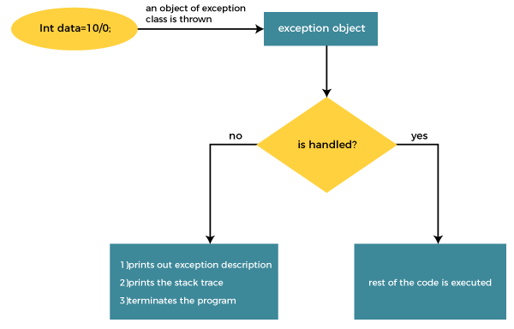
The JVM firstly checks whether the exception is handled or not. If exception is not handled, JVM provides a default exception handler that performs the following tasks:
- Prints out exception description.
- Prints the stack trace (Hierarchy of methods where the exception occurred).
- Causes the program to terminate.
But if the application programmer handles the exception, the normal flow of the application is maintained, i.e., rest of the code is executed.

Problem without exception handling
Let's try to understand the problem if we don't use a try-catch block.

Example 1
TryCatchExample1.java
- public class TryCatchExample1 {

- public static void main(String[] args) {

- int data=50/0; //may throw exception

- System.out.println("rest of the code");

- }

- }
Test it Now
Output:
Exception in thread "main" java.lang.ArithmeticException: / by zero
As displayed in the above example, the rest of the code is not executed (in such case, the rest of the code statement is not printed).
There might be 100 lines of code after the exception. If the exception is not handled, all the code below the exception won't be executed.

Solution by exception handling
Let's see the solution of the above problem by a java try-catch block.

Example 2
TryCatchExample2.java
- public class TryCatchExample2 {

- public static void main(String[] args) {
- try
- {
- int data=50/0; //may throw exception
- }
- //handling the exception
- catch(ArithmeticException e)
- {
- System.out.println(e);
- }
- System.out.println("rest of the code");
- }

- }
Test it Now
Output:
java.lang.ArithmeticException: / by zero
rest of the code
As displayed in the above example, the rest of the code is executed, i.e., the rest of the code statement is printed.

Example 3
In this example, we also kept the code in a try block that will not throw an exception.
TryCatchExample3.java
- public class TryCatchExample3 {

- public static void main(String[] args) {
- try
- {
- int data=50/0; //may throw exception
- // if exception occurs, the remaining statement will not exceute
- System.out.println("rest of the code");
- }
- // handling the exception
- catch(ArithmeticException e)
- {
- System.out.println(e);
- }

- }

- }
Test it Now
Output:
java.lang.ArithmeticException: / by zero
Here, we can see that if an exception occurs in the try block, the rest of the block code will not execute.

Example 4
Here, we handle the exception using the parent class exception.
TryCatchExample4.java
- public class TryCatchExample4 {

- public static void main(String[] args) {
- try
- {
- int data=50/0; //may throw exception
- }
- // handling the exception by using Exception class
- catch(Exception e)
- {
- System.out.println(e);
- }
- System.out.println("rest of the code");
- }

- }
Test it Now
Output:
java.lang.ArithmeticException: / by zero
rest of the code

Example 5
Let's see an example to print a custom message on exception.
TryCatchExample5.java
- public class TryCatchExample5 {

- public static void main(String[] args) {
- try
- {
- int data=50/0; //may throw exception
- }
- // handling the exception
- catch(Exception e)
- {
- // displaying the custom message
- System.out.println("Can't divided by zero");
- }
- }

- }
Test it Now
Output:
Can't divided by zero

Example 6
Let's see an example to resolve the exception in a catch block.
TryCatchExample6.java
- public class TryCatchExample6 {

- public static void main(String[] args) {
- int i=50;
- int j=0;
- int data;
- try
- {
- data=i/j; //may throw exception
- }
- // handling the exception
- catch(Exception e)
- {
- // resolving the exception in catch block
- System.out.println(i/(j+2));
- }
- }
- }
Test it Now
The Java throw keyword is used to throw an exception explicitly.
We specify the exception object which is to be thrown. The Exception has some message with it that provides the error description. These exceptions may be related to user inputs, server, etc.
We can throw either checked or unchecked exceptions in Java by throw keyword. It is mainly used to throw a custom exception. We will discuss custom exceptions later in this section.
We can also define our own set of conditions and throw an exception explicitly using throw keyword. For example, we can throw ArithmeticException if we divide a number by another number. Here, we just need to set the condition and throw exception using throw keyword.
The syntax of the Java throw keyword is given below.
throw Instance i.e.,
- throw new exception_class("error message");
Let's see the example of throw IOException.
- throw new IOException("sorry device error");
Where the Instance must be of type Throwable or subclass of Throwable. For example, Exception is the sub class of Throwable and the user-defined exceptions usually extend the Exception class.

Java throw keyword Example

Example 1: Throwing Unchecked Exception
In this example, we have created a method named validate() that accepts an integer as a parameter. If the age is less than 18, we are throwing the ArithmeticException otherwise print a message welcome to vote.
TestThrow1.java
In this example, we have created the validate method that takes integer value as a parameter. If the age is less than 18, we are throwing the ArithmeticException otherwise print a message welcome to vote.
- public class TestThrow1 {
- //function to check if person is eligible to vote or not
- public static void validate(int age) {
- if(age<18) {
- //throw Arithmetic exception if not eligible to vote
- throw new ArithmeticException("Person is not eligible to vote");
- }
- else {
- System.out.println("Person is eligible to vote!!");
- }
- }
- //main method
- public static void main(String args[]){
- //calling the function
- validate(13);
- System.out.println("rest of the code...");
- }
- }
Output:
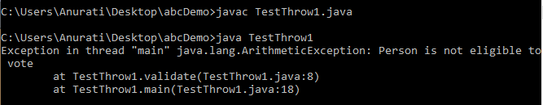
The above code throw an unchecked exception. Similarly, we can also throw unchecked and user defined exceptions.

Note: If we throw unchecked exception from a method, it is must to handle the exception or declare in throws clause.
If we throw a checked exception using throw keyword, it is must to handle the exception using catch block or the method must declare it using throws declaration.

Example 2: Throwing Checked Exception

Note: Every subclass of Error and RuntimeException is an unchecked exception in Java. A checked exception is everything else under the Throwable class.
TestThrow2.java
- import java.io.*;

- public class TestThrow2 {

- //function to check if person is eligible to vote or not
- public static void method() throws FileNotFoundException {

- FileReader file = new FileReader("C:\\Users\\Anurati\\Desktop\\abc.txt");
- BufferedReader fileInput = new BufferedReader(file);

- throw new FileNotFoundException();

- }
- //main method
- public static void main(String args[]){
- try
- {
- method();
- }
- catch (FileNotFoundException e)
- {
- e.printStackTrace();
- }
- System.out.println("rest of the code...");
- }
- }
Output:
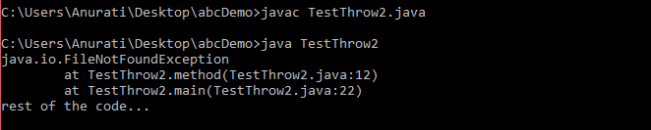

Example 3: Throwing User-defined Exception
exception is everything else under the Throwable class.
TestThrow3.java
- // class represents user-defined exception
- class UserDefinedException extends Exception
- {
- public UserDefinedException(String str)
- {
- // Calling constructor of parent Exception
- super(str);
- }
- }
- // Class that uses above MyException
- public class TestThrow3
- {
- public static void main(String args[])
- {
- try
- {
- // throw an object of user defined exception
- throw new UserDefinedException("This is user-defined exception");
- }
- catch (UserDefinedException ude)
- {
- System.out.println("Caught the exception");
- // Print the message from MyException object
- System.out.println(ude.getMessage());
- }
- }
- }

Java throws keyword
The Java throws keyword is used to declare an exception. It gives an information to the programmer that there may occur an exception. So, it is better for the programmer to provide the exception handling code so that the normal flow of the program can be maintained.
Exception Handling is mainly used to handle the checked exceptions. If there occurs any unchecked exception such as NullPointerException, it is programmers' fault that he is not checking the code before it being used.

Syntax of Java throws
- return_type method_name() throws exception_class_name{
- //method code
- }

Which exception should be declared?
Ans: Checked exception only, because:
- unchecked exception: under our control so we can correct our code.
- error: beyond our control. For example, we are unable to do anything if there occurs VirtualMachineError or StackOverflowError.

Advantage of Java throws keyword
Now Checked Exception can be propagated (forwarded in call stack).
It provides information to the caller of the method about the exception.

Java throws Example
Let's see the example of Java throws clause which describes that checked exceptions can be propagated by throws keyword.
Testthrows1.java
- import java.io.IOException;
- class Testthrows1{
- void m()throws IOException{
- throw new IOException("device error");//checked exception
- }
- void n()throws IOException{
- m();
- }
- void p(){
- try{
- n();
- }catch(Exception e){System.out.println("exception handled");}
- }
- public static void main(String args[]){
- Testthrows1 obj=new Testthrows1();
- obj.p();
- System.out.println("normal flow...");
- }
- }
Test it Now
Output:
exception handled
normal flow...

Rule: If we are calling a method that declares an exception, we must either caught or declare the exception.
There are two cases:
- Case 1: We have caught the exception i.e. we have handled the exception using try/catch block.
- Case 2: We have declared the exception i.e. specified throws keyword with the method.

Case 1: Handle Exception Using try-catch block
In case we handle the exception, the code will be executed fine whether exception occurs during the program or not.
Testthrows2.java
- import java.io.*;
- class M{
- void method()throws IOException{
- throw new IOException("device error");
- }
- }
- public class Testthrows2{
- public static void main(String args[]){
- try{
- M m=new M();
- m.method();
- }catch(Exception e){System.out.println("exception handled");}

- System.out.println("normal flow...");
- }
- }
Test it Now
Output:
exception handled
normal flow...

Case 2: Declare Exception
- In case we declare the exception, if exception does not occur, the code will be executed fine.
- In case we declare the exception and the exception occurs, it will be thrown at runtime because throws does not handle the exception.
Let's see examples for both the scenario.
A) If exception does not occur
Testthrows3.java
- import java.io.*;
- class M{
- void method()throws IOException{
- System.out.println("device operation performed");
- }
- }
- class Testthrows3{
- public static void main(String args[])throws IOException{//declare exception
- M m=new M();
- m.method();

- System.out.println("normal flow...");
- }
- }
Test it Now
Output:
device operation performed
normal flow...
B) If exception occurs
Testthrows4.java
- import java.io.*;
- class M{
- void method()throws IOException{
- throw new IOException("device error");
- }
- }
- class Testthrows4{
- public static void main(String args[])throws IOException{//declare exception
- M m=new M();
- m.method();

- System.out.println("normal flow...");
- }
- }

Java finally block is a block used to execute important code such as closing the connection, etc.
Java finally block is always executed whether an exception is handled or not. Therefore, it contains all the necessary statements that need to be printed regardless of the exception occurs or not.
The finally block follows the try-catch block.

Flowchart of finally block
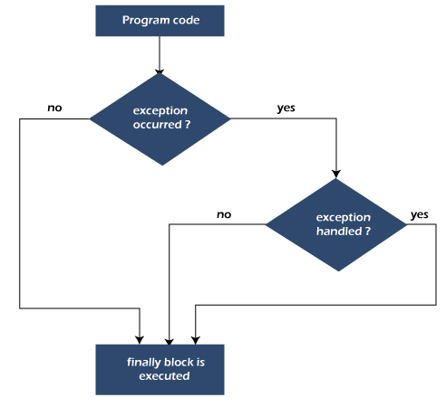

Note: If you don't handle the exception, before terminating the program, JVM executes finally block (if any).

Why use Java finally block?
- finally block in Java can be used to put "cleanup" code such as closing a file, closing connection, etc.
- The important statements to be printed can be placed in the finally block.

Usage of Java finally
Let's see the different cases where Java finally block can be used.
PlayNext
Unmute
Current TimeÂ 0:00
/
DurationÂ 18:10
Loaded: 0.37%
Â
Fullscreen
Backward Skip 10sPlay VideoForward Skip 10s

Case 1: When an exception does not occur
Let's see the below example where the Java program does not throw any exception, and the finally block is executed after the try block.
TestFinallyBlock.java
- class TestFinallyBlock {
- public static void main(String args[]){
- try{
- //below code do not throw any exception
- int data=25/5;
- System.out.println(data);
- }
- //catch won't be executed
- catch(NullPointerException e){
- System.out.println(e);
- }
- //executed regardless of exception occurred or not
- finally {
- System.out.println("finally block is always executed");
- }

- System.out.println("rest of phe code...");
- }
- }
Output:
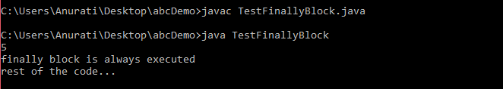

Case 2: When an exception occurr but not handled by the catch block
Let's see the the fillowing example. Here, the code throws an exception however the catch block cannot handle it. Despite this, the finally block is executed after the try block and then the program terminates abnormally.
TestFinallyBlock1.java
- public class TestFinallyBlock1{
- public static void main(String args[]){

- try {

- System.out.println("Inside the try block");

- //below code throws divide by zero exception
- int data=25/0;
- System.out.println(data);
- }
- //cannot handle Arithmetic type exception
- //can only accept Null Pointer type exception
- catch(NullPointerException e){
- System.out.println(e);
- }

- //executes regardless of exception occured or not
- finally {
- System.out.println("finally block is always executed");
- }

- System.out.println("rest of the code...");
- }
- }
Output:
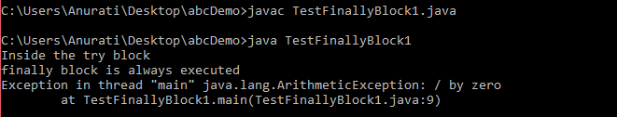

Case 3: When an exception occurs and is handled by the catch block
Example:
Let's see the following example where the Java code throws an exception and the catch block handles the exception. Later the finally block is executed after the try-catch block. Further, the rest of the code is also executed normally.
TestFinallyBlock2.java
- public class TestFinallyBlock2{
- public static void main(String args[]){

- try {

- System.out.println("Inside try block");

- //below code throws divide by zero exception
- int data=25/0;
- System.out.println(data);
- }

- //handles the Arithmetic Exception / Divide by zero exception
- catch(ArithmeticException e){
- System.out.println("Exception handled");
- System.out.println(e);
- }

- //executes regardless of exception occured or not
- finally {
- System.out.println("finally block is always executed");
- }

- System.out.println("rest of the code...");
- }
- }
Output:
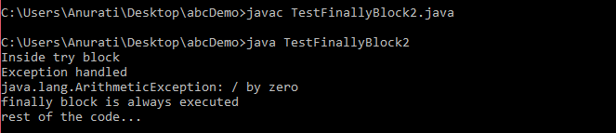

Rule: For each try block there can be zero or more catch blocks, but only one finally block.

Note: The finally block will not be executed if the program exits (either by calling System.exit() or by causing a fatal error that causes the process to abort).

File Operations in Java
In Java, a File is an abstract data type. A named location used to store related information is known as a File. There are several File Operations like creating a new File, getting information about File, writing into a File, reading from a File and deleting a File.
We can perform the following operation on a file:
- Create a File
- Get File Information
- Write to a File
- Read from a File
- Delete a File
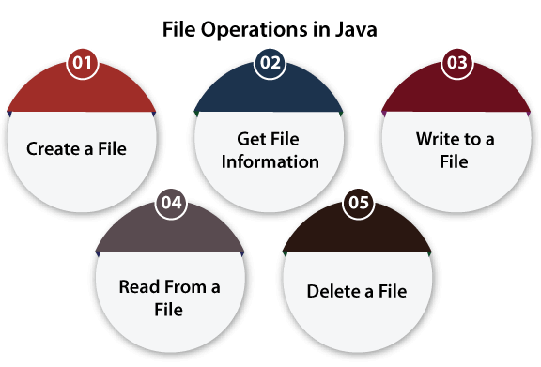

Create a File
Create a File operation is performed to create a new file. We use the createNewFile() method of file. The createNewFile() method returns true when it successfully creates a new file and returns false when the file already exists.
Let's take an example of creating a file to understand how we can use the createNewFile() method to perform this operation.
CreateFile.java
- // Importing File class
- import java.io.File;
- // Importing the IOException class for handling errors
- import java.io.IOException;
- class CreateFile {
- public static void main(String args[]) {
- try {
- // Creating an object of a file
- File f0 = new File("D:FileOperationExample.txt");
- if (f0.createNewFile()) {
- System.out.println("File " + f0.getName() + " is created successfully.");
- } else {
- System.out.println("File is already exist in the directory.");
- }
- } catch (IOException exception) {
- System.out.println("An unexpected error is occurred.");
- exception.printStackTrace();
- }
- }
- }
Output:
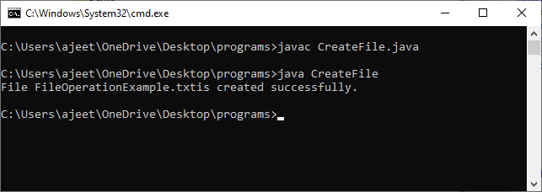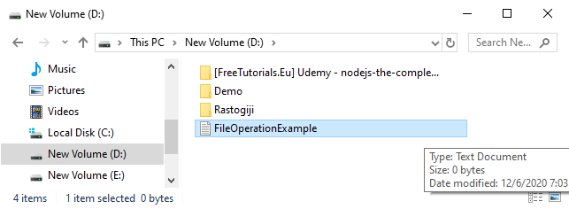
Explanation:
In the above code, we import the File and IOException class for performing file operation and handling errors, respectively. We create the f0 object of the File class and specify the location of the directory where we want to create a file. In the try block, we call the createNewFile() method through the f0 object to create a new file in the specified location. If the method returns false, it will jump to the else section. If there is any error, it gets handled in the catch block.

Get File Information
The operation is performed to get the file information. We use several methods to get the information about the file like name, absolute path, is readable, is writable and length.
Let's take an example to understand how to use file methods to get the information of the file.
FileInfo.java
- // Import the File class
- import java.io.File;
- class FileInfo {
- public static void main(String[] args) {
- // Creating file object
- File f0 = new File("D:FileOperationExample.txt");
- if (f0.exists()) {
- // Getting file name
- System.out.println("The name of the file is: " + f0.getName());

- // Getting path of the file
- System.out.println("The absolute path of the file is: " + f0.getAbsolutePath());

- // Checking whether the file is writable or not
- System.out.println("Is file writeable?: " + f0.canWrite());

- // Checking whether the file is readable or not
- System.out.println("Is file readable " + f0.canRead());

- // Getting the length of the file in bytes
- System.out.println("The size of the file in bytes is: " + f0.length());
- } else {
- System.out.println("The file does not exist.");
- }
- }
- }
Output:
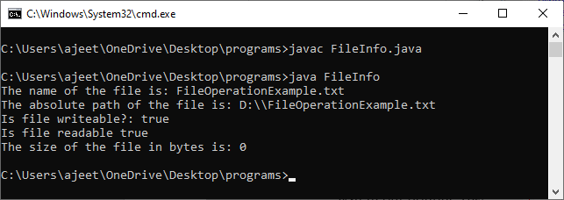
Description:
In the above code, we import the java.io.File package and create a class FileInfo. In the main method, we create an object of the text file which we have created in our previous example. We check the existence of the file using a conditional statement, and if it is present, we get the following information about that file:
- We get the name of the file using the getName()
- We get the absolute path of the file using the getAbsolutePath() method of the file.
- We check whether we can write data into a file or not using the canWrite()
- We check whether we can read the data of the file or not using the canRead()
- We get the length of the file by using the length()
If the file doesn't exist, we show a custom message.

Write to a File
The next operation which we can perform on a file is "writing into a file". In order to write data into a file, we will use the FileWriter class and its write() method together. We need to close the stream using the close() method to retrieve the allocated resources.
Let's take an example to understand how we can write data into a file.
WriteToFile.java
- // Importing the FileWriter class
- import java.io.FileWriter;

- // Importing the IOException class for handling errors
- import java.io.IOException;

- class WriteToFile {
- public static void main(String[] args) {

- try {
- FileWriter fwrite = new FileWriter("D:FileOperationExample.txt");
- // writing the content into the FileOperationExample.txt file
- fwrite.write("A named location used to store related information is referred to as a File.");

- // Closing the stream
- fwrite.close();
- System.out.println("Content is successfully wrote to the file.");
- } catch (IOException e) {
- System.out.println("Unexpected error occurred");
- e.printStackTrace();
- }
- }
- }
Output:
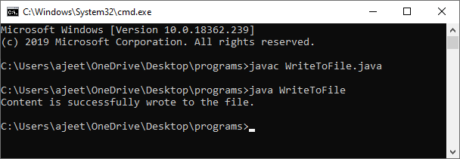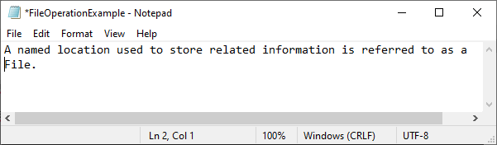
Explanation:
In the above code, we import the java.io.FileWriter and java.io.IOException classes. We create a class WriteToFile, and in its main method, we use the try-catch block. In the try section, we create an instance of the FileWriter class, i.e., fwrite. We call the write method of the FileWriter class and pass the content to that function which we want to write. After that, we call the close() method of the FileWriter class to close the file stream. After writing the content and closing the stream, we print a custom message.
If we get any error in the try section, it jumps to the catch block. In the catch block, we handle the IOException and print a custom message.

Read from a File
The next operation which we can perform on a file is "read from a file". In order to write data into a file, we will use the Scanner class. Here, we need to close the stream using the close() method. We will create an instance of the Scanner class and use the hasNextLine() method nextLine() method to get data from the file.
Let's take an example to understand how we can read data from a file.
ReadFromFile.java
- // Importing the File class
- import java.io.File;
- // Importing FileNotFoundException class for handling errors
- import java.io.FileNotFoundException;
- // Importing the Scanner class for reading text files
- import java.util.Scanner;

- class ReadFromFile {
- public static void main(String[] args) {
- try {
- // Create f1 object of the file to read data
- File f1 = new File("D:FileOperationExample.txt");
- Scanner dataReader = new Scanner(f1);
- while (dataReader.hasNextLine()) {
- String fileData = dataReader.nextLine();
- System.out.println(fileData);
- }
- dataReader.close();
- } catch (FileNotFoundException exception) {
- System.out.println("Unexcpected error occurred!");
- exception.printStackTrace();
- }
- }
- }
Output:
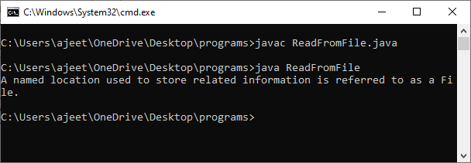
Expalnation:
In the above code, we import the "java.util.Scannner", "java.io.File" and "java.io.IOException" classes. We create a class ReadFromFile, and in its main method, we use the try-catch block. In the try section, we create an instance of both the Scanner and the File classes. We pass the File class object to the Scanner class object and then iterate the scanner class object using the "While" loop and print each line of the file. We also need to close the scanner class object, so we use the close() function. If we get any error in the try section, it jumps to the catch block. In the catch block, we handle the IOException and print a custom message.

Delete a File
The next operation which we can perform on a file is "deleting a file". In order to delete a file, we will use the delete() method of the file. We don't need to close the stream using the close() method because for deleting a file, we neither use the FileWriter class nor the Scanner class.
Let's take an example to understand how we can write data into a file.
DeleteFile.java
- // Importing the File class
- import java.io.File;
- class DeleteFile {
- public static void main(String[] args) {
- File f0 = new File("D:FileOperationExample.txt");
- if (f0.delete()) {
- System.out.println(f0.getName()+ " file is deleted successfully.");
- } else {
- System.out.println("Unexpected error found in deletion of the file.");
- }
- }
- }
Output:
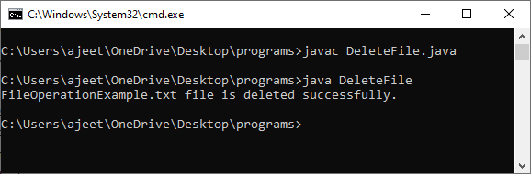
Explanation:
In the above code, we import the File class and create a class DeleteFile. In the main() method of the class, we create f0 object of the file which we want to delete. In the if statement, we call the delete() method of the file using the f0 object. If the delete() method returns true, we print the success custom message. Otherwise, it jumps to the else section where we print the unsuccessful custom message.
All the above-mentioned operations are used to read, write, delete, and create file programmatically.

Multithreading in Java
- Multithreading
- Multitasking
- Process-based multitasking
- Thread-based multitasking
- What is Thread
Multithreading in Java is a process of executing multiple threads simultaneously.
A thread is a lightweight sub-process, the smallest unit of processing. Multiprocessing and multithreading, both are used to achieve multitasking.
However, we use multithreading than multiprocessing because threads use a shared memory area. They don't allocate separate memory area so saves memory, and context-switching between the threads takes less time than process.
Java Multithreading is mostly used in games, animation, etc.

Java Thread Methods
S.N. | Modifier and Type | Method | Description
1) | void | start() | It is used to start the execution of the thread.
2) | void | run() | It is used to do an action for a thread.
3) | static void | sleep() | It sleeps a thread for the specified amount of time.
4) | static Thread | currentThread() | It returns a reference to the currently executing thread object.

Java Threads | How to create a thread in Java
There are two ways to create a thread:
- By extending Thread class
- By implementing Runnable interface.

Thread class:
Thread class provide constructors and methods to create and perform operations on a thread.Thread class extends Object class and implements Runnable interface.

Commonly used Constructors of Thread class:
- Thread()
- Thread(String name)
- Thread(Runnable r)
- Thread(Runnable r,String name)

Commonly used methods of Thread class:
- public void run(): is used to perform action for a thread.
- public void start(): starts the execution of the thread.JVM calls the run() method on the thread.
- public void sleep(long miliseconds): Causes the currently executing thread to sleep (temporarily cease execution) for the specified number of milliseconds.
- public void join(): waits for a thread to die.
- public void join(long miliseconds): waits for a thread to die for the specified miliseconds.
- public int getPriority(): returns the priority of the thread.
- public int setPriority(int priority): changes the priority of the thread.
- public String getName(): returns the name of the thread.
- public void setName(String name): changes the name of the thread.
- public Thread currentThread(): returns the reference of currently executing thread.
- public int getId(): returns the id of the thread.
- public Thread.State getState(): returns the state of the thread.
- public boolean isAlive(): tests if the thread is alive.
- public void yield(): causes the currently executing thread object to temporarily pause and allow other threads to execute.
- public void suspend(): is used to suspend the thread(depricated).
- public void resume(): is used to resume the suspended thread(depricated).
- public void stop(): is used to stop the thread(depricated).
- public boolean isDaemon(): tests if the thread is a daemon thread.
- public void setDaemon(boolean b): marks the thread as daemon or user thread.
- public void interrupt(): interrupts the thread.
- public boolean isInterrupted(): tests if the thread has been interrupted.
- public static boolean interrupted(): tests if the current thread has been interrupted.

Runnable interface:
The Runnable interface should be implemented by any class whose instances are intended to be executed by a thread. Runnable interface have only one method named run().
- public void run(): is used to perform action for a thread.

Starting a thread:
The start() method of Thread class is used to start a newly created thread. It performs the following tasks:
PlayNext
Unmute
Current TimeÂ 0:00
/
DurationÂ 18:10
Loaded: 0.37%
Â
Fullscreen
Backward Skip 10sPlay VideoForward Skip 10s
- A new thread starts(with new callstack).
- The thread moves from New state to the Runnable state.
- When the thread gets a chance to execute, its target run() method will run.

1) Java Thread Example by extending Thread class
FileName: Multi.java
- class Multi extends Thread{
- public void run(){
- System.out.println("thread is running...");
- }
- public static void main(String args[]){
- Multi t1=new Multi();
- t1.start();
- }
- }
Output:
thread is running...

2) Java Thread Example by implementing Runnable interface
FileName: Multi3.java
- class Multi3 implements Runnable{
- public void run(){
- System.out.println("thread is running...");
- }

- public static void main(String args[]){
- Multi3 m1=new Multi3();
- Thread t1 =new Thread(m1); // Using the constructor Thread(Runnable r)
- t1.start();
- }
- }
Output:
thread is running...
If you are not extending the Thread class, your class object would not be treated as a thread object. So you need to explicitly create the Thread class object. We are passing the object of your class that implements Runnable so that your class run() method may execute.

3) Using the Thread Class: Thread(String Name)
We can directly use the Thread class to spawn new threads using the constructors defined above.
FileName: MyThread1.java
- public class MyThread1
- {
- // Main method
- public static void main(String argvs[])
- {
- // creating an object of the Thread class using the constructor Thread(String name)
- Thread t= new Thread("My first thread");

- // the start() method moves the thread to the active state
- t.start();
- // getting the thread name by invoking the getName() method
- String str = t.getName();
- System.out.println(str);
- }
- }
Output:
My first thread

4) Using the Thread Class: Thread(Runnable r, String name)
Observe the following program.
FileName: MyThread2.java
- public class MyThread2 implements Runnable
- {
- public void run()
- {
- System.out.println("Now the thread is running ...");
- }

- // main method
- public static void main(String argvs[])
- {
- // creating an object of the class MyThread2
- Runnable r1 = new MyThread2();

- // creating an object of the class Thread using Thread(Runnable r, String name)
- Thread th1 = new Thread(r1, "My new thread");

- // the start() method moves the thread to the active state
- th1.start();

- // getting the thread name by invoking the getName() method
- String str = th1.getName();
- System.out.println(str);
- }
- }
Output:
My new thread
Now the thread is running ...

Collections in Java
- Java Collection Framework
- Hierarchy of Collection Framework
- Collection interface
- Iterator interface
The Collection in Java is a framework that provides an architecture to store and manipulate the group of objects.
Java Collections can achieve all the operations that you perform on a data such as searching, sorting, insertion, manipulation, and deletion.
Java Collection means a single unit of objects. Java Collection framework provides many interfaces (Set, List, Queue, Deque) and classes (ArrayList, Vector, LinkedList, PriorityQueue, HashSet, LinkedHashSet, TreeSet).

What is Collection in Java
A Collection represents a single unit of objects, i.e., a group.
PlayNext
Unmute
Current TimeÂ 0:00
/
DurationÂ 18:10
Loaded: 0.37%
Â
Fullscreen
Backward Skip 10sPlay VideoForward Skip 10s

What is a framework in Java
- It provides readymade architecture.
- It represents a set of classes and interfaces.
- It is optional.

What is Collection framework
The Collection framework represents a unified architecture for storing and manipulating a group of objects. It has:
- Interfaces and its implementations, i.e., classes
- Algorithm

Hierarchy of Collection Framework
Let us see the hierarchy of Collection framework. The java.util package contains all the classes and interfaces for the Collection framework.
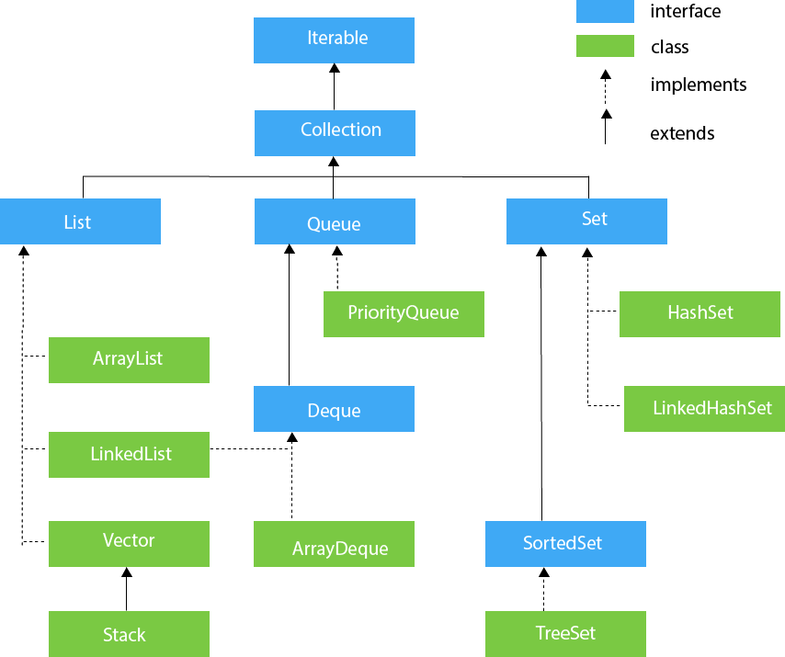

Methods of Collection interface
There are many methods declared in the Collection interface. They are as follows:
No. | Method | Description
1 | public boolean add(E e) | It is used to insert an element in this collection.
2 | public boolean addAll(Collection<? extends E> c) | It is used to insert the specified collection elements in the invoking collection.
3 | public boolean remove(Object element) | It is used to delete an element from the collection.
4 | public boolean removeAll(Collection<?> c) | It is used to delete all the elements of the specified collection from the invoking collection.
5 | default boolean removeIf(Predicate<? super E> filter) | It is used to delete all the elements of the collection that satisfy the specified predicate.
6 | public boolean retainAll(Collection<?> c) | It is used to delete all the elements of invoking collection except the specified collection.
7 | public int size() | It returns the total number of elements in the collection.
8 | public void clear() | It removes the total number of elements from the collection.
9 | public boolean contains(Object element) | It is used to search an element.
10 | public boolean containsAll(Collection<?> c) | It is used to search the specified collection in the collection.
11 | public Iterator iterator() | It returns an iterator.
12 | public Object[] toArray() | It converts collection into array.
13 | public <T> T[] toArray(T[] a) | It converts collection into array. Here, the runtime type of the returned array is that of the specified array.
14 | public boolean isEmpty() | It checks if collection is empty.
15 | default Stream<E> parallelStream() | It returns a possibly parallel Stream with the collection as its source.
16 | default Stream<E> stream() | It returns a sequential Stream with the collection as its source.
17 | default Spliterator<E> spliterator() | It generates a Spliterator over the specified elements in the collection.
18 | public boolean equals(Object element) | It matches two collections.
19 | public int hashCode() | It returns the hash code number of the collection.

Iterator interface
Iterator interface provides the facility of iterating the elements in a forward direction only.

Methods of Iterator interface
There are only three methods in the Iterator interface. They are:
No. | Method | Description
1 | public boolean hasNext() | It returns true if the iterator has more elements otherwise it returns false.
2 | public Object next() | It returns the element and moves the cursor pointer to the next element.
3 | public void remove() | It removes the last elements returned by the iterator. It is less used.

Iterable Interface
The Iterable interface is the root interface for all the collection classes. The Collection interface extends the Iterable interface and therefore all the subclasses of Collection interface also implement the Iterable interface.
It contains only one abstract method. i.e.,
- Iterator<T> iterator()
It returns the iterator over the elements of type T.

Collection Interface
The Collection interface is the interface which is implemented by all the classes in the collection framework. It declares the methods that every collection will have. In other words, we can say that the Collection interface builds the foundation on which the collection framework depends.
Some of the methods of Collection interface are Boolean add ( Object obj), Boolean addAll ( Collection c), void clear(), etc. which are implemented by all the subclasses of Collection interface.

List Interface
List interface is the child interface of Collection interface. It inhibits a list type data structure in which we can store the ordered collection of objects. It can have duplicate values.
List interface is implemented by the classes ArrayList, LinkedList, Vector, and Stack.
To instantiate the List interface, we must use :
- List <data-type> list1= new ArrayList();
- List <data-type> list2 = new LinkedList();
- List <data-type> list3 = new Vector();
- List <data-type> list4 = new Stack();
There are various methods in List interface that can be used to insert, delete, and access the elements from the list.
The classes that implement the List interface are given below.

ArrayList
The ArrayList class implements the List interface. It uses a dynamic array to store the duplicate element of different data types. The ArrayList class maintains the insertion order and is non-synchronized. The elements stored in the ArrayList class can be randomly accessed. Consider the following example.
- import java.util.*;
- class TestJavaCollection1{
- public static void main(String args[]){
- ArrayList<String> list=new ArrayList<String>();//Creating arraylist
- list.add("Ravi");//Adding object in arraylist
- list.add("Vijay");
- list.add("Ravi");
- list.add("Ajay");
- //Traversing list through Iterator
- Iterator itr=list.iterator();
- while(itr.hasNext()){
- System.out.println(itr.next());
- }
- }
- }
Output:
Ravi
Vijay
Ravi
Ajay

LinkedList
LinkedList implements the Collection interface. It uses a doubly linked list internally to store the elements. It can store the duplicate elements. It maintains the insertion order and is not synchronized. In LinkedList, the manipulation is fast because no shifting is required.
Consider the following example.
- import java.util.*;
- public class TestJavaCollection2{
- public static void main(String args[]){
- LinkedList<String> al=new LinkedList<String>();
- al.add("Ravi");
- al.add("Vijay");
- al.add("Ravi");
- al.add("Ajay");
- Iterator<String> itr=al.iterator();
- while(itr.hasNext()){
- System.out.println(itr.next());
- }
- }
- }
Output:
Ravi
Vijay
Ravi
Ajay

Vector
Vector uses a dynamic array to store the data elements. It is similar to ArrayList. However, It is synchronized and contains many methods that are not the part of Collection framework.
Consider the following example.
- import java.util.*;
- public class TestJavaCollection3{
- public static void main(String args[]){
- Vector<String> v=new Vector<String>();
- v.add("Ayush");
- v.add("Amit");
- v.add("Ashish");
- v.add("Garima");
- Iterator<String> itr=v.iterator();
- while(itr.hasNext()){
- System.out.println(itr.next());
- }
- }
- }
Output:
Ayush
Amit
Ashish
Garima

Stack
The stack is the subclass of Vector. It implements the last-in-first-out data structure, i.e., Stack. The stack contains all of the methods of Vector class and also provides its methods like boolean push(), boolean peek(), boolean push(object o), which defines its properties.
Consider the following example.
- import java.util.*;
- public class TestJavaCollection4{
- public static void main(String args[]){
- Stack<String> stack = new Stack<String>();
- stack.push("Ayush");
- stack.push("Garvit");
- stack.push("Amit");
- stack.push("Ashish");
- stack.push("Garima");
- stack.pop();
- Iterator<String> itr=stack.iterator();
- while(itr.hasNext()){
- System.out.println(itr.next());
- }
- }
- }
Output:
Ayush
Garvit
Amit
Ashish

Queue Interface
Queue interface maintains the first-in-first-out order. It can be defined as an ordered list that is used to hold the elements which are about to be processed. There are various classes like PriorityQueue, Deque, and ArrayDeque which implements the Queue interface.
Queue interface can be instantiated as:
- Queue<String> q1 = new PriorityQueue();
- Queue<String> q2 = new ArrayDeque();
There are various classes that implement the Queue interface, some of them are given below.

PriorityQueue
The PriorityQueue class implements the Queue interface. It holds the elements or objects which are to be processed by their priorities. PriorityQueue doesn't allow null values to be stored in the queue.
Consider the following example.
- import java.util.*;
- public class TestJavaCollection5{
- public static void main(String args[]){
- PriorityQueue<String> queue=new PriorityQueue<String>();
- queue.add("Amit Sharma");
- queue.add("Vijay Raj");
- queue.add("JaiShankar");
- queue.add("Raj");
- System.out.println("head:"+queue.element());
- System.out.println("head:"+queue.peek());
- System.out.println("iterating the queue elements:");
- Iterator itr=queue.iterator();
- while(itr.hasNext()){
- System.out.println(itr.next());
- }
- queue.remove();
- queue.poll();
- System.out.println("after removing two elements:");
- Iterator<String> itr2=queue.iterator();
- while(itr2.hasNext()){
- System.out.println(itr2.next());
- }
- }
- }
Output:
head:Amit Sharma
head:Amit Sharma
iterating the queue elements:
Amit Sharma
Raj
JaiShankar
Vijay Raj
after removing two elements:
Raj
Vijay Raj

Deque Interface
Deque interface extends the Queue interface. In Deque, we can remove and add the elements from both the side. Deque stands for a double-ended queue which enables us to perform the operations at both the ends.
Deque can be instantiated as:
- Deque d = new ArrayDeque();

ArrayDeque
ArrayDeque class implements the Deque interface. It facilitates us to use the Deque. Unlike queue, we can add or delete the elements from both the ends.
ArrayDeque is faster than ArrayList and Stack and has no capacity restrictions.
Consider the following example.
- import java.util.*;
- public class TestJavaCollection6{
- public static void main(String[] args) {
- //Creating Deque and adding elements
- Deque<String> deque = new ArrayDeque<String>();
- deque.add("Gautam");
- deque.add("Karan");
- deque.add("Ajay");
- //Traversing elements
- for (String str : deque) {
- System.out.println(str);
- }
- }
- }
Output:
Gautam
Karan
Ajay

Set Interface
Set Interface in Java is present in java.util package. It extends the Collection interface. It represents the unordered set of elements which doesn't allow us to store the duplicate items. We can store at most one null value in Set. Set is implemented by HashSet, LinkedHashSet, and TreeSet.
Set can be instantiated as:
- Set<data-type> s1 = new HashSet<data-type>();
- Set<data-type> s2 = new LinkedHashSet<data-type>();
- Set<data-type> s3 = new TreeSet<data-type>();

HashSet
HashSet class implements Set Interface. It represents the collection that uses a hash table for storage. Hashing is used to store the elements in the HashSet. It contains unique items.
Consider the following example.
- import java.util.*;
- public class TestJavaCollection7{
- public static void main(String args[]){
- //Creating HashSet and adding elements
- HashSet<String> set=new HashSet<String>();
- set.add("Ravi");
- set.add("Vijay");
- set.add("Ravi");
- set.add("Ajay");
- //Traversing elements
- Iterator<String> itr=set.iterator();
- while(itr.hasNext()){
- System.out.println(itr.next());
- }
- }
- }
Output:
Vijay
Ravi
Ajay

LinkedHashSet
LinkedHashSet class represents the LinkedList implementation of Set Interface. It extends the HashSet class and implements Set interface. Like HashSet, It also contains unique elements. It maintains the insertion order and permits null elements.
Consider the following example.
- import java.util.*;
- public class TestJavaCollection8{
- public static void main(String args[]){
- LinkedHashSet<String> set=new LinkedHashSet<String>();
- set.add("Ravi");
- set.add("Vijay");
- set.add("Ravi");
- set.add("Ajay");
- Iterator<String> itr=set.iterator();
- while(itr.hasNext()){
- System.out.println(itr.next());
- }
- }
- }
Output:
Ravi
Vijay
Ajay

SortedSet Interface
SortedSet is the alternate of Set interface that provides a total ordering on its elements. The elements of the SortedSet are arranged in the increasing (ascending) order. The SortedSet provides the additional methods that inhibit the natural ordering of the elements.
The SortedSet can be instantiated as:
- SortedSet<data-type> set = new TreeSet();

TreeSet
Java TreeSet class implements the Set interface that uses a tree for storage. Like HashSet, TreeSet also contains unique elements. However, the access and retrieval time of TreeSet is quite fast. The elements in TreeSet stored in ascending order.
Consider the following example:
- import java.util.*;
- public class TestJavaCollection9{
- public static void main(String args[]){
- //Creating and adding elements
- TreeSet<String> set=new TreeSet<String>();
- set.add("Ravi");
- set.add("Vijay");
- set.add("Ravi");
- set.add("Ajay");
- //traversing elements
- Iterator<String> itr=set.iterator();
- while(itr.hasNext()){
- System.out.println(itr.next());
- }
- }
- }
Output:
Ajay
Ravi
Vijay

ArrayList add
I
Prototype: boolean add (E e)
Parameters: e=> Element to be added to the ArrayList.
Return Value: true=> Element successfully added.
Description: Adds the given element e to the end of the list.
II.
Prototype: void add (int index, E element)
Parameters:
index=> Position at which the element is to be added.
Element=> Element to be added to the ArrayList.
Return Value: void
Description: Adds given element ‘element’ at the specified position ‘index’ by shifting the element at that position and subsequent elements to the right.
Exceptions: IndexOutOfBoundsException => If the specified index is out of the range.

ArrayList addAll
I
Prototype: boolean addAll (Collection<? extends E> c)
Parameters: c=> Collection whose elements are to be added to the ArrayList.
Return Value: true=> If the operation has altered the ArrayList.
Description: Adds all the elements in the given collection c to the end of the list. The result of the operation is undefined if the collection is altered when the operation is in progress.
Exceptions: NullPointerException => If given collection c is null.
II
Prototype: boolean addAll (int index, Collection<? extends E> c)
Parameters: index=> Position at which the elements in the given collection are to be added.
Return Value: true=> If the list has changed as a result of the operation.
Description: Adds all the elements in the given collection c at the position specified by the ‘index’ in the list. The element at the specified index and subsequent elements are shifted to the right. The result of the operation is undefined if the collection being added is altered when the operation is in progress.
Exceptions: IndexOutOfBoundsException: if the index where the collection is to be added is out of bounds
NullPointerException: if the given collection c is null.
The following Java program demonstrates the usage of add and addAll methods.
import java.util.*;
class Main{
public static void main(String args[]){
//create an ArrayList
ArrayList<String> city_List=new ArrayList<String>();
//add elements to the ArrayList using add method
city_List.add("Delhi");
city_List.add("Mumbai");
city_List.add("Chennai");
city_List.add("Kolkata");
//print the list
System.out.println("Initial ArrayList:" + city_List);
//add an element at index 1 using add method overload
city_List.add(1, "NYC");
//print the list
System.out.println("\nrrayList after adding element at index 1:" + city_List);
//define a second list
ArrayList<String> more_Cities = new ArrayList<String>(Arrays.asList("Pune", "Hyderabad"));
//use addAll method to add the list to ArrayList at index 4
city_List.addAll(4,more_Cities);
//print the list
System.out.println("\nArrayList after adding list at index 4:" + city_List);
}
}
Output:
Initial ArrayList:[Delhi, Mumbai, Chennai, Kolkata]
rrayList after adding element at index 1:[Delhi, NYC, Mumbai, Chennai, Kolkata]
ArrayList after adding list at index 4:[Delhi, NYC, Mumbai, Chennai, Pune, Hyderabad, Kolkata]
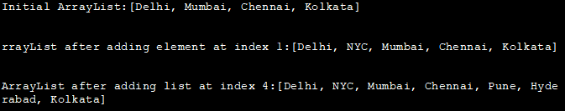
The above program uses both the versions of the add method to add elements to the list. It also adds a collection to the list at the specified index. Note the shifting of elements to the right of the ArrayList as evident from the output of the program.

ArrayList Add To The Front
As already mentioned, the first version of the add method adds the elements to the end of the list. If you want to add the elements at the beginning of the ArrayList, then you have to make use of the second version of the add method. This add method takes an index as a parameter. This index is the position at which the element is to be added.
Thus to add the element at the beginning of the list, you have to specify the index as 0 which is the start of the list.
The following program adds an element to the front of the ArrayList.
import java.util.ArrayList;
public class Main {
public static void main(String[] args) {
//define new ArrayList and initialize it
ArrayList<Integer> numList = new ArrayList<Integer>();
numList.add(5);
numList.add(7);
numList.add(9);
//print the ArrayList
System.out.println("Initial ArrayList:");
System.out.println(numList);

//use add method with index=0 to add elements to the beginning of the list
numList.add(0, 3);
numList.add(0, 1);

System.out.println("ArrayList after adding elements at the beginning:");
//print ArrayList
System.out.println(numList);
}
}
Output:
Initial ArrayList:
[5, 7, 9]
ArrayList after adding elements at the beginning:
[1, 3, 5, 7, 9]
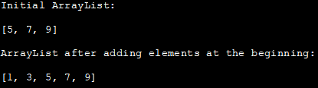

ArrayList remove
I.
Prototype: E remove (int index)
Parameters: index=> Position at which the element is to be removed from the ArrayList.
Return Value: E=> Element that is deleted
Description: Deletes element at the ‘index’ in the ArrayList and moves subsequent elements to the left.
Exceptions: IndexOutOfBoundsException => Index specified is out of range.
II.
Prototype: boolean remove (Object o)
Parameters: o=> Element that is to be removed from the ArrayList.
Return Value: true=> If the element is present in the list.
Description: Deletes the first occurrence of element o from the list. If the element is not present in the list, then there is no effect of this operation. Once the element is deleted, the subsequent elements are shifted to the left.

ArrayList removeAll
Prototype: boolean removeAll (Collection<?> c)
Parameters: c=> Collection whose elements match with those of ArrayList and are to be removed.
Return Value: true=> If the ArrayList is altered by the operation.
Description: Removes all the elements from the list that match the elements in the given collection c. As a result, the elements remaining are shifted to the left of the list.
Exceptions: ClassCastException => Class is not the same as that of the specified collection which implies class is incompatible.
NullPointerException => If the given collection c is null; or if c has a null element and it is not allowed by the collection.

ArrayList removeRange
Prototype: protected void removeRange (int fromIndex, int toIndex)
Parameters: fromIndex=> Index of the starting element of the range to be removed.
toIndex=> Index of the element after the last element in the range to be removed.
Return Value: void
Description: Removes elements specified in the given range, fromIndex (inclusive) to toIndex (exclusive) from the list. This operation shortens the length of the list by (toIndex-fromIndex). This operation has no effect in case fromIndex = toIndex.
Exceptions: IndexOutOfBoundsException=> If any of the indices (fromIndex or toIndex) is out of bounds.
Let us implement a Java program to demonstrate some of these remove methods that we discussed above.
import java.util.*;
class Main{
public static void main(String args[]){
//create an ArrayList
ArrayList<String> city_List=new ArrayList<String>(Arrays.asList("Delhi","Mumbai","Chennai",
"Kolkata", "Pune", "Hyderabad"));
//print the list
System.out.println("Initial ArrayList:" + city_List);

//remove element at index 2
city_List.remove(2);
//print the list
System.out.println("\nArrayList after removing element at index 2:" + city_List);

//remove the element "Kolkata"
city_List.remove("Kolkata");
//print the list
System.out.println("\nArrayList after removing element -> Kolkata:" + city_List);

//create new list
ArrayList<String> newCities=new ArrayList<String>(Arrays.asList("Delhi","Hyderabad"));
//call removeAll to remove elements contained in newCities list.
city_List.removeAll(newCities);
//print the list
System.out.println("\nArrayList after call to removeAll:" + city_List);
}
}
Output:
Initial ArrayList:[Delhi, Mumbai, Chennai, Kolkata, Pune, Hyderabad
ArrayList after removing element at index 2:[Delhi, Mumbai, Kolkata, Pune, Hyderabad]
ArrayList after removing element -> Kolkata:[Delhi, Mumbai, Pune, Hyderabad]
ArrayList after call to removeAll:[Mumbai, Pune]
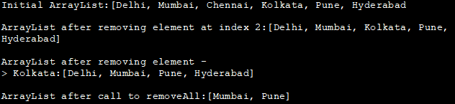

ArrayList size (Length)
Prototype: int size ()
Parameters: NIL
Return Value: int=> Number of elements in the ArrayList.
Description: Returns the total number of elements or the length of the ArrayList.
EnsureCapacity
Prototype: void ensureCapacity (int minCapacity)
Parameters: minCapacity=> The minimum capacity desired for the ArrayList.
Return Value: void
Description: Increases the capacity of the ArrayList to ensure that it has the minCapacity.
trimToSize
Prototype: void trimToSize()
Parameters: NIL
Return Value: void
Description: Trims the ArrayList capacity to the size or number of elements present in the list.
The below programming example demonstrates the methods size (), ensureCapacity () and trimToSize ().
import java.util.ArrayList;
public class Main
{
public static void main(String [] args)
{
//Create and initialize Arraylist
ArrayList<Integer> evenList=new ArrayList<Integer>(5);
System.out.println("Initial size: "+evenList.size());
evenList.add(2);
evenList.add(4);
evenList.add(6);
evenList.add(8);
evenList.add(10);
//print the list and size
System.out.println("Original List: " + evenList);
System.out.println("ArrayList Size after add operation: "+evenList.size());
//call ensureCapacity () with minimum capacity =10
evenList.ensureCapacity(10);
//add two more elements
evenList.add(12);
evenList.add(14);
//print the size again
System.out.println("ArrayList Size after ensureCapacity() call and add operation: "+evenList.size());
//call trimToSize()
evenList.trimToSize();
//print the size and the ArrayList
System.out.println("ArrayList Size after trimToSize() operation: "+evenList.size());
System.out.println("ArrayList final: ");
for(int num: evenList){
System.out.print(num + " ");
}
}
}
Output:
Initial size: 0
Original List: [2, 4, 6, 8, 10]
ArrayList Size after add operation: 5
ArrayList Size after ensureCapacity() call and add operation: 7
ArrayList Size after trimToSize() operation: 7
ArrayList final:
2 4 6 8 10 12 14
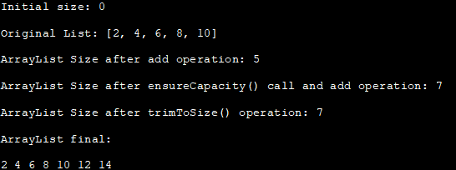

ArrayList contains
Prototype: boolean contains (Object o)
Parameters: o=> Element which is to be checked if present in the ArrayList.
Return Value: true=> If the ArrayList contains element o.
Description: Checks if the list contains the given element ‘o’. Returns true if the element is present.
We make use of the ‘contains’ method in the following program.
import java.util.ArrayList;
public class Main {
public static void main(String[] args) {

//create and initialize colorsList
ArrayList<String> colorsList = new ArrayList<String>();
colorsList.add("Red");
colorsList.add("Green");
colorsList.add("Blue");
colorsList.add("White");

//call contains method to check if different strings are present in ArrayList
System.out.println("ArrayList contains ('Red Green'): "
+colorsList.contains("Red Green"));
System.out.println("ArrayList contains ('Blue'): "
+colorsList.contains("Blue"));
System.out.println("ArrayList contains ('Yellow'): "
+colorsList.contains("Yellow"));
System.out.println("ArrayList contains ('White'): "
+colorsList.contains("White"));
}
}
Output:
ArrayList contains (‘Red Green’): false
ArrayList contains (‘Blue’): true
ArrayList contains (‘Yellow’): false
ArrayList contains (‘White’): true
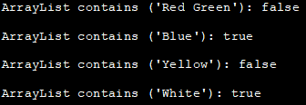
As shown in the above output, the ‘contains’ method checks if the argument provided is present in the ArrayList and returns true or false.

ArrayList get
Prototype: E get (int index)
Parameters: index=> Index at which element is to be retrieved from the ArrayList.
Return Value: E=> Element value at the given index in the ArrayList.
Description: Returns the element in the list present at the position specified by ‘index’.
Exceptions: IndexOutOfBoundsException => If index is out of bounds.

ArrayList set (Replace element)
Prototype: E set (int index, E element)
Parameters: index=> Index at which the element is to be replaced.
Element=> New element to be set at the index specified.
Return Value: E => Element that is replaced by the set operation.
Description: Sets the element value at the given ‘index’ to the new value given by ‘element’.
Exceptions: IndexOutOfBoundsException => If index is out of bounds
The Java program below uses get () and set () method to retrieve and replace values in the ArrayList.
import java.util.ArrayList;
public class Main {
public static void main(String[] args) {
//create and initialize colorsList
ArrayList<String> colorsList = new ArrayList<String>();
colorsList.add("Red");
colorsList.add("Green");
colorsList.add("Blue");
colorsList.add("White");
//call get () method to retrieve value at index 2
System.out.println("Entry at index 2 before call to set: " + colorsList.get(2));

//replace the value at index 2 with new value
colorsList.set(2,"Yellow");

//print the value at index 2 again
System.out.println("Entry at index 2 after call to set: " + colorsList.get(2));
}
}
Output:
Entry at index 2 before call to set: Blue
Entry at index 2 after call to set: Yellow
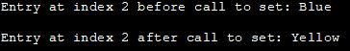

ArrayList clear
Prototype: void clear ()
Parameters: NIL
Return Value: void
Description: Clears the list by removing all the elements from the list.

ArrayList isEmpty
Prototype: boolean isEmpty ()
Parameters: NIL
Return Value: true=> if list is empty
Description: Checks if the given list is empty.
Clear () and isEmpty () functions are demonstrated below.
import java.util.ArrayList;
public class Main {
public static void main(String[] args) {

//create and initialize colorsList
ArrayList<String> colorsList = new ArrayList<String>();
colorsList.add("Red");
colorsList.add("Green");
colorsList.add("Blue");
colorsList.add("White");
//print the ArrayList
System.out.println("The ArrayList: " + colorsList);
//call clear() nethod on ArrayList
colorsList.clear();
//check if ArrayList is empty using isEmpty() method
System.out.println("Is ArrayList empty after clear ()? :" + colorsList.isEmpty());
}
}
Output:
The ArrayList: [Red, Green, Blue, White]
Is ArrayList empty after clear ()? :true
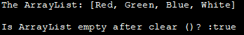

ArrayList indexOf
Prototype: int indexOf (Object o)
Parameters: o=> Element whose index is to be found in the ArrayList.
Return Value: int => Index of the first occurrence of the element in the list.
Description: Returns the index of the first occurrence of the element o in the list. -1 if the element o is not present in the list.

ArrayList lastIndexOf
Prototype: int lastIndexOf (Object o)
Parameters: o=> The element to be searched for.
Return Value: int=> Index of the last occurrence of the element in the list.
Description: Returns the index of the last occurrence of the specified element o in the list. -1 if the element is not present in the list.
The below Java program demonstrates the indexOf and lastIndexOf methods of ArrayList.
import java.util.ArrayList;
public class Main {
public static void main(String[] args) {

//create and initialize intList
ArrayList<Integer> intList = new ArrayList<Integer>();
intList.add(1);
intList.add(1);
intList.add(2);
intList.add(3);
intList.add(5);
intList.add(3);
intList.add(2);
intList.add(1);
intList.add(1);

//print the ArrayList
System.out.println("The ArrayList: " + intList);
//call indexOf() and lastIndexOf() methods to check the indices of specified elements
System.out.println("indexOf(1) : " + intList.indexOf(1));
System.out.println("lastIndexOf(1) : " + intList.lastIndexOf(1));
System.out.println("indexOf(2) : " + intList.indexOf(2));
System.out.println("lastIndexOf(2) : " + intList.lastIndexOf(2));
System.out.println("indexOf(3) : " + intList.indexOf(3));
System.out.println("lastIndexOf(3) : " + intList.lastIndexOf(3));
System.out.println("indexOf(5) : " + intList.indexOf(5));
System.out.println("lastIndexOf(5) : " + intList.lastIndexOf(5));
}
}
Output:
The ArrayList: [1, 1, 2, 3, 5, 3, 2, 1, 1]
indexOf(1) : 0
lastIndexOf(1) : 8
indexOf(2) : 2
lastIndexOf(2) : 6
indexOf(3) : 3
lastIndexOf(3) : 5
indexOf(5) : 4
lastIndexOf(5) : 4
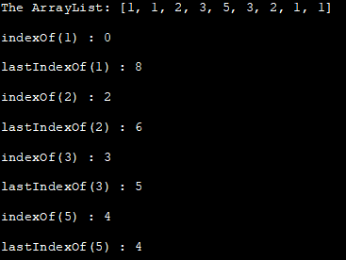

ArrayList toArray
Prototype: Object [] toArray ()
Parameters: NIL
Return Value: Object [] =>an array. This returned array contains all the elements of the list in a proper sequence.
Description: Converts the given list into an array.
Prototype: <T> T[] toArray (T[] a)
Parameters: a=> Array to store elements of the list. If the size of the array is not enough for list elements, another array with the same type as a is created for storing elements.
Return Value: T[] => Array that contains all the list elements.
Description: Converts the given list into an array of the type given by a.
Exceptions: ArrayStoreException => If there is a mismatch in runtime type of the array and runtime type or supertype of its elements.
NullPointerException => The given array is null
The Java program below demonstrates the toArray method of ArrayList.
import java.util.*;
public class Main {
public static void main(String[] args) {
// define and initialize ArrayList
ArrayList<Integer> intList = new ArrayList<Integer>();
intList.add(10);
intList.add(20);
intList.add(30);
intList.add(40);
intList.add(50);

// print ArrayList
System.out.println("ArrayList: " + intList);

//declare array
Integer myArray[] = new Integer[intList.size()];
//use toArray method to convert ArrayList to Array
myArray = intList.toArray(myArray);
//print the Array
System.out.println("Array from ArrayList:" + Arrays.toString(myArray));
}
}
Output:
ArrayList: [10, 20, 30, 40, 50]
Array from ArrayList:[10, 20, 30, 40, 50]

ArrayList clone
Prototype: Object clone ()
Parameters: NIL
Return Value: Object=> Clone of the ArrayList instance.
Description: Makes a shallow copy of the given ArrayList.
import java.util.ArrayList;
public class Main {
public static void main(String a[]){
ArrayList<String> fruitsList = new ArrayList<String>();

//Adding elements to the ArrayList
fruitsList.add("Apple");
fruitsList.add("Orange");
fruitsList.add("Melon");
fruitsList.add("Grapes");
System.out.println("Original ArrayList: "+fruitsList);

ArrayList<String> clone_list = (ArrayList<String>)fruitsList.clone();
System.out.println("Cloned ArrayList: "+ clone_list);

//add one elmeent & remove one element from original arraylist
fruitsList.add("Mango");
fruitsList.remove("Orange");

//print original and cloned ArrayList again
System.out.println("\nOriginal ArrayList after add & remove:"+fruitsList);
System.out.println("Cloned ArrayList after original changed:"+clone_list);
}
}
Output:
Original ArrayList: [Apple, Orange, Melon, Grapes]
Cloned ArrayList: [Apple, Orange, Melon, Grapes]
Original ArrayList after add & remove:[Apple, Melon, Grapes, Mango]
Cloned ArrayList after original changed:[Apple, Orange, Melon, Grapes]

From the above program output, you can see that the cloned ArrayList is a shallow copy of the original ArrayList. This means that when the original ArrayList is changed, these changes do not reflect in the cloned ArrayList as they do not share the memory locations of each element.
For making a deep copy of Array, the original ArrayList needs to be traversed and each of its elements needs to be copied to the destination ArrayList.

ArrayList subList
Prototype: List<E> subList (int fromIndex, int toIndex)
Parameters: fromIndex=> Starting index of the range (inclusive)
toIndex=> End index of the range (exclusive)
Return Value: List<E> => Sublist of the list in the given range.
Description: Returns a subList between a given range, fromIndex to index for the given list. Note that this sublist or the view of the list in the given range supports all the operations supported by the list. No view is returned if fromIndex = toIndex.
Exceptions: IndexOutOfBoundsException => Thrown when toIndex is out of range.
IllegalArgumentException=> If fromIndex > toIndex i.e. indices are out of order.
Let us see an example of the subList method.
import java.util.ArrayList;
import java.util.List;
class Main{
public static void main(String a[]){
//create and initialize the ArrayList
ArrayList<Integer> intList = new ArrayList<Integer>();
intList.add(5);
intList.add(10);
intList.add(15);
intList.add(20);
intList.add(25);
intList.add(30);
intList.add(35);
intList.add(40);
intList.add(45);
intList.add(50);

//print the ArrayList
System.out.println("Original ArrayList: "+intList);

//create a sublist for the given ArrayList
ArrayList<Integer> sub_ArrayList = new ArrayList<Integer>(intList.subList(2, 6));
//print the sublist
System.out.println("Sublist of given ArrayList: "+sub_ArrayList);
}
}
Output:
Original ArrayList: [5, 10, 15, 20, 25, 30, 35, 40, 45, 50]
Sublist of given ArrayList: [15, 20, 25, 30]
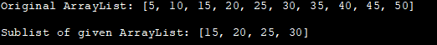

ArrayList retainAll
Prototype: boolean retainAll (Collection<?> c)
Parameters: c=> Collection with elements that are to be retained in the list.
Return Value: true=> If the ArrayList changed as a result of the operation.
Description: Retains those elements in the list that match the elements in the given collection c.
Exceptions: ClassCastException => The collection type and list type do not match
NullPointerException => Given collection is null or the list contains null element and collection does not permit nulls.
The following program demonstrates the retainAll method.
import java.util.*;
class Main{
public static void main(String args[]){
//create and initialize ArrayList
ArrayList<String> colorsList=new ArrayList<String>();
colorsList.add("Red");
colorsList.add("Green");
colorsList.add("Blue");
colorsList.add("Yellow");
//print the ArrayList
System.out.println("Original ArrayList:" + colorsList);

//define another collection
ArrayList<String> color_collection=new ArrayList<String>();
color_collection.add("Red");
color_collection.add("Blue");
System.out.println("Collection elements to be retained in the list:" + color_collection);

//call retainAll method with above collection as an argument
colorsList.retainAll(color_collection);
//print the ArrayList after retainAll call.
System.out.println("ArrayList after retainAll call:" + colorsList);
}
}
Output:
Original ArrayList:[Red, Green, Blue, Yellow]
Collection elements to be retained in the list:[Red, Blue]
ArrayList after retainAll call:[Red, Blue]
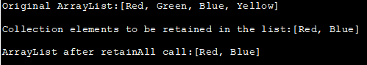

ArrayList Iterator
Prototype: Iterator<E> iterator ()
Parameters: NIL
Return Value: Iterator <E> => iterator over the list elements.
Description: Returns an iterator to traverse over the list elements in the proper sequence.

ArrayList listIterator
I.
Prototype: ListIterator<E> listIterator ()
Parameters: NIL
Return Value: ListIterator <E> => listIterator over the list elements.
Description: Returns list iterator to traverse over the elements of the given list.
II.
Prototype: ListIterator<E> listIterator (int index)
Parameters: index=> Position of the first element in the listIterator.
Return Value: ListIterator<E> => ListIterator for the list from specified index.
Description: Returns the list iterator starting from the specified position ‘index’ to traverse over the elements of the given list.
Exceptions: IndexOutOfBoundsException => Given index is out of range.
Example of iterator () and listIterator () methods.
import java.util.*;
class Main{
public static void main(String args[]){
//create ArrayList and initialize it
ArrayList<String> cities=new ArrayList<String>();
cities.add("Mumbai");
cities.add("Pune");
cities.add("Hyderabad");
cities.add("Delhi");

//use iterator() method to traverse through the list
System.out.println("List contents using Iterator () method:");
Iterator iter=cities.iterator();
while(iter.hasNext()){
System.out.print(iter.next() + " ");
}

//use listIterator() method to traverse through the list
System.out.println("\n\nList contents using listIterator () method:");
ListIterator<String> list_iter=cities.listIterator();
while(list_iter.hasNext()) {
System.out.print(list_iter.next() + " ");
}
}
}
Output:
List contents using Iterator () method:
Mumbai Pune Hyderabad Delhi
List contents using listIterator () method:
Mumbai Pune Hyderabad Delhi
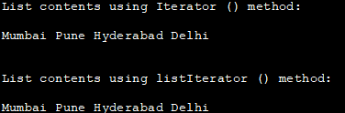

Add Array To ArrayList In Java
ArrayList supports the addAll method to add elements of the collection to the ArrayList. In a similar manner, you can also add an Array to the ArrayList. This is done using the ‘Collections.addAll’ method.
Example of adding an Array to the ArrayList.
import java.util.*;
class Main{
public static void main(String args[]){
//create an ArrayList
ArrayList<String> city_List=new ArrayList<String>();
//add elements to the ArrayList using add method
city_List.add("Delhi");
city_List.add("Mumbai");
city_List.add("Chennai");
city_List.add("Kolkata");
//print ArrayList
System.out.println("\nInitial ArrayList :" + city_List);

//define an array.
String[] myArray = new String[]{"Cochin", "Goa"};
//add the array to the ArrayList
Collections.addAll(city_List,myArray);

//print the ArrayList
System.out.println("\nArrayList after adding array :" + city_List);
}
}
Output:
Initial ArrayList :[Delhi, Mumbai, Chennai, Kolkata]
ArrayList after adding array :[Delhi, Mumbai, Chennai, Kolkata, Cochin, Goa]
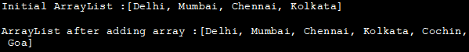

Sort ArrayList In Java
ArrayList uses the Collections.sort method to sort its elements. By default, the list is sorted in ascending order by the Collections.sort method. If the ArrayList is to be sorted in descending order, then you have to provide ‘Collections.reverseOrder()’ a parameter to the sort method.
Given below is a program to sort an ArrayList in ascending and descending order:
import java.util.*;
public class Main {
public static void main(String args[]){
//Create and initialize an ArrayList
ArrayList<String> colorsList = new ArrayList<String>();
colorsList.add("Red");
colorsList.add("Green");
colorsList.add("Blue");
colorsList.add("Yellow");

//print initial ArrayList
System.out.println("Initial ArrayList:" + colorsList);

//sort ArrayList in ascending order
Collections.sort(colorsList);

//print sorted ArrayList
System.out.println("\nArrayList sorted in ascending order:");
System.out.println(colorsList);

//sort ArrayList in reverse(desending) order
Collections.sort(colorsList, Collections.reverseOrder());

//print sorted list
System.out.println("\nArrayList sorted in descending order:");
System.out.println(colorsList);
}
}
Output:
Initial ArrayList:[Red, Green, Blue, Yellow]
ArrayList sorted in ascending order:
[Blue, Green, Red, Yellow]
ArrayList sorted in descending order:
[Yellow, Red, Green, Blue]
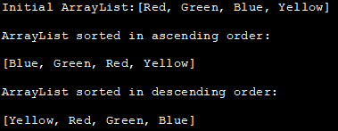
In case the ArrayList contains other class objects as elements, then you can make use of Comparable and Comparator interfaces. More details about interfaces will be covered in our later tutorials.

Reverse An ArrayList In Java
You can also reverse an ArrayList in Java. One method to do this is to use the traditional method of traversing the ArrayList in the reverse order and copy each element to a new ArrayList.
Another method is using the Collections class which provides the ‘reverse’ method that is used to reverse a collection.
The program to reverse an ArrayList using the Collections class is given below.
import java.io.*;
import java.util.*;

public class Main {
public static void main(String[] args)
{
// create and initialize an ArrayList
ArrayList<Integer> oddList = new ArrayList<Integer>();
oddList.add(1);
oddList.add(3);
oddList.add(5);
oddList.add(7);
oddList.add(9);
System.out.print("Initial ArrayList: " + oddList);

// use Collections.reverse method to reverse the ArrayList
Collections.reverse(oddList);
//print the ArrayList
System.out.print("\nReversed ArrayList: " + oddList);
}
}
Output:
Initial ArrayList: [1, 3, 5, 7, 9]
Reversed ArrayList: [9, 7, 5, 3, 1]
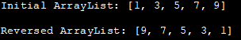

Remove Duplicates From An ArrayList In Java
To remove duplicates from the ArrayList, you can once again resort to the traditional method of using an iterator to traverse through the ArrayList and store only the first occurrence of the element into a different ArrayList.
Yet another method is by using the ‘distinct ()’ method of stream () class. This method returns a stream of distinct elements. The stream () feature is available in Java from Java 8 onwards.
The implementation of stream ().distinct () method is given below:
import java.util.*;
import java.util.stream.Collectors;

public class Main {
public static void main(String[] args) {
// Create an ArrayList of numbers
ArrayList<Integer> numList = new ArrayList<>
(Arrays.asList(1, 2, 3, 1, 3, 5, 5, 6, 6, 7, 7, 8, 8));

//print the original ArrayList
System.out.println("Original ArrayList:" + numList);

//Use Java 8 stream().distinct() method to remove duplicates from the list
List<Integer> distinctList = numList.stream().distinct().collect(Collectors.toList());
//print the new list
System.out.println("ArrayList without duplicates:" + distinctList);
}
}
Output:
Original ArrayList:[1, 2, 3, 1, 3, 5, 5, 6, 6, 7, 7, 8, 8]
ArrayList without duplicates:[1, 2, 3, 5, 6, 7, 8]
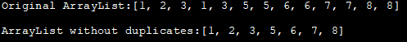

Shuffle (Randomize) An ArrayList In Java
You can also ‘shuffle’ or randomize the ArrayList elements. This is done using the Collections.shuffle () method. Using this method, either you can shuffle the ArrayList with default settings or provide a random () function that will randomize the elements according to the random value provided.
A Java program to achieve this is given below.
import java.util.*;

public class Main {
public static void main(String[] args)
{
//create and initialize a String ArrayList
ArrayList<String> strlist = new ArrayList<String>();
strlist.add("east");
strlist.add("west");
strlist.add("north");
strlist.add("south");
strlist.add("southwest");
strlist.add("northeast");
//print the original list
System.out.println("Original ArrayList : \n" + strlist);

//shuffle the ArrayList without random function
Collections.shuffle(strlist);
System.out.println("\nShuffled ArrayList without Random() : \n"
+ strlist);

// shuffle the ArrayList with random() function
Collections.shuffle(strlist, new Random());
System.out.println("\nShuffled ArrayList with Random() : \n" + strlist);

// use random (2) to shuffle the ArrayList
Collections.shuffle(strlist, new Random(2));
System.out.println("\nShuffled ArrayList with Random(2) : \n" + strlist);
}
}
Output:
Original ArrayList :[east, west, north, south, southwest, northeast] Shuffled ArrayList without Random() :[north, northeast, east, southwest, south, west]
Shuffled ArrayList with Random() :[south, east, north, northeast, west, southwest]
Shuffled ArrayList with Random(2) :[southwest, south, east, northeast, north, west]
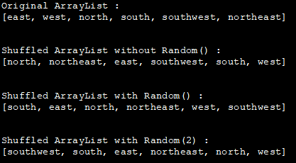

Set Interface

The set is an interface available in the java.util package. The set interface extends the Collection interface. An unordered collection or list in which duplicates are not allowed is referred to as a collection interface. The set interface is used to create the mathematical set. The set interface use collection interface's methods to avoid the insertion of the same elements. SortedSet and NavigableSet are two interfaces that extend the set implementation.
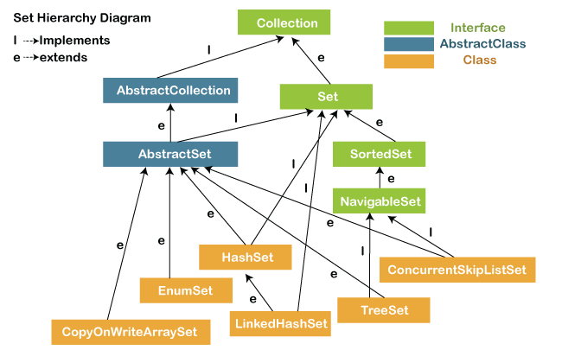

In the above diagram, the NavigableSet and SortedSet are both the interfaces. The NavigableSet extends the SortedSet, so it will not retain the insertion order and store the data in a sorted way.

SetExample1.java
- import java.util.*;
- public class setExample{
- public static void main(String[] args)
- {
- // creating LinkedHashSet using the Set
- Set<String> data = new LinkedHashSet<String>();

- data.add("JavaTpoint");
- data.add("Set");
- data.add("Example");
- data.add("Set");

- System.out.println(data);
- }
- }
Output:
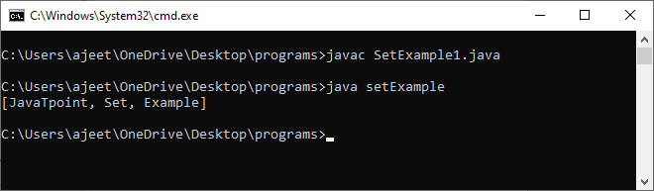

Note: Throughout the section, we have compiled the program with file name and run the program with class name. Because the file name and the class name are different.

Operations on the Set Interface
On the Set, we can perform all the basic mathematical operations like intersection, union and difference.
Suppose, we have two sets, i.e., set1 = [22, 45, 33, 66, 55, 34, 77] and set2 = [33, 2, 83, 45, 3, 12, 55]. We can perform the following operation on the Set:
- Intersection: The intersection operation returns all those elements which are present in both the set. The intersection of set1 and set2 will be [33, 45, 55].
- Union: The union operation returns all the elements of set1 and set2 in a single set, and that set can either be set1 or set2. The union of set1 and set2 will be [2, 3, 12, 22, 33, 34, 45, 55, 66, 77, 83].
- Difference: The difference operation deletes the values from the set which are present in another set. The difference of the set1 and set2 will be [66, 34, 22, 77].
In set, addAll() method is used to perform the union, retainAll() method is used to perform the intersection and removeAll() method is used to perform difference. Let's take an example to understand how these methods are used to perform the intersection, union, and difference operations.

SetExample2.java
- import java.util.*;
- public class SetOperations
- {
- public static void main(String args[])
- {
- Integer[] A = {22, 45,33, 66, 55, 34, 77};
- Integer[] B = {33, 2, 83, 45, 3, 12, 55};
- Set<Integer> set1 = new HashSet<Integer>();
- set1.addAll(Arrays.asList(A));
- Set<Integer> set2 = new HashSet<Integer>();
- set2.addAll(Arrays.asList(B));

- // Finding Union of set1 and set2
- Set<Integer> union_data = new HashSet<Integer>(set1);
- union_data.addAll(set2);
- System.out.print("Union of set1 and set2 is:");
- System.out.println(union_data);

- // Finding Intersection of set1 and set2
- Set<Integer> intersection_data = new HashSet<Integer>(set1);
- intersection_data.retainAll(set2);
- System.out.print("Intersection of set1 and set2 is:");
- System.out.println(intersection_data);

- // Finding Difference of set1 and set2
- Set<Integer> difference_data = new HashSet<Integer>(set1);
- difference_data.removeAll(set2);
- System.out.print("Difference of set1 and set2 is:");
- System.out.println(difference_data);
- }
- }
Output:
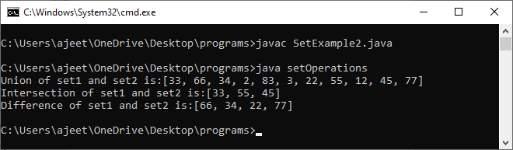

Description:
In the above code, first, we create two arrays, i.e., A and B of type integer. After that, we create two set, i.e., set1 and set2 of type integer. We convert both the array into a list and add the elements of array A into set1 and elements of array B into set2.
For performing the union, we create a new set union_data with the same element of the set1. We then call the addAll() method of set and pass the set2 as an argument to it. This method will add all those elements to the union_data which are not present in it and gives the union of both sets.
For performing the intersection, we create a new set intersection_data with the same element of the set1. We then call the retainAll() method of set and pass the set2 as an argument to it. This method will get all those elements from the intersection_data which are present in set2 and store it in the intersection_data. Now, the intersection_data contains the intersect value of both the sets.
For performing the difference, we create a new set difference_data with the same element of the set1. We then call the removeAll() method of set and pass the set2 as an argument to it. This method will remove all those elements from the difference_data which are present in the set2 and gives the difference of both the sets.

Set Methods
There are several methods available in the set interface which we can use to perform a certain operation on our sets. These methods are as follows:

1) add()
The add() method insert a new value to the set. The method returns true and false depending on the presence of the insertion element. It returns false if the element is already present in the set and returns true if it is not present in the set.
Syntax:
- boolean add(type element).
SetExample3.java
- import java.io.*;
- import java.util.*;
- public class addMethod {
- public static void main(String args[])
- {
- Set<Integer> data = new LinkedHashSet<Integer>();
- data.add(31);
- data.add(21);
- data.add(41);
- data.add(11);
- data.add(61);
- data.add(51);
- System.out.println("data: " + data);
- }
- }
Output:
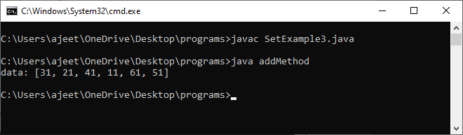

2) addAll()
The addAll() method appends all the elements of the specified collection to the set.
Syntax:
- boolean addAll(Collection data)
SetExample4.java
- import java.io.*;
- import java.util.*;
- class addAllMethod {
- public static void main(String args[])
- {
- Set<Integer> data = new LinkedHashSet<Integer>();
- data.add(31);
- data.add(21);
- data.add(41);
- System.out.println("Set: " + data);
- ArrayList<Integer> newData = new ArrayList<Integer>();
- newData.add(91);
- newData.add(71);
- newData.add(81);
- data.addAll(newData);
- System.out.println("Set: " + data);
- }
- }
Output:
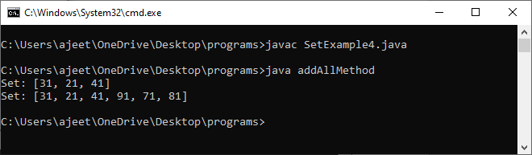

3) clear()
The method removes all the elements from the set. It doesn't delete the reference of the set. It only deletes the elements of the set.
Syntax:
- void clear()
SetExample5.java
- import java.io.*;
- import java.util.*;
- public class clearMethod {
- public static void main(String args[])
- {
- Set<Integer> data = new LinkedHashSet<Integer>();

- data.add(31);
- data.add(21);
- data.add(41);
- System.out.println("Set: " + data);

- data.clear();
- System.out.println("The final set: " + data);
- }
- }
Output:
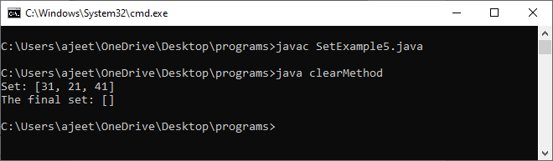

4) contains()
The contains() method is used to know the presence of an element in the set. Its return value is true or false depending on the presence of the element.
Syntax:
- boolean contains(Object element)
SetExample6.java
- import java.io.*;
- import java.util.*;
- class containsMethod {
- public static void main(String args[])
- {
- Set<Integer> data = new LinkedHashSet<Integer>();
- data.add(31);
- data.add(21);
- data.add(41);
- data.add(51);
- data.add(11);
- data.add(81);
- System.out.println("Set: " + data);
- System.out.println("Does the Set contains '91'?" + data.contains(91));
- System.out.println("Does the Set contains 'javaTpoint'? " + data.contains("4"));
- System.out.println("Does the Set contains '51'? " + data.contains(51));
- }
- }
Output:
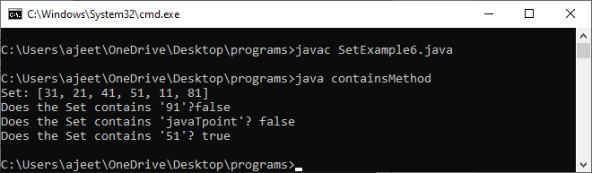

5) containsAll()
The method is used to check whether all the elements of the collection are available in the existing set or not. It returns true if all the elements of the collection are present in the set and returns false even if one of the elements is missing in the existing set.
Syntax:
- public boolean containsAll(Collection data)
SetExample7.java
- import java.io.*;
- import java.util.*;
- class containsAllMethod {
- public static void main(String args[])
- {
- Set<Integer> data = new LinkedHashSet<Integer>();
- data.add(31);
- data.add(21);
- data.add(41);
- data.add(51);
- data.add(11);
- data.add(81);

- System.out.println("data: " + data);

- Set<Integer> newData = new LinkedHashSet<Integer>();
- newData.add(31);
- newData.add(21);
- newData.add(41);

- System.out.println("\nDoes data contains newData?: "+ data.containsAll(newData));

- }
- }
Output:
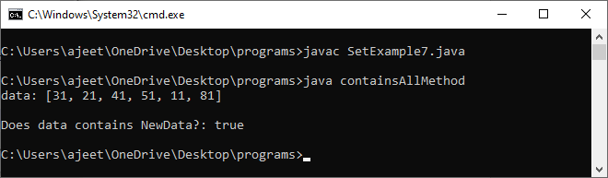

6) hashCode()
The method is used to derive the hash code value for the current instance of the set. It returns hash code value of integer type.
Syntax:
- public int hashCode()
SetExample8.java
- import java.io.*;
- import java.util.*;
- class hashCodeMethod {
- public static void main(String args[])
- {
- Set<Integer> data = new LinkedHashSet<Integer>();
- data.add(31);
- data.add(21);
- data.add(41);
- data.add(51);
- data.add(11);
- data.add(81);
- System.out.println("data: " + data);
- System.out.println("\nThe hash code value of set is:"+ data.hashCode());
- }
- }
Output:
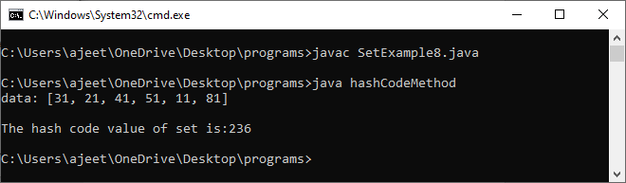

7) isEmpty()
The isEmpty() method is used to identify the emptiness of the set . It returns true if the set is empty and returns false if the set is not empty.
Syntax:
- boolean isEmpty()
SetExample9.java
- import java.io.*;
- import java.util.*;
- class isEmptyMethod {
- public static void main(String args[])
- {
- Set<Integer> data = new LinkedHashSet<Integer>();
- data.add(31);
- data.add(21);
- data.add(41);
- data.add(51);
- data.add(11);
- data.add(81);
- System.out.println("data: " + data);
- System.out.println("\nIs data empty?: "+ data.isEmpty());
- }
- }
Output:
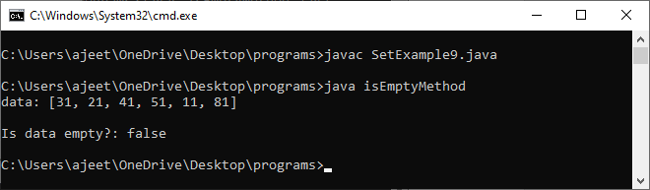

8) iterator()
The iterator() method is used to find the iterator of the set. The iterator is used to get the element one by one.
Syntax:
- Iterator iterate_value = set1.iterator();
SetExample10.java
- import java.io.*;
- import java.util.*;
- class iteratorMethod {
- public static void main(String args[])
- {
- Set<Integer> data = new LinkedHashSet<Integer>();
- data.add(31);
- data.add(21);
- data.add(41);
- data.add(51);
- data.add(11);
- data.add(81);
- System.out.println("data: " + data);

- Iterator newData = data.iterator();
- System.out.println("The NewData values are: ");
- while (newData.hasNext()) {
- System.out.println(newData.next());
- }
- }
- }
Output:
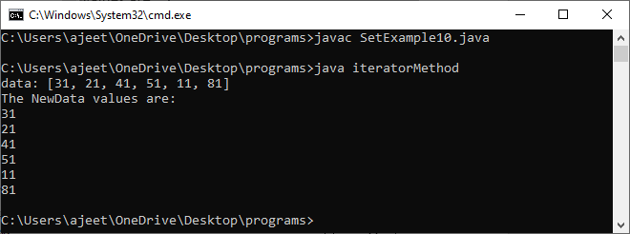

9) remove()
The method is used to remove a specified element from the Set. Its return value depends on the availability of the element. It returns true if the element is available in the set and returns false if it is unavailable in the set.
Syntax:
- boolean remove(Object O)
SetExample11.java
- import java.io.*;
- import java.util.*;
- class removeMethod {
- public static void main(String args[])
- {
- Set<Integer> data = new LinkedHashSet<Integer>();
- data.add(31);
- data.add(21);
- data.add(41);
- data.add(51);
- data.add(11);
- data.add(81);
- System.out.println("data: " + data);

- data.remove(81);
- data.remove(21);
- data.remove(11);
- System.out.println("data after removing elements: " + data);
- }
- }
Output:
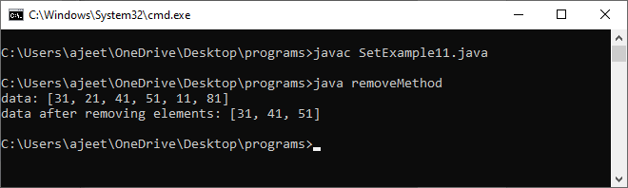

11) removeAll()
The method removes all the elements of the existing set from the specified collection.
Syntax:
- public boolean removeAll(Collection data)
SetExample12.java
- import java.io.*;
- import java.util.*;
- class removeAllMethod {
- public static void main(String args[])
- {
- Set<Integer> data = new LinkedHashSet<Integer>();
- data.add(31);
- data.add(21);
- data.add(41);
- data.add(91);
- data.add(71);
- data.add(81);
- System.out.println("data: " + data);

- ArrayList<Integer> newData = new ArrayList<Integer>();
- newData.add(91);
- newData.add(71);
- newData.add(81);
- System.out.println("NewData: " + newData);

- data.removeAll(newData);
- System.out.println("data after removing Newdata elements : " + data);
- }
- }
Output:
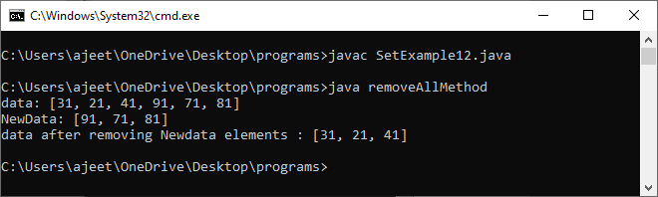

11) retainAll()
The method retains all the elements from the set specified in the given collection.
Syntax:
- public boolean retainAll(Collection data)
SetExample13.java
- import java.io.*;
- import java.util.*;
- class retainAllMethod {
- public static void main(String args[])
- {
- Set<Integer> data = new LinkedHashSet<Integer>();
- data.add(31);
- data.add(21);
- data.add(41);
- data.add(91);
- data.add(71);
- data.add(81);
- System.out.println("data: " + data);

- ArrayList<Integer> newData = new ArrayList<Integer>();
- newData.add(91);
- newData.add(71);
- newData.add(81);
- System.out.println("newData: " + newData);

- data.retainAll(newData);
- System.out.println("data after retaining newdata elements : " + data);
- }
- }
Output:
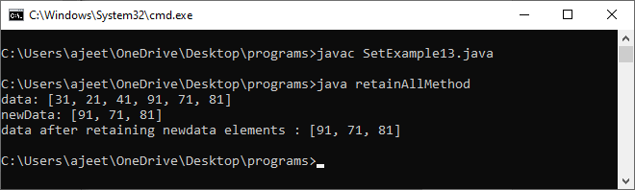

12) size()
The method returns the size of the set.
Syntax:
- int size()
SetExample14.java
- import java.io.*;
- import java.util.*;
- class sizeMethod {
- public static void main(String args[])
- {
- Set<Integer> data = new LinkedHashSet<Integer>();
- data.add(31);
- data.add(21);
- data.add(41);
- data.add(91);
- data.add(71);
- data.add(81);
- System.out.println("data: " + data);

- System.out.println("size of the data is : " + data.size());
- }
- }
Output:
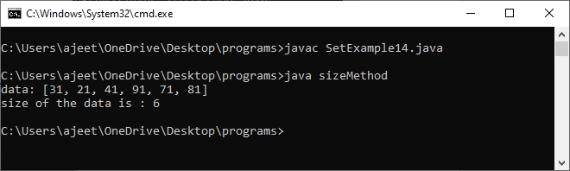

13) removeAll()
The method is used to create an array with the same elements of the set.
Syntax:
- Object[] toArray()
SetExample15.java
- import java.io.*;
- import java.util.*;
- class toArrayMethod {
- public static void main(String args[])
- {
- Set<Integer> data = new LinkedHashSet<Integer>();
- data.add(31);
- data.add(21);
- data.add(41);
- data.add(91);
- data.add(71);
- data.add(81);
- System.out.println("data: " + data);

- Object[] array_data = data.toArray();
- System.out.println("The array is:");
- for (int i = 0; i < array_data.length; i++)
- System.out.println(array_data[i]);
- }
- }
Output:
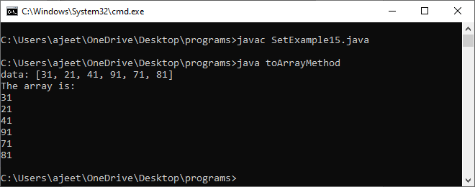

Linked Hash Set

Java LinkedHashSet class is a Hashtable and Linked list implementation of the Set interface. It inherits the HashSet class and implements the Set interface.
The important points about the Java LinkedHashSet class are:
- Java LinkedHashSet class contains unique elements only like HashSet.
- Java LinkedHashSet class provides all optional set operations and permits null elements.
- Java LinkedHashSet class is non-synchronized.
- Java LinkedHashSet class maintains insertion order.

Note: Keeping the insertion order in the LinkedHashset has some additional costs, both in terms of extra memory and extra CPU cycles. Therefore, if it is not required to maintain the insertion order, go for the lighter-weight HashMap or the HashSet instead.

Hierarchy of LinkedHashSet class
The LinkedHashSet class extends the HashSet class, which implements the Set interface. The Set interface inherits Collection and Iterable interfaces in hierarchical order.

LinkedHashSet Class Declaration
Let's see the declaration for java.util.LinkedHashSet class.
- public class LinkedHashSet<E> extends HashSet<E> implements Set<E>, Cloneable, Serializable

Constructors of Java LinkedHashSet Class
Constructor | Description
HashSet() | It is used to construct a default HashSet.
HashSet(Collection c) | It is used to initialize the hash set by using the elements of the collection c.
LinkedHashSet(int capacity) | It is used to initialize the capacity of the linked hash set to the given integer value capacity.
LinkedHashSet(int capacity, float fillRatio) | It is used to initialize both the capacity and the fill ratio (also called load capacity) of the hash set from its argument.

Java LinkedHashSet Example
Let's see a simple example of the Java LinkedHashSet class. Here you can notice that the elements iterate in insertion order.
FileName: LinkedHashSet1.java
- import java.util.*;
- class LinkedHashSet1{
- public static void main(String args[]){
- //Creating HashSet and adding elements
- LinkedHashSet<String> set=new LinkedHashSet();
- set.add("One");
- set.add("Two");
- set.add("Three");
- set.add("Four");
- set.add("Five");
- Iterator<String> i=set.iterator();
- while(i.hasNext())
- {
- System.out.println(i.next());
- }
- }
- }
Output:
One
Two
Three
Four
Five

Note: We can also use the enhanced for loop for displaying the elements.

Java LinkedHashSet example ignoring duplicate Elements
sFileName: LinkedHashSet2.java
- import java.util.*;
- class LinkedHashSet2{
- public static void main(String args[]){
- LinkedHashSet<String> al=new LinkedHashSet<String>();
- al.add("Ravi");
- al.add("Vijay");
- al.add("Ravi");
- al.add("Ajay");
- Iterator<String> itr=al.iterator();
- while(itr.hasNext()){
- System.out.println(itr.next());
- }
- }
- }
Output:
Ravi
Vijay
Ajay

Remove Elements Using LinkeHashSet Class
FileName: LinkedHashSet3.java
- import java.util.*;

- public class LinkedHashSet3
- {

- // main method
- public static void main(String argvs[])
- {

- // Creating an empty LinekdhashSet of string type
- LinkedHashSet<String> lhs = new LinkedHashSet<String>();

- // Adding elements to the above Set
- // by invoking the add() method
- lhs.add("Java");
- lhs.add("T");
- lhs.add("Point");
- lhs.add("Good");
- lhs.add("Website");

- // displaying all the elements on the console
- System.out.println("The hash set is: " + lhs);

- // Removing an element from the above linked Set

- // since the element "Good" is present, therefore, the method remove()
- // returns true
- System.out.println(lhs.remove("Good"));

- // After removing the element
- System.out.println("After removing the element, the hash set is: " + lhs);

- // since the element "For" is not present, therefore, the method remove()
- // returns false
- System.out.println(lhs.remove("For"));

- }
- }
Output:
The hash set is: [Java, T, Point, Good, Website]
true
After removing the element, the hash set is: [Java, T, Point, Website]
false

Java LinkedHashSet Example: Book
FileName: Book.java
- import java.util.*;
- class Book {
- int id;
- String name,author,publisher;
- int quantity;
- public Book(int id, String name, String author, String publisher, int quantity) {
- this.id = id;
- this.name = name;
- this.author = author;
- this.publisher = publisher;
- this.quantity = quantity;
- }
- }
- public class LinkedHashSetExample {
- public static void main(String[] args) {
- LinkedHashSet<Book> hs=new LinkedHashSet<Book>();
- //Creating Books
- Book b1=new Book(101,"Let us C","Yashwant Kanetkar","BPB",8);
- Book b2=new Book(102,"Data Communications & Networking","Forouzan","Mc Graw Hill",4);
- Book b3=new Book(103,"Operating System","Galvin","Wiley",6);
- //Adding Books to hash table
- hs.add(b1);
- hs.add(b2);
- hs.add(b3);
- //Traversing hash table
- for(Book b:hs){
- System.out.println(b.id+" "+b.name+" "+b.author+" "+b.publisher+" "+b.quantity);
- }
- }
- }
Output:
101 Let us C Yashwant Kanetkar BPB 8
102 Data Communications & Networking Forouzan Mc Graw Hill 4
103 Operating System Galvin Wiley 6

Tree Set

Java TreeSet class implements the Set interface that uses a tree for storage. It inherits AbstractSet class and implements the NavigableSet interface. The objects of the TreeSet class are stored in ascending order.
The important points about the Java TreeSet class are:
- Java TreeSet class contains unique elements only like HashSet.
- Java TreeSet class access and retrieval times are quiet fast.
- Java TreeSet class doesn't allow null element.
- Java TreeSet class is non synchronized.
- Java TreeSet class maintains ascending order.
- Java TreeSet class contains unique elements only like HashSet.
- Java TreeSet class access and retrieval times are quite fast.
- Java TreeSet class doesn't allow null elements.
- Java TreeSet class is non-synchronized.
- Java TreeSet class maintains ascending order.
- The TreeSet can only allow those generic types that are comparable. For example The Comparable interface is being implemented by the StringBuffer class.

Internal Working of The TreeSet Class
TreeSet is being implemented using a binary search tree, which is self-balancing just like a Red-Black Tree. Therefore, operations such as a search, remove, and add consume O(log(N)) time. The reason behind this is there in the self-balancing tree. It is there to ensure that the tree height never exceeds O(log(N)) for all of the mentioned operations. Therefore, it is one of the efficient data structures in order to keep the large data that is sorted and also to do operations on it.

Synchronization of The TreeSet Class
As already mentioned above, the TreeSet class is not synchronized. It means if more than one thread concurrently accesses a tree set, and one of the accessing threads modify it, then the synchronization must be done manually. It is usually done by doing some object synchronization that encapsulates the set. However, in the case where no such object is found, then the set must be wrapped with the help of the Collections.synchronizedSet() method. It is advised to use the method during creation time in order to avoid the unsynchronized access of the set. The following code snippet shows the same.
- TreeSet treeSet = new TreeSet();
- Set syncrSet = Collections.synchronziedSet(treeSet);

Hierarchy of TreeSet class
As shown in the above diagram, the Java TreeSet class implements the NavigableSet interface. The NavigableSet interface extends SortedSet, Set, Collection and Iterable interfaces in hierarchical order.

TreeSet Class Declaration
Let's see the declaration for java.util.TreeSet class.
- public class TreeSet<E> extends AbstractSet<E> implements NavigableSet<E>, Cloneable, Serializable

Constructors of Java TreeSet Class
Constructor | Description
TreeSet() | It is used to construct an empty tree set that will be sorted in ascending order according to the natural order of the tree set.
TreeSet(Collection<? extends E> c) | It is used to build a new tree set that contains the elements of the collection c.
TreeSet(Comparator<? super E> comparator) | It is used to construct an empty tree set that will be sorted according to given comparator.
TreeSet(SortedSet<E> s) | It is used to build a TreeSet that contains the elements of the given SortedSet.

Methods of Java TreeSet Class
Method | Description
boolean add(E e) | It is used to add the specified element to this set if it is not already present.
boolean addAll(Collection<? extends E> c) | It is used to add all of the elements in the specified collection to this set.
E ceiling(E e) | It returns the equal or closest greatest element of the specified element from the set, or null there is no such element.
Comparator<? super E> comparator() | It returns a comparator that arranges elements in order.
Iterator descendingIterator() | It is used to iterate the elements in descending order.
NavigableSet descendingSet() | It returns the elements in reverse order.
E floor(E e) | It returns the equal or closest least element of the specified element from the set, or null there is no such element.
SortedSet headSet(E toElement) | It returns the group of elements that are less than the specified element.
NavigableSet headSet(E toElement, boolean inclusive) | It returns the group of elements that are less than or equal to(if, inclusive is true) the specified element.
E higher(E e) | It returns the closest greatest element of the specified element from the set, or null there is no such element.
Iterator iterator() | It is used to iterate the elements in ascending order.
E lower(E e) | It returns the closest least element of the specified element from the set, or null there is no such element.
E pollFirst() | It is used to retrieve and remove the lowest(first) element.
E pollLast() | It is used to retrieve and remove the highest(last) element.
Spliterator spliterator() | It is used to create a late-binding and fail-fast spliterator over the elements.
NavigableSet subSet(E fromElement, boolean fromInclusive, E toElement, boolean toInclusive) | It returns a set of elements that lie between the given range.
SortedSet subSet(E fromElement, E toElement)) | It returns a set of elements that lie between the given range which includes fromElement and excludes toElement.
SortedSet tailSet(E fromElement) | It returns a set of elements that are greater than or equal to the specified element.
NavigableSet tailSet(E fromElement, boolean inclusive) | It returns a set of elements that are greater than or equal to (if, inclusive is true) the specified element.
boolean contains(Object o) | It returns true if this set contains the specified element.
boolean isEmpty() | It returns true if this set contains no elements.
boolean remove(Object o) | It is used to remove the specified element from this set if it is present.
void clear() | It is used to remove all of the elements from this set.
Object clone() | It returns a shallow copy of this TreeSet instance.
E first() | It returns the first (lowest) element currently in this sorted set.
E last() | It returns the last (highest) element currently in this sorted set.
int size() | It returns the number of elements in this set.

Java TreeSet Examples

Java TreeSet Example 1:
Let's see a simple example of Java TreeSet.
FileName: TreeSet1.java
- import java.util.*;
- class TreeSet1{
- public static void main(String args[]){
- //Creating and adding elements
- TreeSet<String> al=new TreeSet<String>();
- al.add("Ravi");
- al.add("Vijay");
- al.add("Ravi");
- al.add("Ajay");
- //Traversing elements
- Iterator<String> itr=al.iterator();
- while(itr.hasNext()){
- System.out.println(itr.next());
- }
- }
- }
Test it Now
Output:
Ajay
Ravi
Vijay

Java TreeSet Example 2:
Let's see an example of traversing elements in descending order.
FileName: TreeSet2.java
- import java.util.*;
- class TreeSet2{
- public static void main(String args[]){
- TreeSet<String> set=new TreeSet<String>();
- set.add("Ravi");
- set.add("Vijay");
- set.add("Ajay");
- System.out.println("Traversing element through Iterator in descending order");
- Iterator i=set.descendingIterator();
- while(i.hasNext())
- {
- System.out.println(i.next());
- }

- }
- }
Test it Now
Output:
Traversing element through Iterator in descending order
Vijay
Ravi
Ajay
Traversing element through NavigableSet in descending order
Vijay
Ravi
Ajay

Java TreeSet Example 3:
Let's see an example to retrieve and remove the highest and lowest Value.
FileName: TreeSet3.java
- import java.util.*;
- class TreeSet3{
- public static void main(String args[]){
- TreeSet<Integer> set=new TreeSet<Integer>();
- set.add(24);
- set.add(66);
- set.add(12);
- set.add(15);
- System.out.println("Lowest Value: "+set.pollFirst());
- System.out.println("Highest Value: "+set.pollLast());
- }
- }
Output:
Lowest Value: 12
Highest Value: 66

Java TreeSet Example 4:
In this example, we perform various NavigableSet operations.
FileName: TreeSet4.java
- import java.util.*;
- class TreeSet4{
- public static void main(String args[]){
- TreeSet<String> set=new TreeSet<String>();
- set.add("A");
- set.add("B");
- set.add("C");
- set.add("D");
- set.add("E");
- System.out.println("Initial Set: "+set);

- System.out.println("Reverse Set: "+set.descendingSet());

- System.out.println("Head Set: "+set.headSet("C", true));

- System.out.println("SubSet: "+set.subSet("A", false, "E", true));

- System.out.println("TailSet: "+set.tailSet("C", false));
- }
- }
Output:
Initial Set: [A, B, C, D, E]
Reverse Set: [E, D, C, B, A]
Head Set: [A, B, C]
SubSet: [B, C, D, E]
TailSet: [D, E]

Java TreeSet Example 5:
In this example, we perform various SortedSetSet operations.
FileName: TreeSet5.java
- import java.util.*;
- class TreeSet5{
- public static void main(String args[]){
- TreeSet<String> set=new TreeSet<String>();
- set.add("A");
- set.add("B");
- set.add("C");
- set.add("D");
- set.add("E");

- System.out.println("Intial Set: "+set);

- System.out.println("Head Set: "+set.headSet("C"));

- System.out.println("SubSet: "+set.subSet("A", "E"));

- System.out.println("TailSet: "+set.tailSet("C"));
- }
- }
Output:
Intial Set: [A, B, C, D, E]
Head Set: [A, B]
SubSet: [A, B, C, D]
TailSet: [C, D, E]

Java TreeSet Example: Book
Let's see a TreeSet example where we are adding books to the set and printing all the books. The elements in TreeSet must be of a Comparable type. String and Wrapper classes are Comparable by default. To add user-defined objects in TreeSet, you need to implement the Comparable interface.
FileName: TreeSetExample.java
- import java.util.*;
- class Book implements Comparable<Book>{
- int id;
- String name,author,publisher;
- int quantity;
- public Book(int id, String name, String author, String publisher, int quantity) {
- this.id = id;
- this.name = name;
- this.author = author;
- this.publisher = publisher;
- this.quantity = quantity;
- }
- // implementing the abstract method
- public int compareTo(Book b) {
- if(id>b.id){
- return 1;
- }else if(id<b.id){
- return -1;
- }else{
- return 0;
- }
- }
- }
- public class TreeSetExample {
- public static void main(String[] args) {
- Set<Book> set=new TreeSet<Book>();
- //Creating Books
- Book b1=new Book(121,"Let us C","Yashwant Kanetkar","BPB",8);
- Book b2=new Book(233,"Operating System","Galvin","Wiley",6);
- Book b3=new Book(101,"Data Communications & Networking","Forouzan","Mc Graw Hill",4);
- //Adding Books to TreeSet
- set.add(b1);
- set.add(b2);
- set.add(b3);
- //Traversing TreeSet
- for(Book b:set){
- System.out.println(b.id+" "+b.name+" "+b.author+" "+b.publisher+" "+b.quantity);
- }
- }
- }
Output:
101 Data Communications & Networking Forouzan Mc Graw Hill 4
121 Let us C Yashwant Kanetkar BPB 8
233 Operating System Galvin Wiley 6

Map in Java

A map contains values on the basis of key, i.e. key and value pair. Each key and value pair is known as an entry. A Map contains unique keys.
A Map is useful if you have to search, update or delete elements on the basis of a key.

Java Map Hierarchy
There are two interfaces for implementing Map in java: Map and SortedMap, and three classes: HashMap, LinkedHashMap, and TreeMap. The hierarchy of Java Map is given below:

A Map doesn't allow duplicate keys, but you can have duplicate values. HashMap and LinkedHashMap allow null keys and values, but TreeMap doesn't allow any null key or value.
PlayNext
Unmute
Current TimeÂ 0:00
/
DurationÂ 18:10
Loaded: 0.37%
Â
Fullscreen
Backward Skip 10sPlay VideoForward Skip 10s
A Map can't be traversed, so you need to convert it into Set using keySet() or entrySet() method.
Class | Description
HashMap | HashMap is the implementation of Map, but it doesn't maintain any order.
LinkedHashMap | LinkedHashMap is the implementation of Map. It inherits HashMap class. It maintains insertion order.
TreeMap | TreeMap is the implementation of Map and SortedMap. It maintains ascending order.

Useful methods of Map interface
Method | Description
V put(Object key, Object value) | It is used to insert an entry in the map.
void putAll(Map map) | It is used to insert the specified map in the map.
V putIfAbsent(K key, V value) | It inserts the specified value with the specified key in the map only if it is not already specified.
V remove(Object key) | It is used to delete an entry for the specified key.
boolean remove(Object key, Object value) | It removes the specified values with the associated specified keys from the map.
Set keySet() | It returns the Set view containing all the keys.
Set<Map.Entry<K,V>> entrySet() | It returns the Set view containing all the keys and values.
void clear() | It is used to reset the map.
V compute(K key, BiFunction<? super K,? super V,? extends V> remappingFunction) | It is used to compute a mapping for the specified key and its current mapped value (or null if there is no current mapping).
V computeIfAbsent(K key, Function<? super K,? extends V> mappingFunction) | It is used to compute its value using the given mapping function, if the specified key is not already associated with a value (or is mapped to null), and enters it into this map unless null.
V computeIfPresent(K key, BiFunction<? super K,? super V,? extends V> remappingFunction) | It is used to compute a new mapping given the key and its current mapped value if the value for the specified key is present and non-null.
boolean containsValue(Object value) | This method returns true if some value equal to the value exists within the map, else return false.
boolean containsKey(Object key) | This method returns true if some key equal to the key exists within the map, else return false.
boolean equals(Object o) | It is used to compare the specified Object with the Map.
void forEach(BiConsumer<? super K,? super V> action) | It performs the given action for each entry in the map until all entries have been processed or the action throws an exception.
V get(Object key) | This method returns the object that contains the value associated with the key.
V getOrDefault(Object key, V defaultValue) | It returns the value to which the specified key is mapped, or defaultValue if the map contains no mapping for the key.
int hashCode() | It returns the hash code value for the Map
boolean isEmpty() | This method returns true if the map is empty; returns false if it contains at least one key.
V merge(K key, V value, BiFunction<? super V,? super V,? extends V> remappingFunction) | If the specified key is not already associated with a value or is associated with null, associates it with the given non-null value.
V replace(K key, V value) | It replaces the specified value for a specified key.
boolean replace(K key, V oldValue, V newValue) | It replaces the old value with the new value for a specified key.
void replaceAll(BiFunction<? super K,? super V,? extends V> function) | It replaces each entry's value with the result of invoking the given function on that entry until all entries have been processed or the function throws an exception.
Collection values() | It returns a collection view of the values contained in the map.
int size() | This method returns the number of entries in the map.

Map.Entry Interface
Entry is the subinterface of Map. So we will be accessed it by Map.Entry name. It returns a collection-view of the map, whose elements are of this class. It provides methods to get key and value.

Methods of Map.Entry interface
Method | Description
K getKey() | It is used to obtain a key.
V getValue() | It is used to obtain value.
int hashCode() | It is used to obtain hashCode.
V setValue(V value) | It is used to replace the value corresponding to this entry with the specified value.
boolean equals(Object o) | It is used to compare the specified object with the other existing objects.
static <K extends Comparable<? super K>,V> Comparator<Map.Entry<K,V>> comparingByKey() | It returns a comparator that compare the objects in natural order on key.
static <K,V> Comparator<Map.Entry<K,V>> comparingByKey(Comparator<? super K> cmp) | It returns a comparator that compare the objects by key using the given Comparator.
static <K,V extends Comparable<? super V>> Comparator<Map.Entry<K,V>> comparingByValue() | It returns a comparator that compare the objects in natural order on value.
static <K,V> Comparator<Map.Entry<K,V>> comparingByValue(Comparator<? super V> cmp) | It returns a comparator that compare the objects by value using the given Comparator.

Java Map Example: Non-Generic (Old Style)
- //Non-generic
- import java.util.*;
- public class MapExample1 {
- public static void main(String[] args) {
- Map map=new HashMap();
- //Adding elements to map
- map.put(1,"Amit");
- map.put(5,"Rahul");
- map.put(2,"Jai");
- map.put(6,"Amit");
- //Traversing Map
- Set set=map.entrySet();//Converting to Set so that we can traverse
- Iterator itr=set.iterator();
- while(itr.hasNext()){
- //Converting to Map.Entry so that we can get key and value separately
- Map.Entry entry=(Map.Entry)itr.next();
- System.out.println(entry.getKey()+" "+entry.getValue());
- }
- }
- }
Output:
1 Amit
2 Jai
5 Rahul
6 Amit

Java Map Example: Generic (New Style)
- import java.util.*;
- class MapExample2{
- public static void main(String args[]){
- Map<Integer,String> map=new HashMap<Integer,String>();
- map.put(100,"Amit");
- map.put(101,"Vijay");
- map.put(102,"Rahul");
- //Elements can traverse in any order
- for(Map.Entry m:map.entrySet()){
- System.out.println(m.getKey()+" "+m.getValue());
- }
- }
- }
Output:
102 Rahul
100 Amit
101 Vijay

Java Map Example: comparingByKey()
- import java.util.*;
- class MapExample3{
- public static void main(String args[]){
- Map<Integer,String> map=new HashMap<Integer,String>();
- map.put(100,"Amit");
- map.put(101,"Vijay");
- map.put(102,"Rahul");
- //Returns a Set view of the mappings contained in this map
- map.entrySet()
- //Returns a sequential Stream with this collection as its source
- .stream()
- //Sorted according to the provided Comparator
- .sorted(Map.Entry.comparingByKey())
- //Performs an action for each element of this stream
- .forEach(System.out::println);
- }
- }
Output:
100=Amit
101=Vijay
102=Rahul

Java Map Example: comparingByKey() in Descending Order
- import java.util.*;
- class MapExample4{
- public static void main(String args[]){
- Map<Integer,String> map=new HashMap<Integer,String>();
- map.put(100,"Amit");
- map.put(101,"Vijay");
- map.put(102,"Rahul");
- //Returns a Set view of the mappings contained in this map
- map.entrySet()
- //Returns a sequential Stream with this collection as its source
- .stream()
- //Sorted according to the provided Comparator
- .sorted(Map.Entry.comparingByKey(Comparator.reverseOrder()))
- //Performs an action for each element of this stream
- .forEach(System.out::println);
- }
- }
Output:
102=Rahul
101=Vijay
100=Amit

Java Map Example: comparingByValue()
- import java.util.*;
- class MapExample5{
- public static void main(String args[]){
- Map<Integer,String> map=new HashMap<Integer,String>();
- map.put(100,"Amit");
- map.put(101,"Vijay");
- map.put(102,"Rahul");
- //Returns a Set view of the mappings contained in this map
- map.entrySet()
- //Returns a sequential Stream with this collection as its source
- .stream()
- //Sorted according to the provided Comparator
- .sorted(Map.Entry.comparingByValue())
- //Performs an action for each element of this stream
- .forEach(System.out::println);
- }
- }
Output:
100=Amit
102=Rahul
101=Vijay

Java Map Example: comparingByValue() in Descending Order
- import java.util.*;
- class MapExample6{
- public static void main(String args[]){
- Map<Integer,String> map=new HashMap<Integer,String>();
- map.put(100,"Amit");
- map.put(101,"Vijay");
- map.put(102,"Rahul");
- //Returns a Set view of the mappings contained in this map
- map.entrySet()
- //Returns a sequential Stream with this collection as its source
- .stream()
- //Sorted according to the provided Comparator
- .sorted(Map.Entry.comparingByValue(Comparator.reverseOrder()))
- //Performs an action for each element of this stream
- .forEach(System.out::println);
- }
- }
Output:
101=Vijay
102=Rahul
100=Amit

Linked Hash Map

Java LinkedHashMap class is Hashtable and Linked list implementation of the Map interface, with predictable iteration order. It inherits HashMap class and implements the Map interface.

Points to remember
- Java LinkedHashMap contains values based on the key.
- Java LinkedHashMap contains unique elements.
- Java LinkedHashMap may have one null key and multiple null values.
- Java LinkedHashMap is non synchronized.
- Java LinkedHashMap maintains insertion order.
- The initial default capacity of Java HashMap class is 16 with a load factor of 0.75.

LinkedHashMap class declaration
Let's see the declaration for java.util.LinkedHashMap class.
- public class LinkedHashMap<K,V> extends HashMap<K,V> implements Map<K,V>

LinkedHashMap class Parameters
Let's see the Parameters for java.util.LinkedHashMap class.
- K: It is the type of keys maintained by this map.
- V: It is the type of mapped values.

Constructors of Java LinkedHashMap class
Constructor | Description
LinkedHashMap() | It is used to construct a default LinkedHashMap.
LinkedHashMap(int capacity) | It is used to initialize a LinkedHashMap with the given capacity.
LinkedHashMap(int capacity, float loadFactor) | It is used to initialize both the capacity and the load factor.
LinkedHashMap(int capacity, float loadFactor, boolean accessOrder) | It is used to initialize both the capacity and the load factor with specified ordering mode.
LinkedHashMap(Map<? extends K,? extends V> m) | It is used to initialize the LinkedHashMap with the elements from the given Map class m.

Methods of Java LinkedHashMap class
Method | Description
V get(Object key) | It returns the value to which the specified key is mapped.
void clear() | It removes all the key-value pairs from a map.
boolean containsValue(Object value) | It returns true if the map maps one or more keys to the specified value.
Set<Map.Entry<K,V>> entrySet() | It returns a Set view of the mappings contained in the map.
void forEach(BiConsumer<? super K,? super V> action) | It performs the given action for each entry in the map until all entries have been processed or the action throws an exception.
V getOrDefault(Object key, V defaultValue) | It returns the value to which the specified key is mapped or defaultValue if this map contains no mapping for the key.
Set<K> keySet() | It returns a Set view of the keys contained in the map
protected boolean removeEldestEntry(Map.Entry<K,V> eldest) | It returns true on removing its eldest entry.
void replaceAll(BiFunction<? super K,? super V,? extends V> function) | It replaces each entry's value with the result of invoking the given function on that entry until all entries have been processed or the function throws an exception.
Collection<V> values() | It returns a Collection view of the values contained in this map.

Java LinkedHashMap Example
- import java.util.*;
- class LinkedHashMap1{
- public static void main(String args[]){

- LinkedHashMap<Integer,String> hm=new LinkedHashMap<Integer,String>();

- hm.put(100,"Amit");
- hm.put(101,"Vijay");
- hm.put(102,"Rahul");

- for(Map.Entry m:hm.entrySet()){
- System.out.println(m.getKey()+" "+m.getValue());
- }
- }
- }
Output:100 Amit
101 Vijay
102 Rahul

Java LinkedHashMap Example: Key-Value pair
- import java.util.*;
- class LinkedHashMap2{
- public static void main(String args[]){
- LinkedHashMap<Integer, String> map = new LinkedHashMap<Integer, String>();
- map.put(100,"Amit");
- map.put(101,"Vijay");
- map.put(102,"Rahul");
- //Fetching key
- System.out.println("Keys: "+map.keySet());
- //Fetching value
- System.out.println("Values: "+map.values());
- //Fetching key-value pair
- System.out.println("Key-Value pairs: "+map.entrySet());
- }
- }
Keys: [100, 101, 102]
Values: [Amit, Vijay, Rahul]
Key-Value pairs: [100=Amit, 101=Vijay, 102=Rahul]

Java LinkedHashMap Example:remove()
- import java.util.*;
- public class LinkedHashMap3 {
- public static void main(String args[]) {
- Map<Integer,String> map=new LinkedHashMap<Integer,String>();
- map.put(101,"Amit");
- map.put(102,"Vijay");
- map.put(103,"Rahul");
- System.out.println("Before invoking remove() method: "+map);
- map.remove(102);
- System.out.println("After invoking remove() method: "+map);
- }
- }
Output:
PlayNext
Unmute
Current TimeÂ 0:00
/
DurationÂ 0:00
Loaded: 0%
Â
Fullscreen
Backward Skip 10sPlay VideoForward Skip 10s
Before invoking remove() method: {101=Amit, 102=Vijay, 103=Rahul}
After invoking remove() method: {101=Amit, 103=Rahul}

Java LinkedHashMap Example: Book
- import java.util.*;
- class Book {
- int id;
- String name,author,publisher;
- int quantity;
- public Book(int id, String name, String author, String publisher, int quantity) {
- this.id = id;
- this.name = name;
- this.author = author;
- this.publisher = publisher;
- this.quantity = quantity;
- }
- }
- public class MapExample {
- public static void main(String[] args) {
- //Creating map of Books
- Map<Integer,Book> map=new LinkedHashMap<Integer,Book>();
- //Creating Books
- Book b1=new Book(101,"Let us C","Yashwant Kanetkar","BPB",8);
- Book b2=new Book(102,"Data Communications & Networking","Forouzan","Mc Graw Hill",4);
- Book b3=new Book(103,"Operating System","Galvin","Wiley",6);
- //Adding Books to map
- map.put(2,b2);
- map.put(1,b1);
- map.put(3,b3);

- //Traversing map
- for(Map.Entry<Integer, Book> entry:map.entrySet()){
- int key=entry.getKey();
- Book b=entry.getValue();
- System.out.println(key+" Details:");
- System.out.println(b.id+" "+b.name+" "+b.author+" "+b.publisher+" "+b.quantity);
- }
- }
- }
Output:
2 Details:
102 Data Communications & Networking Forouzan Mc Graw Hill 4
1 Details:
101 Let us C Yashwant Kanetkar BPB 8
3 Details:
103 Operating System Galvin Wiley 6

Tree Map
Java TreeMap class is a red-black tree based implementation. It provides an efficient means of storing key-value pairs in sorted order.
The important points about Java TreeMap class are:
- Java TreeMap contains values based on the key. It implements the NavigableMap interface and extends AbstractMap class.
- Java TreeMap contains only unique elements.
- Java TreeMap cannot have a null key but can have multiple null values.
- Java TreeMap is non synchronized.
- Java TreeMap maintains ascending order.

TreeMap class declaration
Let's see the declaration for java.util.TreeMap class.
- public class TreeMap<K,V> extends AbstractMap<K,V> implements NavigableMap<K,V>, Cloneable, Serializable

TreeMap class Parameters
Let's see the Parameters for java.util.TreeMap class.
Skip 10s
- K: It is the type of keys maintained by this map.
- V: It is the type of mapped values.

Constructors of Java TreeMap class
Constructor | Description
TreeMap() | It is used to construct an empty tree map that will be sorted using the natural order of its key.
TreeMap(Comparator<? super K> comparator) | It is used to construct an empty tree-based map that will be sorted using the comparator comp.
TreeMap(Map<? extends K,? extends V> m) | It is used to initialize a treemap with the entries from m, which will be sorted using the natural order of the keys.
TreeMap(SortedMap<K,? extends V> m) | It is used to initialize a treemap with the entries from the SortedMap sm, which will be sorted in the same order as sm.

Methods of Java TreeMap class
Method | Description
Map.Entry<K,V> ceilingEntry(K key) | It returns the key-value pair having the least key, greater than or equal to the specified key, or null if there is no such key.
K ceilingKey(K key) | It returns the least key, greater than the specified key or null if there is no such key.
void clear() | It removes all the key-value pairs from a map.
Object clone() | It returns a shallow copy of TreeMap instance.
Comparator<? super K> comparator() | It returns the comparator that arranges the key in order, or null if the map uses the natural ordering.
NavigableSet<K> descendingKeySet() | It returns a reverse order NavigableSet view of the keys contained in the map.
NavigableMap<K,V> descendingMap() | It returns the specified key-value pairs in descending order.
Map.Entry firstEntry() | It returns the key-value pair having the least key.
Map.Entry<K,V> floorEntry(K key) | It returns the greatest key, less than or equal to the specified key, or null if there is no such key.
void forEach(BiConsumer<? super K,? super V> action) | It performs the given action for each entry in the map until all entries have been processed or the action throws an exception.
SortedMap<K,V> headMap(K toKey) | It returns the key-value pairs whose keys are strictly less than toKey.
NavigableMap<K,V> headMap(K toKey, boolean inclusive) | It returns the key-value pairs whose keys are less than (or equal to if inclusive is true) toKey.
Map.Entry<K,V> higherEntry(K key) | It returns the least key strictly greater than the given key, or null if there is no such key.
K higherKey(K key) | It is used to return true if this map contains a mapping for the specified key.
Set keySet() | It returns the collection of keys exist in the map.
Map.Entry<K,V> lastEntry() | It returns the key-value pair having the greatest key, or null if there is no such key.
Map.Entry<K,V> lowerEntry(K key) | It returns a key-value mapping associated with the greatest key strictly less than the given key, or null if there is no such key.
K lowerKey(K key) | It returns the greatest key strictly less than the given key, or null if there is no such key.
NavigableSet<K> navigableKeySet() | It returns a NavigableSet view of the keys contained in this map.
Map.Entry<K,V> pollFirstEntry() | It removes and returns a key-value mapping associated with the least key in this map, or null if the map is empty.
Map.Entry<K,V> pollLastEntry() | It removes and returns a key-value mapping associated with the greatest key in this map, or null if the map is empty.
V put(K key, V value) | It inserts the specified value with the specified key in the map.
void putAll(Map<? extends K,? extends V> map) | It is used to copy all the key-value pair from one map to another map.
V replace(K key, V value) | It replaces the specified value for a specified key.
boolean replace(K key, V oldValue, V newValue) | It replaces the old value with the new value for a specified key.
void replaceAll(BiFunction<? super K,? super V,? extends V> function) | It replaces each entry's value with the result of invoking the given function on that entry until all entries have been processed or the function throws an exception.
NavigableMap<K,V> subMap(K fromKey, boolean fromInclusive, K toKey, boolean toInclusive) | It returns key-value pairs whose keys range from fromKey to toKey.
SortedMap<K,V> subMap(K fromKey, K toKey) | It returns key-value pairs whose keys range from fromKey, inclusive, to toKey, exclusive.
SortedMap<K,V> tailMap(K fromKey) | It returns key-value pairs whose keys are greater than or equal to fromKey.
NavigableMap<K,V> tailMap(K fromKey, boolean inclusive) | It returns key-value pairs whose keys are greater than (or equal to, if inclusive is true) fromKey.
boolean containsKey(Object key) | It returns true if the map contains a mapping for the specified key.
boolean containsValue(Object value) | It returns true if the map maps one or more keys to the specified value.
K firstKey() | It is used to return the first (lowest) key currently in this sorted map.
V get(Object key) | It is used to return the value to which the map maps the specified key.
K lastKey() | It is used to return the last (highest) key currently in the sorted map.
V remove(Object key) | It removes the key-value pair of the specified key from the map.
Set<Map.Entry<K,V>> entrySet() | It returns a set view of the mappings contained in the map.
int size() | It returns the number of key-value pairs exists in the hashtable.
Collection values() | It returns a collection view of the values contained in the map.

Java TreeMap Example
- import java.util.*;
- class TreeMap1{
- public static void main(String args[]){
- TreeMap<Integer,String> map=new TreeMap<Integer,String>();
- map.put(100,"Amit");
- map.put(102,"Ravi");
- map.put(101,"Vijay");
- map.put(103,"Rahul");

- for(Map.Entry m:map.entrySet()){
- System.out.println(m.getKey()+" "+m.getValue());
- }
- }
- }
Output:100 Amit
101 Vijay
102 Ravi
103 Rahul

Java TreeMap Example: remove()
- import java.util.*;
- public class TreeMap2 {
- public static void main(String args[]) {
- TreeMap<Integer,String> map=new TreeMap<Integer,String>();
- map.put(100,"Amit");
- map.put(102,"Ravi");
- map.put(101,"Vijay");
- map.put(103,"Rahul");
- System.out.println("Before invoking remove() method");
- for(Map.Entry m:map.entrySet())
- {
- System.out.println(m.getKey()+" "+m.getValue());
- }
- map.remove(102);
- System.out.println("After invoking remove() method");
- for(Map.Entry m:map.entrySet())
- {
- System.out.println(m.getKey()+" "+m.getValue());
- }
- }
- }
Output:
Before invoking remove() method
100 Amit
101 Vijay
102 Ravi
103 Rahul
After invoking remove() method
100 Amit
101 Vijay
103 Rahul

Java TreeMap Example: NavigableMap
- import java.util.*;
- class TreeMap3{
- public static void main(String args[]){
- NavigableMap<Integer,String> map=new TreeMap<Integer,String>();
- map.put(100,"Amit");
- map.put(102,"Ravi");
- map.put(101,"Vijay");
- map.put(103,"Rahul");
- //Maintains descending order
- System.out.println("descendingMap: "+map.descendingMap());
- //Returns key-value pairs whose keys are less than or equal to the specified key.
- System.out.println("headMap: "+map.headMap(102,true));
- //Returns key-value pairs whose keys are greater than or equal to the specified key.
- System.out.println("tailMap: "+map.tailMap(102,true));
- //Returns key-value pairs exists in between the specified key.
- System.out.println("subMap: "+map.subMap(100, false, 102, true));
- }
- }
descendingMap: {103=Rahul, 102=Ravi, 101=Vijay, 100=Amit}
headMap: {100=Amit, 101=Vijay, 102=Ravi}
tailMap: {102=Ravi, 103=Rahul}
subMap: {101=Vijay, 102=Ravi}

Java TreeMap Example: SortedMap
- import java.util.*;
- class TreeMap4{
- public static void main(String args[]){
- SortedMap<Integer,String> map=new TreeMap<Integer,String>();
- map.put(100,"Amit");
- map.put(102,"Ravi");
- map.put(101,"Vijay");
- map.put(103,"Rahul");
- //Returns key-value pairs whose keys are less than the specified key.
- System.out.println("headMap: "+map.headMap(102));
- //Returns key-value pairs whose keys are greater than or equal to the specified key.
- System.out.println("tailMap: "+map.tailMap(102));
- //Returns key-value pairs exists in between the specified key.
- System.out.println("subMap: "+map.subMap(100, 102));
- }
- }
headMap: {100=Amit, 101=Vijay}
tailMap: {102=Ravi, 103=Rahul}
subMap: {100=Amit, 101=Vijay}

What is difference between HashMap and TreeMap?
HashMap | TreeMap
1) HashMap can contain one null key. | TreeMap cannot contain any null key.
2) HashMap maintains no order. | TreeMap maintains ascending order.

Java TreeMap Example: Book
- import java.util.*;
- class Book {
- int id;
- String name,author,publisher;
- int quantity;
- public Book(int id, String name, String author, String publisher, int quantity) {
- this.id = id;
- this.name = name;
- this.author = author;
- this.publisher = publisher;
- this.quantity = quantity;
- }
- }
- public class MapExample {
- public static void main(String[] args) {
- //Creating map of Books
- Map<Integer,Book> map=new TreeMap<Integer,Book>();
- //Creating Books
- Book b1=new Book(101,"Let us C","Yashwant Kanetkar","BPB",8);
- Book b2=new Book(102,"Data Communications & Networking","Forouzan","Mc Graw Hill",4);
- Book b3=new Book(103,"Operating System","Galvin","Wiley",6);
- //Adding Books to map
- map.put(2,b2);
- map.put(1,b1);
- map.put(3,b3);

- //Traversing map
- for(Map.Entry<Integer, Book> entry:map.entrySet()){
- int key=entry.getKey();
- Book b=entry.getValue();
- System.out.println(key+" Details:");
- System.out.println(b.id+" "+b.name+" "+b.author+" "+b.publisher+" "+b.quantity);
- }
- }
- }
Output:
1 Details:
101 Let us C Yashwant Kanetkar BPB 8
2 Details:
102 Data Communications & Networking Forouzan Mc Graw Hill 4
3 Details:
103 Operating System Galvin Wiley 6

